UNITED STATES

SECURITIES AND EXCHANGE COMMISSION

Washington, D.C. 20549

SCHEDULE 14A

Proxy Statement Pursuant to Section 14(a) of

the Securities Exchange Act of 1934 (Amendment No. )

Filed by the Registrant x

Filed by a Party other than the Registrant o

Check the appropriate box:

- Preliminary Proxy Statement

- Confidential, for Use of the Commission Only (as permitted by Rule 14a-6(e)(2))

- Definitive Proxy Statement

- Definitive Additional Materials

- Soliciting Material under §240.14a-12

The Allstate Corporation

(Name of Registrant as Specified In Its Charter)

(Name of Person(s) Filing Proxy Statement, if other than the Registrant)

Payment of Filing Fee (Check the appropriate box):

- No fee required.

- Fee computed on table below per Exchange Act Rules 14a-6(i)(1) and 0-11.

  - Title of each class of securities to which transaction applies:

  - Aggregate number of securities to which transaction applies:

  - Per unit price or other underlying value of transaction computed pursuant to Exchange Act Rule 0-11 (set forth the amount on which the filing fee is calculated and state how it was determined):

  - Proposed maximum aggregate value of transaction:

  - Total fee paid:

- Fee paid previously with preliminary materials.

- Check box if any part of the fee is offset as provided by Exchange Act Rule 0-11(a)(2) and identify the filing for which the offsetting fee was paid previously. Identify the previous filing by registration statement number, or the Form or Schedule and the date of its filing.
  - Amount Previously Paid:

  - Form, Schedule or Registration Statement No.:

  - Filing Party:

  - Date Filed:

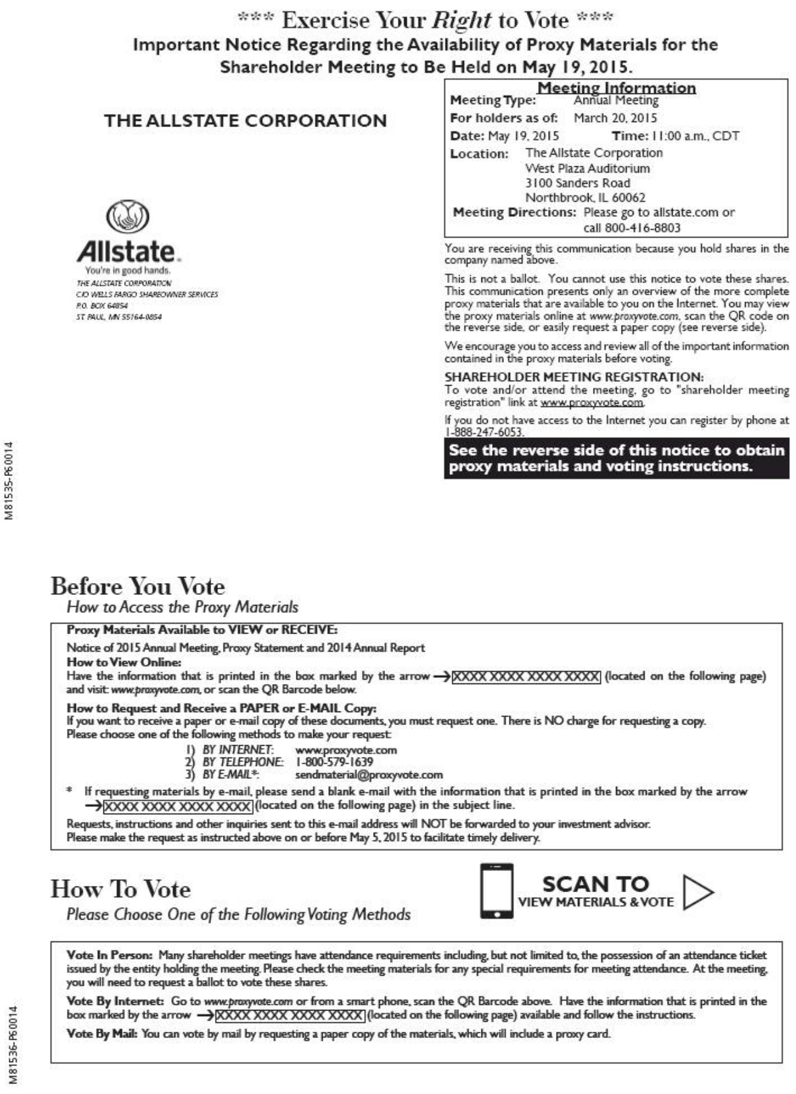

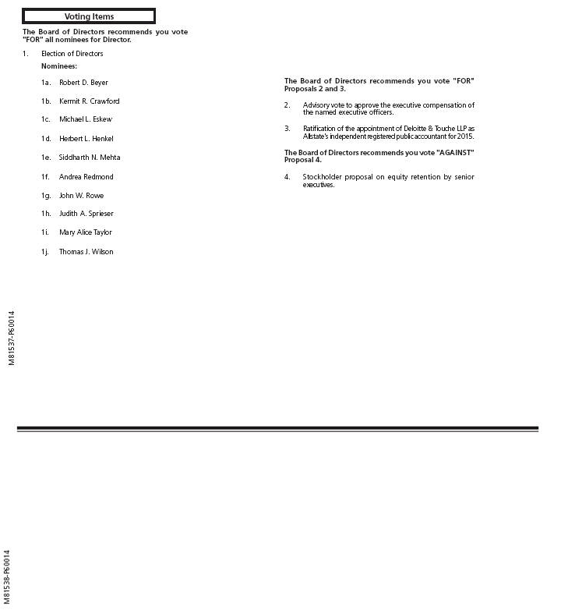

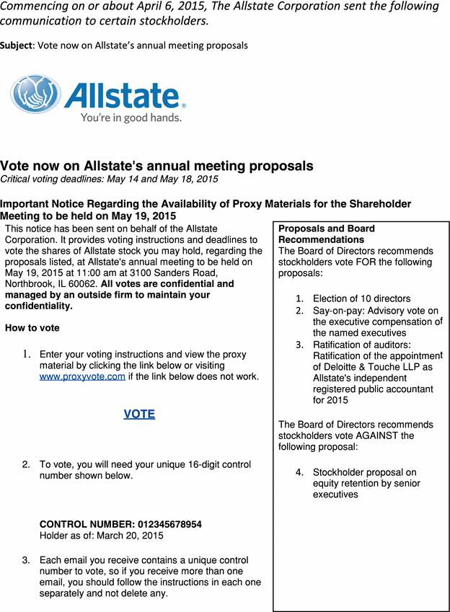

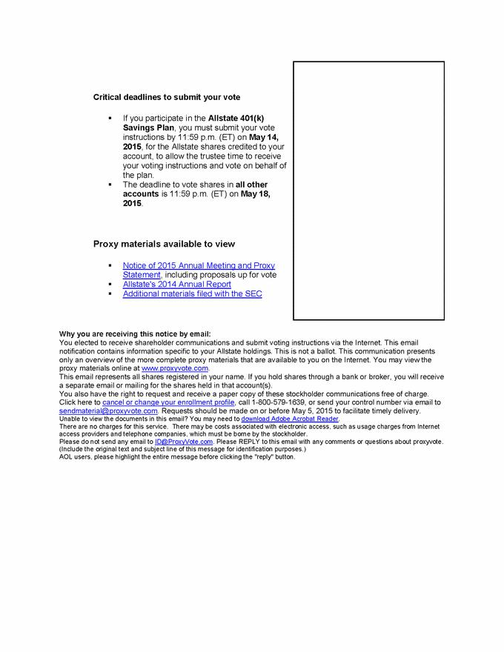

Commencing on or about April 6, 2015, The Allstate Corporation made the following intranet webpage available to employees.

Now available: annual meeting educational materials

Online toolkit, Q&A aim to help employees understand proxy voting process, proposals

Allstate began mailing annual meeting materials to stockholders April 6.

The annual stockholder meeting and proxy vote give stockholders — including employees who hold shares through the Allstate 401(k) Savings Plan — an opportunity to voice their opinions on the re-election of the board of directors and other matters presented for a vote.

This online toolkit aims to help employees understand the proxy voting process and proposals by offering FAQs, an overview of the 2015 annual meeting’s proposals and a clear, simple explanation of the voting process. And this Q&A with Susie Lees, executive vice president, general counsel and secretary of the corporation, provides additional information.

In addition to these materials, the corporation advises that all stockholders read the Notice of 2015 Annual Meeting, Proxy Statement and 2014 Annual Report before voting.

Commencing on or about April 6, 2015, The Allstate Corporation made the following intranet webpage available to employees.

Employee Stockholders’ Guide to Voting on Annual Meeting Proposals

Every year at Allstate’s annual meeting, stockholders vote on important matters. Most of the voting takes place before the meeting, through proxy voting.

Voting by proxy allows stockholders to vote on issues that will be considered at the meeting, without actually attending.

Every vote matters. All stockholders — including employees — are encouraged to voice their opinion by voting their shares.

Voting by proxy continues until 11:59 p.m. ET on May 18 (or May 14 for shares held through the Allstate 401(k) Savings Plan), in advance of the annual meeting on May 19.

The annual voting process may seem confusing at first, but Allstate provides several resources to help employee stockholders understand the issues up for vote and feel comfortable with the voting process.

Resources

Understanding the 2015 Proposals: Find out more about the matters up for vote this year, in clear, simple terms.

Frequently Asked Questions: Learn more about the importance of voting and how the process works.

2014 Annual Report, Notice of 2015 Annual Meeting and Proxy Statement: Each year, Allstate publishes an annual report about the previous year, and includes a notice of meeting and a proxy statement with information to help stockholders make informed voting decisions. The proxy statement includes detailed information about the proposals that are up for vote this year. The company filed the 2015 Proxy Statement with the Securities and Exchange Commission on April 6. Please be sure to read these documents before voting.

How to Vote

Employee stockholders who have not opted to receive materials in paper form will begin receiving the email on or around April 9 with a link and instructions to vote electronically. The email will have the subject line “Vote now on Allstate’s annual meeting proposals” and will be sent by The Allstate Corporation.

If you own shares of Allstate stock through other accounts, proxy materials will be sent to you either electronically or through postal mail, based on preferences on file with the firm/broker.

In either case, you may vote by following the instructions in the materials you receive.

Commencing on or about April 6, 2015, The Allstate Corporation made the following intranet webpage available to employees.

Frequently Asked Questions

Employee Stockholders’ Guide to Voting on Annual Meeting Proposals

What is proxy voting?

Voting by proxy allows stockholders to voice their opinion on important issues that will be considered at Allstate’s annual stockholder meeting, without having to attend the meeting. Stockholders can vote in advance on the matters to be considered at the meeting.

Why are stockholders’ votes gathered this way?

Voting by proxy is a common practice among publicly traded companies, because it allows stockholders to express their opinion without having to attend the company’s annual meeting. Typically, few stockholders attend a company’s annual meeting in person. Widely held companies like Allstate have stockholders around the world; voting by proxy is a more convenient way to vote shares on proposals.

Why do stockholders have a vote?

When someone has an investment interest in Allstate or another company’s stock, they have a financial stake in its success. Our annual stockholder meeting and vote give stockholders an important opportunity to voice their opinion on the election of the board of directors and other governance matters.

Through the annual meeting process, employee stockholders have an opportunity to influence the company’s corporate governance by voting their shares, just as they help to drive Allstate’s success through the work they do every day.

Why is Allstate encouraging me to vote?

Every vote matters, including those of our employee stockholders. All stockholders — including employees — are encouraged to vote.

Why is Allstate providing more information about the annual meeting and vote?

It is important for employee stockholders to understand the issues and add their voices to the dialogue. The proxy vote process and issues up for vote can be confusing, and we don’t want that to discourage employee stockholders from participating. As with any significant decision, it is important to gather the facts and feel comfortable with the process.

To help, Allstate offers tools that outline the annual proxy vote process and provide more information about the issues in clear, simple language. These resources are meant to help employees feel comfortable with the voting process and issues up for vote.

What issues are up for vote in 2015?

Allstate stockholders will be asked to vote on governance items, including the re-election of the board of directors. More information is available in the Notice of 2015 Annual Meeting and Proxy Statement. Please review this information before voting.

The items up for vote are:

- Election of directors

- Say-on-pay — advisory vote on the executive compensation of the named executive officers

- Ratification of auditors — ratification of the appointment of Deloitte & Touche LLP as Allstate’s independent registered public accountant for 2015

- Stockholder proposal on equity retention by senior executives

How can I vote?

Employees who own shares of Allstate stock will receive a notice that the proxy materials and voting instructions are available. Most of these employee stockholders will begin receiving it by email from The Allstate Corporation on or around April 9, with the subject line “Vote now on Allstate’s annual meeting proposals,” while others will receive the email from their broker. Some employees may receive materials by postal mail if they previously selected this delivery option.

In either case, stockholders may vote by following the instructions in the materials.

How do I set my delivery preferences for proxy materials?

Each year, an Allstate NOW article is published to remind employees that they can opt out of electronic delivery of proxy materials. However, employees can change their election at any time by following the processes set forth in the materials they receive.

Will Allstate leaders or employees know how I vote?

No. Allstate has a confidential voting policy that applies to all votes cast, including employee votes. All votes are confidential and managed by an outside firm to maintain confidentiality, except as necessary to allow the inspector of election to certify the vote result or meet certain legal requirements. The votes are tabulated by an independent outside vendor, and the results are certified by an independent inspector of election. However, if a stockholder provides a comment on his or her ballot, and knowing the vote is important to understand the comment, then the comment and the vote may be disclosed to the corporate secretary.

What happens if I don’t vote?

Stockholders who decide not to vote will miss an opportunity to voice their opinion. However, the decision about whether to vote will not affect their status as an Allstate stockholder. The trustee of the Allstate 401(k) Savings Plan, The Northern Trust Corp., will vote any shares not voted by plan participants. If less than 50 percent of shares held by participants are voted, the trustee would use its sole discretion to vote unvoted shares. If more than 50 percent of the shares held by participants are voted, the trustee would vote all other shares in the same proportion and in the same manner as the shares that have been voted, unless to do so would be inconsistent with the trustee’s duties.

When will the annual meeting take place? Can I attend?

The annual meeting is scheduled to begin at 11 a.m. on Tuesday, May 19, at West Plaza in home office. All Allstate stockholders are invited to attend.

Registration begins at 10 a.m. Stockholders are encouraged to pre-register to attend the annual meeting by following the instructions in the proxy statement.

You may also register on-site, but to do so, you will need to bring information with you to be confirmed as a stockholder.

- If you hold your shares beneficially (through a bank or broker), you must bring a statement showing your ownership on March 20, 2015, in order to attend the meeting.
- Participants in the Allstate 401(k) Savings Plan may attend the meeting, but may not vote the shares credited to their accounts at the meeting. All voting instructions for shares in the Allstate 401(k) Savings Plan must be received by May 14 so the trustee can tabulate and vote the shares.

Commencing on or about April 6, 2015, The Allstate Corporation made the following intranet webpage available to employees.

Understanding the 2015 Proposals

Employee Stockholders’ Guide to Voting on Annual Meeting Proposals

Each year, Allstate stockholders are asked to consider and vote on proposals related to important governance matters. Some of the issues can be challenging to understand. The 2015 proposals are listed below, followed by explanations to help you understand the matters up for vote.

The proxy statement and the descriptions below provide the vote recommendation of the Allstate board of directors. These recommendations are based on the board’s view of what is best for stockholders and the corporation. Please review the proxy statement and annual report before voting.

Proposal 1 — Election of directors

Who are the directors of The Allstate Corporation?

The Allstate Corporation has 10 nominees for election as directors at the 2015 annual meeting. Nine of the directors are independent from Allstate, which means they are not Allstate employees and have no relationships with the company that would create a conflict of interest that would impair independence. Tom Wilson, chairman and CEO, is the only Allstate employee on the board. For more information, see the biographies of the board members, beginning on page 13 of the 2015 proxy statement.

Why do we vote to elect our board of directors every year?

Electing directors on an annual basis is considered by many to be a “best governance practice,” as annual elections are said to enhance director accountability. Some companies have what is typically referred to as a “staggered” board. This means out of 10 or 12 directors, only three or four are elected each year to serve a multi-year term — usually three years at a time. Allstate’s practice of electing each director every year is considered good governance, as it allows stockholders the opportunity to vote on each director’s continued service in each year.

What is the vote standard required to elect an Allstate director?

Each Allstate director must receive a majority of affirmative or “for” votes out of the votes cast. Some companies apply a plurality vote standard, which means a director can be elected by less than a majority of votes cast.

Proposal 2 — Say-on-pay — advisory vote on the compensation of the named executive officers

Why do stockholders get to vote on executive compensation?

The Dodd-Frank Act required public companies to provide stockholders with the opportunity to cast an advisory vote on the company’s executive compensation program for named executive officers. The vote is non-binding, but it gives stockholders an opportunity to voice any concerns about a company’s executive compensation program. Allstate’s compensation and succession committee (a committee of the board) takes the stockholder vote into consideration when it conducts its annual review of the compensation program.

How does the board of directors determine executive compensation?

The compensation and succession committee of the board of directors works with an independent compensation consultant to design an executive compensation program that aligns compensation with the company’s strategic and operational business goals. In designing such a program, the committee examines market pay and practices at a group of peer companies and uses the 50th percentile of this peer group as a guideline in setting target direct compensation. To read more about this, see the 2015 proxy statement.

Proposal 3 — Ratification of auditors — ratification of the appointment of Deloitte & Touche LLP as Allstate’s independent registered public accountant for 2015

Why do we vote to ratify the auditors?

The audit committee of the board of directors annually appoints an independent registered public accounting firm. As has been our longstanding practice, stockholders are asked to ratify the appointment. If the appointment is not ratified by stockholders, the committee may reconsider which accounting firm to appoint. The proxy statement contains details on the fees paid to Deloitte & Touche LLP for 2014 and 2013.

Proposal 4 — Stockholder proposal

What is a stockholder proposal?

Stockholders who meet certain eligibility requirements set by the Securities and Exchange Commission can submit a proposal to be included in the company’s annual proxy statement. There is one stockholder proposal in the 2015 proxy statement.

- The stockholder proposal, Proposal 4, is asking for a policy to require that senior executives of Allstate retain 75% of the net after-tax shares of stock received as equity compensation until reaching normal retirement age. The board of directors recommends that stockholders vote against this proposal because Allstate already has significant executive stock ownership guidelines in place, expanded equity retention guidelines in 2014, and existing policies already align executives’ incentives with stockholders’ interests. See pages 71-72 of the proxy statement for more information.

Commencing on or about April 6, 2015, The Allstate Corporation made the following intranet webpage available to employees.

Q&A: How to have a seat at the boardroom table

Learn how the proxy vote helps you voice opinions and influence corporate governance

The 2015 annual meeting of Allstate stockholders will take place on May 19 at 11 a.m. at home office’s West Plaza. The re-election of Allstate’s board of directors, approval of Allstate’s executive compensation practices, ratification of Deloitte & Touche LLP as Allstate’s independent registered public accountant, and consideration of a stockholder proposal will be up for a vote at this meeting. Most of these votes will be cast in advance — by proxy.

If you are part of the 88 percent of Allstaters who participate in the Allstate 401(k) Savings Plan and you have Allstate shares credited to your account as of March 20, 2015, you are entitled to vote. You don’t even have to attend the meeting. In fact, the proxy voting process actually requires that plan participants who want to vote do so in advance of the annual meeting, before May 14. Employees who hold Allstate shares through any other accounts (i.e., as a registered stockholder or through a bank or broker) can vote those shares through May 18.

Conscientious citizens don’t cast votes without first educating themselves about the process and the issues, and Allstate doesn’t expect its stockholders to act any differently. The proxy process and the issues up for vote can be confusing. That’s why Allstate NOW asked Susie Lees, executive vice president, general counsel and secretary of the corporation, to explain the process.

What is corporate governance, exactly, and why is it important?

Lees: Corporate governance refers to the rules, customs and practices that define the way companies manage responsibility among stockholders, the board of directors and management.

How does proxy voting fit into all of this?

Lees: It’s kind of like casting an absentee ballot for a political election. Proxy voting allows stockholders to voice their opinion by voting on important matters presented for consideration at the annual stockholder meeting without having to attend the meeting in person. The proxy voting process ensures that stockholders have the opportunity to play an important role by voting their shares, regardless of their attendance at the meeting.

How do employee stockholders cast their proxy votes?

Lees: Stockholders will receive either an email from “The Allstate Corporation” the week of April 6 or materials by postal mail in the next few weeks. These materials will include instructions on how to vote online, by phone or by mail. If received through email, the subject line will read, “Vote now on Allstate’s annual meeting proposals.” Employees who hold stock

through the Allstate 401(k) Savings Plan must cast their voting instructions for those shares in advance of the meeting — by May 14.

Employees who own shares of Allstate stock that are held by investment brokers/firms will receive proxy materials electronically or through the mail, based on the delivery preferences they have on file with the broker/firm.

So, what issues are up for vote in 2015?

Lees: This year, stockholders are asked to vote on the following proposals, also outlined in the 2015 proxy statement:

- Election of directors

- Say-on-pay — advisory vote on the executive compensation of the named executive officers

- Ratification of auditors — ratification of the appointment of Deloitte & Touche LLP as Allstate’s independent registered public accountant for 2015

- Stockholder proposal on equity retention by senior executives

This year, Allstate is providing a toolkit with simplified explanations of the key terms included in these vote items to help employees understand each issue presented.

How can employee stockholders become better informed about their proxy votes and the 2015 proposals?

Lees: Allstate’s online toolkit provides an FAQ and links to the proxy statement and explanations of the process and proposals in clear, simple language designed to help employees feel more comfortable voting their shares. Please make sure to also review the proxy statement and 2014 annual report before voting.

Does the amount of shares an employee holds affect the weight of his or her vote?

Lees: Allstate common stock provides one vote for each share of stock owned. The size of an employee’s ownership interest in Allstate stock will affect the significance of his or her vote in the overall vote results. Publicly traded companies are market-based entities, and the more shares a stockholder owns and votes, the larger the effect on the final vote outcome.

Will Allstate leaders or fellow employees know how an employee stockholder votes?

Lees: No. All votes are confidential and are tabulated by an outside firm to maintain confidentiality, except as necessary to allow the independent inspector of election to certify the vote result or to meet certain legal requirements.

Allstate management will see the votes only in the aggregate and will have no way to know how any one stockholder voted. If you write a comment on your proxy card, voting instruction form or ballot, it may be provided to me as the secretary of the corporation, along with your name and

address. Your comments will be provided without reference to how you voted unless the vote is mentioned in your comment or disclosure of the vote is necessary to understand your comment.

Why is it important that employee stockholders have, and exercise, their votes?

Lees: Having an ownership interest in Allstate stock provides employees with a financial stake in the company’s success other than their paychecks. Voting your shares helps influence Allstate’s corporate governance.

What happens if an employee stockholder chooses not to vote?

Lees: Just as choosing not to vote in a civic election doesn’t affect one’s status as a citizen, an employee’s decision not to cast a proxy vote will not change his or her status as an Allstate stockholder. The vote is simply an opportunity for stockholders to voice their opinions and help influence corporate governance at Allstate. As with political elections, if you don’t express your views and affirmatively vote your interests, the winning vote outcome becomes your vote by default.

More information about the 2015 annual stockholder meeting and the proxy vote is available in the Employee Stockholders’ Guide to Voting. Click here to access this online toolkit. Please review the Notice of 2015 Annual Meeting, Proxy Statement, and the 2014 Annual Report before voting.

Commencing on or about April 6, 2015, The Allstate Corporation sent the following communication to employees.

Subject: Be an informed voter — Prepare for annual meeting vote

Your vote matters: Voting on Allstate’s annual meeting proposals

You help shape Allstate’s future through the work you do every day. Through the annual meeting process, if you are employee stockholders, you have another opportunity to take an ownership role and influence the company’s corporate governance — by voting your Allstate shares. Your vote is your voice.

Research shows us that many employees remain unclear about the proxy voting process and proposals, which often discourages them from voting. Some have even told us they weren’t aware they could vote even with the Allstate shares they hold through the Allstate 401(k) Savings Plan. For those of you who are eligible, this is an important opportunity to share your opinion.

To help you prepare, we are providing an online toolkit, including an FAQ and an overview of the proposals and voting process in clear, simple language. As always, you should review the Notice of 2015 Annual Meeting, Proxy Statement and the 2014 Annual Report. We want you to feel comfortable with the voting process and issues up for vote.

This year, stockholders are asked to consider and vote on the following matters:

- Election of directors

- Say-on-pay: advisory vote on the executive compensation of the named executive officers

- Ratification of auditors: ratification of the appointment of Deloitte & Touche LLP as Allstate’s independent registered public accountant for 2015

- Stockholder proposal on equity retention by senior executives

Those of you who own shares of Allstate stock will receive a notice that the proxy materials are available. Most of you will have received it by email from The Allstate Corporation on or around April 9. Some of you will receive it by postal mail if you previously selected this delivery option.

I encourage you to vote. If you hold shares as a registered stockholder, as a beneficial stockholder or as a participant in the 401(k) plan with Allstate shares credited to your account, voting your shares is an important way to take an active role in the overall governance of our company.

Thank you,

Harriet Harty

Executive Vice President

Human Resources

