UNITED STATES
SECURITIES AND EXCHANGE COMMISSION
Washington, D.C. 20549

FORM 8-K

CURRENT REPORT
PURSUANT TO SECTION 13 OR 15 (d) OF THE
SECURITIES EXCHANGE ACT OF 1934

Date of report (Date of earliest event reported): April 29, 2026
THE ALLSTATE CORPORATION
(Exact name of registrant as specified in its charter)

Delaware |  |  |  |  |  | 1-11840 |  |  |  |  |  | 36-3871531
(State or other  jurisdiction of incorporation) |  |  |  |  |  | (Commission  File Number) |  |  |  |  |  | (IRS Employer  Identification No.)
3100 Sanders Road, Northbrook, Illinois 60062
(Address of principal executive offices) (Zip Code)

Registrant’s telephone number, including area code (847) 402-2800

Check the appropriate box below if the Form 8-K filing is intended to simultaneously satisfy the filing obligation of the registrant under any of the following provisions:

☐ Written communications pursuant to Rule 425 under the Securities Act (17 CFR 230.425)
☐ Soliciting material pursuant to Rule 14a-12 under the Exchange Act (17 CFR 240.14a-12)
☐ Pre-commencement communications pursuant to Rule 14d-2(b) under the Exchange Act (17 CFR 240.14d-2(b))
☐ Pre-commencement communications pursuant to Rule 13e-4(c) under the Exchange Act (17 CFR 240.13e-4(c))

Securities registered pursuant to Section 12(b) of the Act:
Title of each class |  |  | Trading Symbols |  |  | Name of each exchange on which registered
Common Stock, par value $0.01 per share |  |  | ALL |  |  | New York Stock Exchange  NYSE Texas
5.100% Fixed-to-Floating Rate Subordinated Debentures due 2053 |  |  | ALL.PR.B |  |  | New York Stock Exchange
Depositary Shares represent 1/1,000th of a share of 5.100% Noncumulative Preferred Stock, Series H |  |  | ALL PR H |  |  | New York Stock Exchange
Depositary Shares represent 1/1,000th of a share of 4.750% Noncumulative Preferred Stock, Series I |  |  | ALL PR I |  |  | New York Stock Exchange
Depositary Shares represent 1/1,000th of a share of 7.375% Noncumulative Preferred Stock, Series J |  |  | ALL PR J |  |  | New York Stock Exchange

Indicate by check mark whether the registrant is an emerging growth company as defined in Rule 405 of the Securities Act of 1933 (§230.405 of this chapter) or Rule 12b-2 of the Securities Exchange Act of 1934 (§240.12b-2 of this chapter).
 |  |  |  |  |  | Emerging growth company |  |  | ☐

If an emerging growth company, indicate by check mark if the registrant has elected not to use the extended transition period for complying with any new or revised financial accounting standards provided pursuant to Section 13(a) of the Exchange Act. ☐

Section 2 – Financial Information

Item 2.02. Results of Operations and Financial Condition.

The Registrant’s press release dated April 29, 2026, announcing its financial results for the first quarter of 2026, and the Registrant’s first quarter 2026 investor supplement are furnished as Exhibits 99.1 and 99.2, respectively, to this report. The information contained in the press release and the investor supplement are furnished and not filed pursuant to instruction B.2 of Form 8-K.

Section 9 – Financial Statements and Exhibits

Item 9.01. Financial Statements and Exhibits.

(d) Exhibits

99.1 Registrant’s Press Release dated April 29, 2026
99.2 First Quarter 2026 Investor Supplement of The Allstate Corporation
104 Cover Page Interactive Data File (formatted as inline XBRL)

2

SIGNATURES

Pursuant to the requirements of the Securities Exchange Act of 1934, the Registrant has duly caused this report to be signed on its behalf by the undersigned hereunto duly authorized.

 |  |  | THE ALLSTATE CORPORATION
 |  |  | (Registrant)
 |  |  | By: |  |  | /s/ Eric K. Ferren
 |  |  | Name: Eric K. Ferren
 |  |  | Title: Senior Vice President, Controller and Chief Accounting Officer

Date: April 29, 2026

Exhibit 99.1
3

FOR IMMEDIATE RELEASE

Contacts:
Nick Nottoli Allister Gobin
Media Relations Investor Relations
mediateam@allstate.com invrel@allstate.com

Allstate Reports Strong Earnings and Increased Growth

NORTHBROOK, Ill., April 29, 2026 – The Allstate Corporation (NYSE: ALL) today reported financial results for the first quarter of 2026.
“Allstate’s strategy and execution capabilities generated strong earnings and increased growth in the first quarter,” said Tom Wilson, who leads The Allstate Corporation. “Revenues were $16.9 billion and net income was $2.4 billion. Policies in force reached 212 million, reflecting increased growth in auto and homeowners insurance and Protection Plans. The Property-Liability combined ratio was strong, and the underlying combined ratio* improved in all personal lines products and brands. Investment income increased by 9.8%, reflecting portfolio growth and higher fixed income yields. Adjusted net income* was $2.8 billion, or $10.65 per diluted common share.”

“The broad set of competitive tools created through Transformative Growth is driving strong performance,” continued Wilson. “Market share of auto and homeowners insurance increased in many states due to a comprehensive approach of more affordable prices, new products, expanded benefits, bundled offerings, lower expenses, sophisticated analytics and increased marketing. This positioned Allstate and independent agents and direct distribution to capture a record amount of new business in the quarter. Retention losses were slightly lower reflecting last year’s focus on improving customer experience. Protection offerings were also broadened with Protection Services policies increasing over the prior year. Shareholders benefited from strong earnings, higher dividends and increased share repurchases,” concluded Wilson.

First Quarter 2026 Results
•Total revenues of $16.9 billion in the first quarter of 2026 were $489 million or 3.0% higher than the prior year quarter.
•Net income applicable to common shareholders was $2.4 billion in the first quarter of 2026, compared to $566 million in the prior year quarter, reflecting strong underwriting results.
•Adjusted net income* was $2.8 billion, or $10.65 per diluted share, compared to $949 million in the prior year quarter.

Exhibit 99.1
1
The Allstate Corporation Consolidated Highlights
 |  |  |  |  | As of or for the three months ended March 31,
($ in millions, except per share data and ratios) |  |  |  |  |  |  |  | 2026 |  |  |  | 2025 |  |  | % / pts  Change
Consolidated revenues |  |  |  |  |  |  |  | $ | 16,941 |  |  | $ | 16,452 |  | 3.0 |  | %
Net income applicable to common shareholders |  |  |  |  |  |  |  | 2,428 |  |  |  | 566 |  |  | NM
per diluted common share |  |  |  |  |  |  |  | 9.25 |  |  |  | 2.11 |  |  | NM
Adjusted net income* |  |  |  |  |  |  |  | 2,797 |  |  |  | 949 |  |  | NM
per diluted common share* |  |  |  |  |  |  |  | 10.65 |  |  |  | 3.53 |  |  | NM
Return on Allstate common shareholders’ equity (trailing twelve months)
Net income applicable to common shareholders |  |  |  |  |  |  |  | 48.4 |  | % |  | 21.4 |  | % | 27.0
Adjusted net income* |  |  |  |  |  |  |  | 44.4 |  | % |  | 23.7 |  | % | 20.7
Common shares outstanding (in millions) |  |  |  |  |  |  |  | 257.8 |  |  |  | 265.1 |  |  | (2.8) |  | %
Book value per common share |  |  |  |  |  |  |  | $ | 113.52 |  |  | $ | 74.61 |  | 52.2 |  | %
Total policies in force (in thousands) (1) |  |  |  |  |  |  |  | 212,052 |  |  |  | 206,898 |  |  | 2.5 |  | %
NM = not meaningful
(1)Excludes policies in force related to the employer voluntary benefits and group health businesses sold in 2025.
* Measures used in this release that are not based on accounting principles generally accepted in the United States of America (“non-GAAP”) are denoted with an asterisk and defined and reconciled to the most directly comparable GAAP measure in the “Definitions of Non-GAAP Measures” section of this document.
----------------------------------------------------------------------------------------------------------------------------------------------------------

•Property-Liability earned premiums of $14.8 billion increased 5.5% in the first quarter of 2026 compared to the prior year, primarily driven by higher homeowners insurance average premiums and policy in force growth. Underwriting income was $2.7 billion compared to $360 million in the prior year quarter.

Property-Liability Results
 |  |  |  |  | As of or for the three months ended March 31,
($ in millions) |  |  |  |  |  |  | 2026 |  |  | 2025 |  |  | % / pts  Change
Premiums written |  |  |  |  |  |  | $ | 14,625 |  | $ | 14,297 |  | 2.3 |  | %
Premiums earned |  |  |  |  |  |  | $ | 14,802 |  | $ | 14,027 |  | 5.5 |  | %
Recorded combined ratio |  |  |  |  |  |  | 82.0 |  |  | 97.4 |  |  | (15.4)
Underlying combined ratio* |  |  |  |  |  |  | 80.3 |  |  | 83.1 |  |  | (2.8)
Catastrophe losses |  |  |  |  |  |  | $ | 1,240 |  | $ | 2,202 |  | (43.7) |  | %
Underwriting income |  |  |  |  |  |  | $ | 2,658 |  | $ | 360 |  | NM
Policies in force (in thousands) |  |  |  |  |  |  | 38,576 |  |  | 37,712 |  |  | 2.3 |  | %
NM = not meaningful
◦Premiums written increased 2.3% compared to the prior year quarter, reflecting policy in force growth and higher homeowners insurance average premiums. Written premium growth was less than earned premium growth reflecting lower average premiums on new insurance policies and actions to improve affordability while maintaining margins.

◦Property-Liability combined ratio was 82.0 for the quarter, which was an improvement of 15.4 points versus the prior year quarter due to lower catastrophe losses, the benefit of prior year reserve releases and higher average earned premiums.

◦Policies in force increased by 2.3%, led by growth in auto and homeowners insurance policies.

◦Allstate-branded Affordable, Simple, Connected auto insurance products are now available in 45 states with the homeowners insurance product available in 36 states. Custom360® middle market standard and preferred auto and homeowners insurance products for the independent agent channel are available in 40 states.

Exhibit 99.1
2
◦Allstate Protection auto insurance results reflect Transformative Growth execution, with strong margins and new business growth across all distribution channels.

Allstate Protection Auto Results
 |  |  |  |  | As of or for the three months ended March 31,
($ in millions, except ratios) |  |  |  |  |  |  | 2026 |  |  | 2025 |  |  | % / pts  Change
Premiums written |  |  |  |  |  |  | $ | 9,850 |  | $ | 9,848 |  | — |  | %
Premiums earned |  |  |  |  |  |  | $ | 9,547 |  | $ | 9,347 |  | 2.1 |  | %
Recorded combined ratio |  |  |  |  |  |  | 81.9 |  |  | 91.3 |  |  | (9.4)
Underlying combined ratio* |  |  |  |  |  |  | 89.5 |  |  | 91.2 |  |  | (1.7)
Underwriting income |  |  |  |  |  |  | $ | 1,729 |  | $ | 816 |  | 111.9 |  | %
Policies in force (in thousands) |  |  |  |  |  |  | 25,758 |  |  | 25,100 |  |  | 2.6 |  | %

◦Written premiums were in line with the prior year as higher policies in force were offset by lower average premiums. Earned premiums grew 2.1% compared to the prior year quarter.

◦The recorded auto insurance combined ratio of 81.9 in the first quarter of 2026 was a 9.4 point improvement from the prior year quarter, due primarily to the benefit of prior year reserve releases. Prior year reserve liabilities were lowered by $838 million as estimated claims costs for 2023 through 2025 were reduced, improving the current quarter combined ratio by 8.8 points.

◦The underlying auto insurance combined ratio* of 89.5 in the first quarter of 2026 was a 1.7 point improvement from the prior year quarter, reflecting improvements in the underlying loss and expense ratios.

◦Auto insurance policies in force grew by 2.6% with a 9.4% increase in new business, reflecting expanded distribution, increased marketing, new products and sophisticated rating plans. Active brand auto insurance policies grew by 3.5%, which was partially offset by decreases in legacy Esurance and Encompass policies.

◦Allstate Protection homeowners insurance remains a competitive advantage for Allstate. Underwriting profit of $685 million increased from a loss of $451 million in the prior year quarter, primarily reflecting 2025’s California wildfire losses.

Allstate Protection Homeowners Results
 |  |  |  |  | As of or for the three months ended March 31,
($ in millions, except ratios) |  |  |  |  |  |  | 2026 |  |  | 2025 |  |  | % / pts  Change
Premiums written |  |  |  |  |  |  | $ | 3,741 |  | $ | 3,453 |  | 8.3 |  | %
Premiums earned |  |  |  |  |  |  | $ | 4,164 |  | $ | 3,657 |  | 13.9 |  | %
Recorded combined ratio |  |  |  |  |  |  | 83.5 |  |  | 112.3 |  |  | (28.8)
Catastrophe Losses |  |  |  |  |  |  | $ | 1,046 |  | $ | 1,824 |  | (42.7) |  | %
Underlying combined ratio* |  |  |  |  |  |  | 60.5 |  |  | 62.4 |  |  | (1.9)
Underwriting income (loss) |  |  |  |  |  |  | $ | 685 |  | $ | (451) |  | NM
Policies in force (in thousands) |  |  |  |  |  |  | 7,739 |  |  | 7,549 |  |  | 2.5 |  | %
NM = not meaningful
◦Written premiums and earned premiums increased by 8.3% and 13.9% compared to the prior year quarter, respectively, due to higher average premiums and policy in force growth. A 6.8% increase in Allstate brand homeowners insurance average gross written premium compared to the prior year quarter reflects continued rate increases and higher home replacement costs.

◦The recorded homeowners insurance combined ratio of 83.5 was 28.8 points below the first quarter of 2025, due to lower catastrophe losses and higher average earned premiums.

◦Catastrophe losses of $1.0 billion in the quarter decreased $778 million compared to the prior year.
Exhibit 99.1
3
◦The underlying combined ratio* of 60.5 improved by 1.9 points compared to the prior year quarter, primarily driven by higher average premiums.

◦Policies in force increased 2.5% compared to the prior year quarter, primarily driven by 3.2% growth in Allstate brand homeowners insurance policies, offset by a reduction in National General legacy products.

----------------------------------------------------------------------------------------------------------------------------------------------------------

•Protection Services is comprised of five businesses that broaden protection through embedded product offerings. Revenues increased to $922 million in the first quarter of 2026, 7.2% higher than the prior year quarter, primarily due to Protection Plans and Roadside. Adjusted net income of $47 million decreased by $8 million compared to the prior year quarter.

Protection Services Results
 |  |  |  |  | Three months ended March 31,
($ in millions) |  |  |  |  |  |  | 2026 |  |  | 2025 |  |  | % / $  Change
Total revenues (1) |  |  |  |  |  |  | $ | 922 |  | $ | 860 |  | 7.2 |  | %
Protection Plans |  |  |  |  |  |  | 613 |  |  | 540 |  |  | 13.5
Roadside |  |  |  |  |  |  | 63 |  |  | 55 |  |  | 14.5
Dealer Services |  |  |  |  |  |  | 148 |  |  | 146 |  |  | 1.4
Identity Protection |  |  |  |  |  |  | 40 |  |  | 40 |  |  | —
Arity |  |  |  |  |  |  | 58 |  |  | 79 |  |  | (26.6)
Adjusted net income (loss) |  |  |  |  |  |  | $ | 47 |  | $ | 55 |  | $ | (8)
Protection Plans |  |  |  |  |  |  | 41 |  |  | 45 |  |  | (4)
Roadside |  |  |  |  |  |  | 12 |  |  | 11 |  |  | 1
Dealer Services |  |  |  |  |  |  | 5 |  |  | 4 |  |  | 1
Identity Protection |  |  |  |  |  |  | 1 |  |  | 1 |  |  | —
Arity |  |  |  |  |  |  | (12) |  |  | (6) |  |  | (6)
(1)Excludes net gains and losses on investments and derivatives.

◦Protection Plans continued to expand distribution relationships and product offerings. Revenue of $613 million increased $73 million, or 13.5%, compared to the prior year quarter primarily due to strong international and domestic growth. Adjusted net income of $41 million in the first quarter of 2026 decreased $4 million compared to the prior year quarter.

◦Roadside revenue of $63 million in the first quarter of 2026 increased 14.5% compared to the prior year quarter reflecting increased bundling with Allstate branded Affordable, Simple, Connected auto insurance products and higher third-party sales. Adjusted net income of $12 million in the first quarter was $1 million higher than the prior year quarter.

◦Dealer Services generated revenue of $148 million, an increase of $2 million compared to the prior year quarter. Adjusted net income of $5 million was $1 million higher than the prior year quarter.

◦Identity Protection revenue of $40 million in the first quarter of 2026 was in line with the prior year quarter. Adjusted net income of $1 million in the first quarter of 2026 was in line with the prior year quarter.

◦Arity revenue of $58 million decreased $21 million compared to the prior year quarter due to lower lead generation revenue. Adjusted net loss was $12 million in the first quarter of 2026 compared to a loss of $6 million in the prior year quarter.

-------------------------------------------------------------------------------------------------------------------------------------------------------

Exhibit 99.1
4
•Allstate Investments uses a proactive enterprise risk and return framework for the $85.2 billion portfolio. Net investment income of $938 million in the first quarter of 2026 increased by $84 million from the prior year quarter primarily due to market-based portfolio growth. Economic capital allocated to the investment portfolio increased in the first quarter, reflecting higher public equity exposure and the lengthening of fixed income duration to 5.7 years.

Allstate Investment Results
 |  |  |  |  | Three months ended March 31,
($ in millions, except ratios) |  |  |  |  |  |  | 2026 |  |  | 2025 |  |  | $ / pts  Change
Net investment income |  |  |  |  |  |  | $ | 938 |  | $ | 854 |  | $ | 84
Market-based (1) |  |  |  |  |  |  | 791 |  |  | 719 |  |  | 72
Performance-based (1) |  |  |  |  |  |  | 207 |  |  | 196 |  |  | 11
Net gains (losses) on investments and derivatives |  |  |  |  |  |  | $ | (405) |  | $ | (349) |  | $ | (56)
Change in unrealized net capital gains and losses, pre-tax (2) |  |  |  |  |  |  | $ | (664) |  | $ | 540 |  | $ | (1,204)
Total return on investment portfolio (2) |  |  |  |  |  |  | (0.2) |  | % | 1.4 |  | % | (1.6)
Total return on investment portfolio (2) (trailing twelve months) |  |  |  |  |  |  | 4.2 |  | % | 4.7 |  | % | (0.5)
(1)Investment expenses are not allocated between market-based and performance-based portfolios with the exception of investee level expenses.
(2)Includes investments held for sale.

◦Market-based investment income was $791 million in the first quarter of 2026, an increase of $72 million, or 10.0%, compared to the prior year quarter, reflecting growth in the asset balances to $75.2 billion in the market-based portfolio.

◦Performance-based investment income totaled $207 million in the first quarter of 2026, an increase of $11 million compared to the prior year quarter with higher private equity and real estate income. The overall portfolio allocation to performance-based assets provides a diversifying source of attractive long-term returns; quarterly volatility in reported results is expected.

◦Net losses on investments and derivatives were $405 million in the first quarter of 2026, compared to losses of $349 million in the prior year quarter. First quarter results primarily reflected valuation declines on public equity securities in March, which have since recovered.

◦Unrealized net capital losses totaled $282 million (pre-tax), a $664 million decrease to the prior quarter end as higher interest rates and wider credit spreads resulted in lower fixed income valuations.

◦Total return on the investment portfolio was negative 0.2% for the first quarter. Total return for the trailing twelve months was 4.2%.

Proactive Capital Management

“Allstate’s active capital management continues to create shareholder value,” said John Dugenske, Interim Chief Financial Officer and President, Investments and Corporate Strategy. “Operating results generated an adjusted net income return on equity* of 44.4% over the last year. Increased capital was deployed to investment opportunities, and $881 million of cash was provided to shareholders through dividends and share repurchases,” concluded Dugenske.

Visit www.allstateinvestors.com for additional information about Allstate’s results, including a webcast of its quarterly conference call and the call presentation. The conference call will be at 9 a.m. ET on Thursday, April 30. Financial information, including material announcements about The Allstate Corporation, is routinely posted on www.allstateinvestors.com.

Exhibit 99.1
5
Forward-Looking Statements
This news release contains “forward-looking statements” that anticipate results based on our estimates, assumptions and plans that are subject to uncertainty. These statements are made subject to the safe-harbor provisions of the Private Securities Litigation Reform Act of 1995. These forward-looking statements do not relate strictly to historical or current facts and may be identified by their use of words like “plans,” “seeks,” “expects,” “will,” “should,” “anticipates,” “estimates,” “intends,” “believes,” “likely,” “targets” and other words with similar meanings. We believe these statements are based on reasonable estimates, assumptions and plans. However, if the estimates, assumptions or plans underlying the forward-looking statements prove inaccurate or if other risks or uncertainties arise, actual results could differ materially from those communicated in these forward-looking statements. Factors that could cause actual results to differ materially from those expressed in, or implied by, the forward-looking statements may be found in our filings with the U.S. Securities and Exchange Commission, including the “Risk Factors” section in our most recent annual report on Form 10-K. Forward-looking statements are as of the date on which they are made, and we assume no obligation to update or revise any forward-looking statement.

About Allstate
The Allstate Corporation (NYSE: ALL) protects people from life’s uncertainties with affordable, simple and connected protection for autos, homes, electronic devices and identities. Products are available through a broad distribution network including Allstate agents, independent agents, major retailers, online and at the workplace. Allstate has more than 212 million policies in force and is widely known for the slogan “You’re in Good Hands with Allstate.” For more information, visit www.allstate.com.

6
THE ALLSTATE CORPORATION AND SUBSIDIARIES
CONDENSED CONSOLIDATED STATEMENTS OF FINANCIAL POSITION (UNAUDITED)
($ in millions, except par value data) |  |  | March 31, 2026 |  |  |  |  |  | December 31, 2025
Assets
Investments
Fixed income securities, at fair value (amortized cost, net $59,338 and $58,730) |  |  | $ | 59,060 |  |  |  |  | $ | 59,115
Equity securities, at fair value (cost $10,354 and $8,026) |  |  | 10,431 |  |  |  |  |  | 8,398
Mortgage loans, net |  |  | 868 |  |  |  |  |  | 879
Limited partnership interests |  |  | 8,946 |  |  |  |  |  | 8,844
Short-term, at fair value (amortized cost $4,707 and $4,888) |  |  | 4,705 |  |  |  |  |  | 4,887
Other investments, net |  |  | 1,150 |  |  |  |  |  | 1,114
Total investments |  |  | 85,160 |  |  |  |  |  | 83,237
Cash |  |  | 697 |  |  |  |  |  | 678
Premium installment receivables, net |  |  | 11,648 |  |  |  |  |  | 11,474
Deferred policy acquisition costs |  |  | 6,070 |  |  |  |  |  | 6,163
Reinsurance and indemnification recoverables, net |  |  | 8,422 |  |  |  |  |  | 8,501
Accrued investment income |  |  | 656 |  |  |  |  |  | 708
Deferred income taxes |  |  | 12 |  |  |  |  |  | —
Property and equipment, net |  |  | 606 |  |  |  |  |  | 627
Goodwill |  |  | 3,118 |  |  |  |  |  | 3,118
Other assets, net |  |  | 7,583 |  |  |  |  |  | 5,252
Total assets |  |  | $ | 123,972 |  |  |  |  | $ | 119,758
Liabilities
Reserve for property and casualty insurance claims and claims expense |  |  | $ | 41,320 |  |  |  |  | $ | 41,079
Unearned premiums |  |  | 28,863 |  |  |  |  |  | 29,080
Claim payments outstanding |  |  | 1,473 |  |  |  |  |  | 1,419
Deferred income taxes |  |  | — |  |  |  |  |  | 227
Other liabilities and accrued expenses |  |  | 13,238 |  |  |  |  |  | 9,874
Debt |  |  | 7,491 |  |  |  |  |  | 7,490
Total liabilities |  |  | 92,385 |  |  |  |  |  | 89,169
Equity
Preferred stock and additional capital paid-in, $1 par value, 25 million shares authorized, 82.0 thousand shares issued and outstanding, $2,050 aggregate liquidation preference |  |  | 2,001 |  |  |  |  |  | 2,001
Common stock, $.01 par value, 2.0 billion shares authorized and 900 million issued, 258 million and 260 million shares outstanding |  |  | 9 |  |  |  |  |  | 9
Additional capital paid-in |  |  | 4,169 |  |  |  |  |  | 4,158
Retained income |  |  | 64,540 |  |  |  |  |  | 62,393
Treasury stock, at cost (642 million and 640 million shares) |  |  | (38,820) |  |  |  |  |  | (38,206)
Accumulated other comprehensive income (loss):
Unrealized net capital gains and losses |  |  | (221) |  |  |  |  |  | 297
Unrealized foreign currency translation adjustments |  |  | (83) |  |  |  |  |  | (55)
Unamortized pension and other postretirement prior service credit |  |  | 10 |  |  |  |  |  | 11
Discount rate for reserve for future policy benefits |  |  | 2 |  |  |  |  |  | 2
Total accumulated other comprehensive (loss) income |  |  | (292) |  |  |  |  |  | 255
Total Allstate shareholders’ equity |  |  | 31,607 |  |  |  |  |  | 30,610
Noncontrolling interest |  |  | (20) |  |  |  |  |  | (21)
Total equity |  |  | 31,587 |  |  |  |  |  | 30,589
Total liabilities and equity |  |  | $ | 123,972 |  |  |  |  | $ | 119,758

7
THE ALLSTATE CORPORATION AND SUBSIDIARIES
CONDENSED CONSOLIDATED STATEMENTS OF OPERATIONS (UNAUDITED)
($ in millions, except per share data) |  |  |  |  | Three months ended March 31,
 |  |  |  |  |  |  | 2026 |  |  |  |  |  | 2025
Revenues
Property and casualty insurance premiums |  |  |  |  |  |  | $ | 15,553 |  |  |  |  | $ | 14,698
Accident and health insurance premiums and contract charges |  |  |  |  |  |  | 136 |  |  |  |  |  | 487
Other revenue |  |  |  |  |  |  | 719 |  |  |  |  |  | 762
Net investment income |  |  |  |  |  |  | 938 |  |  |  |  |  | 854
Net gains (losses) on investments and derivatives |  |  |  |  |  |  | (405) |  |  |  |  |  | (349)
Total revenues |  |  |  |  |  |  | 16,941 |  |  |  |  |  | 16,452
Costs and expenses
Property and casualty insurance claims and claims expense |  |  |  |  |  |  | 9,185 |  |  |  |  |  | 10,815
Accident, health and other policy benefits |  |  |  |  |  |  | 76 |  |  |  |  |  | 333
Amortization of deferred policy acquisition costs |  |  |  |  |  |  | 2,178 |  |  |  |  |  | 2,087
Operating costs and expenses |  |  |  |  |  |  | 2,225 |  |  |  |  |  | 2,245
Pension and other postretirement remeasurement (gains) losses |  |  |  |  |  |  | 19 |  |  |  |  |  | 78
Restructuring and related charges |  |  |  |  |  |  | 5 |  |  |  |  |  | 16
Amortization of purchased intangibles |  |  |  |  |  |  | 47 |  |  |  |  |  | 59
Interest expense |  |  |  |  |  |  | 98 |  |  |  |  |  | 100
Total costs and expenses |  |  |  |  |  |  | 13,833 |  |  |  |  |  | 15,733
Income from operations before income tax expense |  |  |  |  |  |  | 3,108 |  |  |  |  |  | 719
Income tax expense |  |  |  |  |  |  | 650 |  |  |  |  |  | 123
Net income |  |  |  |  |  |  | 2,458 |  |  |  |  |  | 596
Less: Net income attributable to noncontrolling interest |  |  |  |  |  |  | 1 |  |  |  |  |  | 1
Net income attributable to Allstate |  |  |  |  |  |  | 2,457 |  |  |  |  |  | 595
Less: Preferred stock dividends |  |  |  |  |  |  | 29 |  |  |  |  |  | 29
Net income applicable to common shareholders |  |  |  |  |  |  | $ | 2,428 |  |  |  |  | $ | 566
Earnings per common share:
Net income applicable to common shareholders per common share - Basic |  |  |  |  |  |  | $ | 9.36 |  |  |  |  | $ | 2.13
Weighted average common shares - Basic |  |  |  |  |  |  | 259.4 |  |  |  |  |  | 265.3
Net income applicable to common shareholders per common share - Diluted |  |  |  |  |  |  | $ | 9.25 |  |  |  |  | $ | 2.11
Weighted average common shares - Diluted |  |  |  |  |  |  | 262.6 |  |  |  |  |  | 268.8

8
Definitions of Non-GAAP Measures
We believe that investors’ understanding of Allstate’s performance is enhanced by our disclosure of the following non-GAAP measures. Our methods for calculating these measures may differ from those used by other companies and therefore comparability may be limited.
Adjusted net income (loss) is net income (loss) applicable to common shareholders, excluding:
◦Net gains and losses on investments and derivatives
◦Pension and other postretirement remeasurement gains and losses
◦Amortization or impairment of purchased intangibles
◦Gain or loss on disposition
◦Adjustments for other significant non-recurring, infrequent or unusual items, when (a) the nature of the charge or gain is such that it is reasonably unlikely to recur within two years, or (b) there has been no similar charge or gain within the prior two years
◦Related income tax expense or benefit of these items
Net income (loss) applicable to common shareholders is the GAAP measure that is most directly comparable to adjusted net income.
We use adjusted net income as an important measure to evaluate our results of operations. We believe that the measure provides investors with a valuable measure of the Company’s ongoing performance because it reveals trends in our insurance and financial services business that may be obscured by the net effect of net gains and losses on investments and derivatives, pension and other postretirement remeasurement gains and losses, amortization or impairment of purchased intangibles, gain or loss on disposition and adjustments for other significant non-recurring, infrequent or unusual items and the related tax expense or benefit of these items. Net gains and losses on investments and derivatives, and pension and other postretirement remeasurement gains and losses may vary significantly between periods and are generally driven by business decisions and external economic developments such as capital market conditions, the timing of which is unrelated to the insurance underwriting process. Gain or loss on disposition is excluded because it is non-recurring in nature and the amortization or impairment of purchased intangibles is excluded because it relates to the acquisition purchase price and is not indicative of our underlying business results or trends. Non-recurring items are excluded because, by their nature, they are not indicative of our business or economic trends. Accordingly, adjusted net income excludes the effect of items that tend to be highly variable from period to period and highlights the results from ongoing operations and the underlying profitability of our business. A byproduct of excluding these items to determine adjusted net income is the transparency and understanding of their significance to net income variability and profitability while recognizing these or similar items may recur in subsequent periods. Adjusted net income is used by management along with the other components of net income (loss) applicable to common shareholders to assess our performance. We use adjusted measures of adjusted net income in incentive compensation. Therefore, we believe it is useful for investors to evaluate net income (loss) applicable to common shareholders, adjusted net income and their components separately and in the aggregate when reviewing and evaluating our performance. We note that investors, financial analysts, financial and business media organizations and rating agencies utilize adjusted net income results in their evaluation of our and our industry’s financial performance and in their investment decisions, recommendations and communications as it represents a reliable, representative and consistent measurement of the industry and the Company and management’s performance. We note that the price to earnings multiple commonly used by insurance investors as a forward-looking valuation technique uses adjusted net income as the denominator. Adjusted net income should not be considered a substitute for net income (loss) applicable to common shareholders and does not reflect the overall profitability of our business.
The following tables reconcile net income (loss) applicable to common shareholders and adjusted net income (loss). Taxes on adjustments to reconcile net income (loss) applicable to common shareholders and adjusted net income (loss) generally use a 21% effective tax rate.
($ in millions, except per share data) |  |  | Three months ended March 31,
 |  |  | 2026 |  |  |  |  |  | 2025 |  |  |  |  |  | 2026 |  |  |  |  |  | 2025
 |  |  | Consolidated |  |  |  |  |  |  |  |  |  |  |  | Per diluted common share
Net income applicable to common shareholders |  |  | $ | 2,428 |  |  |  |  | $ | 566 |  |  |  |  | $ | 9.25 |  |  |  |  | $ | 2.11
Net (gains) losses on investments and derivatives |  |  | 405 |  |  |  |  |  | 349 |  |  |  |  |  | 1.54 |  |  |  |  |  | 1.30
Pension and other postretirement remeasurement (gains) losses |  |  | 19 |  |  |  |  |  | 78 |  |  |  |  |  | 0.07 |  |  |  |  |  | 0.29
Amortization of purchased intangibles |  |  | 47 |  |  |  |  |  | 59 |  |  |  |  |  | 0.18 |  |  |  |  |  | 0.22
Gain on disposition |  |  | (6) |  |  |  |  |  | — |  |  |  |  |  | (0.02) |  |  |  |  |  | —
Income tax expense (benefit) |  |  | (96) |  |  |  |  |  | (103) |  |  |  |  |  | (0.37) |  |  |  |  |  | (0.39)
Adjusted net income * |  |  | $ | 2,797 |  |  |  |  | $ | 949 |  |  |  |  | $ | 10.65 |  |  |  |  | $ | 3.53

9
Adjusted net income (loss) return on Allstate common shareholders’ equity is a ratio that uses a non-GAAP measure. It is calculated by dividing the rolling 12-month adjusted net income by the average of Allstate common shareholders’ equity at the beginning and at the end of the 12-months, after excluding the effect of unrealized net capital gains and losses. Return on Allstate common shareholders’ equity is the most directly comparable GAAP measure. We use adjusted net income as the numerator for the same reasons we use adjusted net income, as discussed previously. We use average Allstate common shareholders’ equity excluding the effect of unrealized net capital gains and losses for the denominator as a representation of common shareholders’ equity primarily applicable to Allstate's earned and realized business operations because it eliminates the effect of items that are unrealized and vary significantly between periods due to external economic developments such as capital market conditions like changes in interest rates, the amount and timing of which are unrelated to the insurance underwriting process. We use it to supplement our evaluation of net income (loss) applicable to common shareholders and return on Allstate common shareholders’ equity because it excludes the effect of items that tend to be highly variable from period to period. We believe that this measure is useful to investors and that it provides a valuable tool for investors when considered along with return on Allstate common shareholders’ equity because it eliminates the after-tax effects of realized and unrealized net capital gains and losses that can fluctuate significantly from period to period and that are driven by economic developments, the magnitude and timing of which are generally not influenced by management. In addition, it eliminates non-recurring items that are not indicative of our ongoing business or economic trends. A byproduct of excluding the items noted above to determine adjusted net income return on Allstate common shareholders’ equity from return on Allstate common shareholders’ equity is the transparency and understanding of their significance to return on common shareholders’ equity variability and profitability while recognizing these or similar items may recur in subsequent periods. We use adjusted measures of adjusted net income return on Allstate common shareholders’ equity in incentive compensation. Therefore, we believe it is useful for investors to have adjusted net income return on Allstate common shareholders’ equity and return on Allstate common shareholders’ equity when evaluating our performance. We note that investors, financial analysts, financial and business media organizations and rating agencies utilize adjusted net income return on common shareholders’ equity results in their evaluation of our and our industry’s financial performance and in their investment decisions, recommendations and communications as it represents a reliable, representative and consistent measurement of the industry and the company and management’s utilization of capital. We also provide it to facilitate a comparison to our long-term adjusted net income return on Allstate common shareholders’ equity goal. Adjusted net income return on Allstate common shareholders’ equity should not be considered a substitute for return on Allstate common shareholders’ equity and does not reflect the overall profitability of our business.
The following tables reconcile return on Allstate common shareholders’ equity and adjusted net income (loss) return on Allstate common shareholders’ equity.
($ in millions) |  |  | For the twelve months ended March 31,
 |  |  | 2026 |  |  |  |  |  | 2025
Return on Allstate common shareholders’ equity
Numerator:
Net income applicable to common shareholders |  |  | $ | 12,027 |  |  |  |  | $ | 3,927
Denominator:
Beginning Allstate common shareholders’ equity |  |  | $ | 20,054 |  |  |  |  | $ | 16,638
Ending Allstate common shareholders’ equity (1) |  |  | 29,606 |  |  |  |  |  | 20,054
Average Allstate common shareholders’ equity |  |  | $ | 24,830 |  |  |  |  | $ | 18,346
Return on Allstate common shareholders’ equity |  |  | 48.4 |  | % |  |  |  | 21.4 |  | %

($ in millions) |  |  | For the twelve months ended March 31,
 |  |  | 2026 |  |  |  |  |  | 2025
Adjusted net income return on Allstate common shareholders’ equity
Numerator:
Adjusted net income * |  |  | $ | 11,152 |  |  |  |  | $ | 4,488
Denominator:
Beginning Allstate common shareholders’ equity |  |  | $ | 20,054 |  |  |  |  | $ | 16,638
Less: Unrealized net capital gains and losses |  |  | (351) |  |  |  |  |  | (819)
Adjusted beginning Allstate common shareholders’ equity |  |  | 20,405 |  |  |  |  |  | 17,457
Ending Allstate common shareholders’ equity (1) |  |  | 29,606 |  |  |  |  |  | 20,054
Less: Unrealized net capital gains and losses |  |  | (221) |  |  |  |  |  | (351)
Adjusted ending Allstate common shareholders’ equity |  |  | 29,827 |  |  |  |  |  | 20,405
Average adjusted Allstate common shareholders’ equity |  |  | $ | 25,116 |  |  |  |  | $ | 18,931
Adjusted net income return on Allstate common shareholders’ equity * |  |  | 44.4 |  | % |  |  |  | 23.7 |  | %
_____________
(1) Excludes equity related to preferred stock of $2,001 million for both periods shown.
10
Combined ratio excluding the effect of catastrophes, prior year reserve reestimates and amortization or impairment of purchased intangibles (“underlying combined ratio”) is a non-GAAP ratio, which is computed as the difference between four GAAP operating ratios: the combined ratio, the effect of catastrophes on the combined ratio, the effect of prior year reserve reestimates, excluding catastrophes on the combined ratio, and the effect of amortization or impairment of purchased intangibles on the combined ratio. We believe that this ratio is useful to investors, and it is used by management to reveal the trends in our Property-Liability business that may be obscured by catastrophe losses, prior year reserve reestimates and amortization or impairment of purchased intangibles. Catastrophe losses cause our loss trends to vary significantly between periods as a result of their incidence of occurrence and magnitude, and can have a significant impact on the combined ratio. Prior year reserve reestimates are caused by unexpected loss development on historical reserves, which could increase or decrease current year net income. Amortization or impairment of purchased intangibles relates to the acquisition purchase price and is not indicative of our underlying insurance business results or trends. We believe it is useful for investors to evaluate these components separately and in the aggregate when reviewing our underwriting performance. The most directly comparable GAAP measure is the combined ratio. The underlying combined ratio should not be considered a substitute for the combined ratio and does not reflect the overall underwriting profitability of our business.
The following tables reconcile the respective combined ratio to the underlying combined ratio. Underwriting margin is calculated as 100% minus the combined ratio.
Property-Liability |  |  | Three months ended March 31,
 |  |  | 2026 |  |  |  |  |  | 2025
Combined ratio |  |  | 82.0 |  |  |  |  |  | 97.4
Effect of catastrophe losses |  |  | (8.4) |  |  |  |  |  | (15.7)
Effect of prior year reserve reestimates, excluding catastrophes |  |  | 6.9 |  |  |  |  |  | 1.7
Effect of amortization of purchased intangibles |  |  | (0.2) |  |  |  |  |  | (0.3)
Underlying combined ratio* |  |  | 80.3 |  |  |  |  |  | 83.1
Effect of prior year catastrophe reserve reestimates |  |  | 0.1 |  |  |  |  |  | (0.1)
Allstate Protection - Auto Insurance |  |  | Three months ended March 31,
 |  |  | 2026 |  |  |  |  |  | 2025
Combined ratio |  |  | 81.9 |  |  |  |  |  | 91.3
Effect of catastrophe losses |  |  | (0.9) |  |  |  |  |  | (2.2)
Effect of prior year reserve reestimates, excluding catastrophes |  |  | 8.8 |  |  |  |  |  | 2.5
Effect of amortization of purchased intangibles |  |  | (0.3) |  |  |  |  |  | (0.4)
Underlying combined ratio* |  |  | 89.5 |  |  |  |  |  | 91.2
Effect of prior year catastrophe reserve reestimates |  |  | — |  |  |  |  |  | (0.1)
Allstate Protection - Homeowners Insurance |  |  | Three months ended March 31,
 |  |  | 2026 |  |  |  |  |  | 2025
Combined ratio |  |  | 83.5 |  |  |  |  |  | 112.3
Effect of catastrophe losses |  |  | (25.1) |  |  |  |  |  | (49.9)
Effect of prior year reserve reestimates, excluding catastrophes |  |  | 2.3 |  |  |  |  |  | 0.2
Effect of amortization of purchased intangibles |  |  | (0.2) |  |  |  |  |  | (0.2)
Underlying combined ratio* |  |  | 60.5 |  |  |  |  |  | 62.4
Effect of prior year catastrophe reserve reestimates |  |  | (0.4) |  |  |  |  |  | —

# # # # #


11
The Allstate Corporation Investor Supplement First Quarter 2026 The condensed consolidated financial statements and financial exhibits included herein are unaudited and should be read in conjunction with the consolidated financial statements and notes thereto included in the most recent Annual Report on Form 10-K and Quarterly Reports on Form 10-Q. The results of operations for interim periods should not be considered indicative of results to be expected for the full year. Measures used in these financial statements and exhibits that are not based on generally accepted accounting principles ("non-GAAP") are denoted with an asterisk (*). These measures are defined on the pages "Definitions of Non-GAAP Measures" and are reconciled to the most directly comparable generally accepted accounting principles ("GAAP") measure herein. Exhibit 99.2

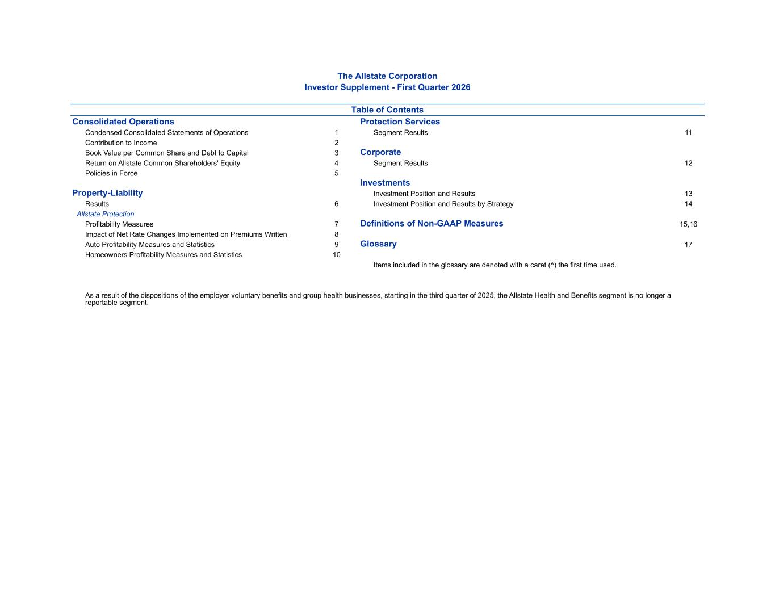
The Allstate Corporation Investor Supplement - First Quarter 2026 Table of Contents Consolidated Operations Protection Services Condensed Consolidated Statements of Operations 1 Segment Results 11 Contribution to Income 2 Book Value per Common Share and Debt to Capital 3 Corporate Return on Allstate Common Shareholders' Equity 4 Segment Results 12 Policies in Force 5 Investments Property-Liability Investment Position and Results 13 Results 6 Investment Position and Results by Strategy 14 Allstate Protection Profitability Measures 7 Definitions of Non-GAAP Measures 15,16 Impact of Net Rate Changes Implemented on Premiums Written 8 Auto Profitability Measures and Statistics 9 Glossary 17 Homeowners Profitability Measures and Statistics 10 Items included in the glossary are denoted with a caret (^) the first time used. As a result of the dispositions of the employer voluntary benefits and group health businesses, starting in the third quarter of 2025, the Allstate Health and Benefits segment is no longer a reportable segment.

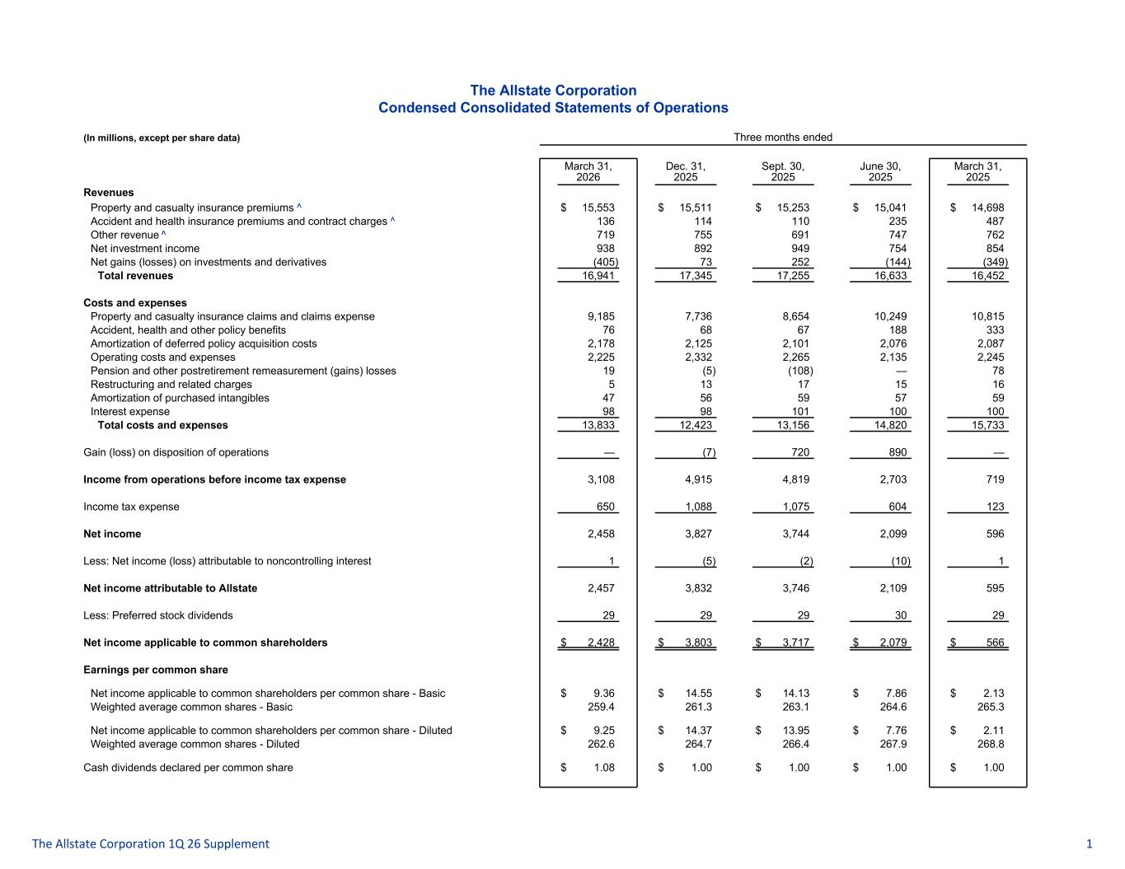
The Allstate Corporation Condensed Consolidated Statements of Operations (In millions, except per share data) Three months ended March 31, 2026 Dec. 31, 2025 Sept. 30, 2025 June 30, 2025 March 31, 2025 Revenues Property and casualty insurance premiums ^ $ 15,553 $ 15,511 $ 15,253 $ 15,041 $ 14,698 Accident and health insurance premiums and contract charges ^ 136 114 110 235 487 Other revenue ^ 719 755 691 747 762 Net investment income 938 892 949 754 854 Net gains (losses) on investments and derivatives (405) 73 252 (144) (349) Total revenues 16,941 17,345 17,255 16,633 16,452 Costs and expenses Property and casualty insurance claims and claims expense 9,185 7,736 8,654 10,249 10,815 Accident, health and other policy benefits 76 68 67 188 333 Amortization of deferred policy acquisition costs 2,178 2,125 2,101 2,076 2,087 Operating costs and expenses 2,225 2,332 2,265 2,135 2,245 Pension and other postretirement remeasurement (gains) losses 19 (5) (108) — 78 Restructuring and related charges 5 13 17 15 16 Amortization of purchased intangibles 47 56 59 57 59 Interest expense 98 98 101 100 100 Total costs and expenses 13,833 12,423 13,156 14,820 15,733 Gain (loss) on disposition of operations — (7) 720 890 — Income from operations before income tax expense 3,108 4,915 4,819 2,703 719 Income tax expense 650 1,088 1,075 604 123 Net income 2,458 3,827 3,744 2,099 596 Less: Net income (loss) attributable to noncontrolling interest 1 (5) (2) (10) 1 Net income attributable to Allstate 2,457 3,832 3,746 2,109 595 Less: Preferred stock dividends 29 29 29 30 29 Net income applicable to common shareholders $ 2,428 $ 3,803 $ 3,717 $ 2,079 $ 566 Earnings per common share Net income applicable to common shareholders per common share - Basic $ 9.36 $ 14.55 $ 14.13 $ 7.86 $ 2.13 Weighted average common shares - Basic 259.4 261.3 263.1 264.6 265.3 Net income applicable to common shareholders per common share - Diluted $ 9.25 $ 14.37 $ 13.95 $ 7.76 $ 2.11 Weighted average common shares - Diluted 262.6 264.7 266.4 267.9 268.8 Cash dividends declared per common share $ 1.08 $ 1.00 $ 1.00 $ 1.00 $ 1.00 The Allstate Corporation 1Q 26 Supplement 1

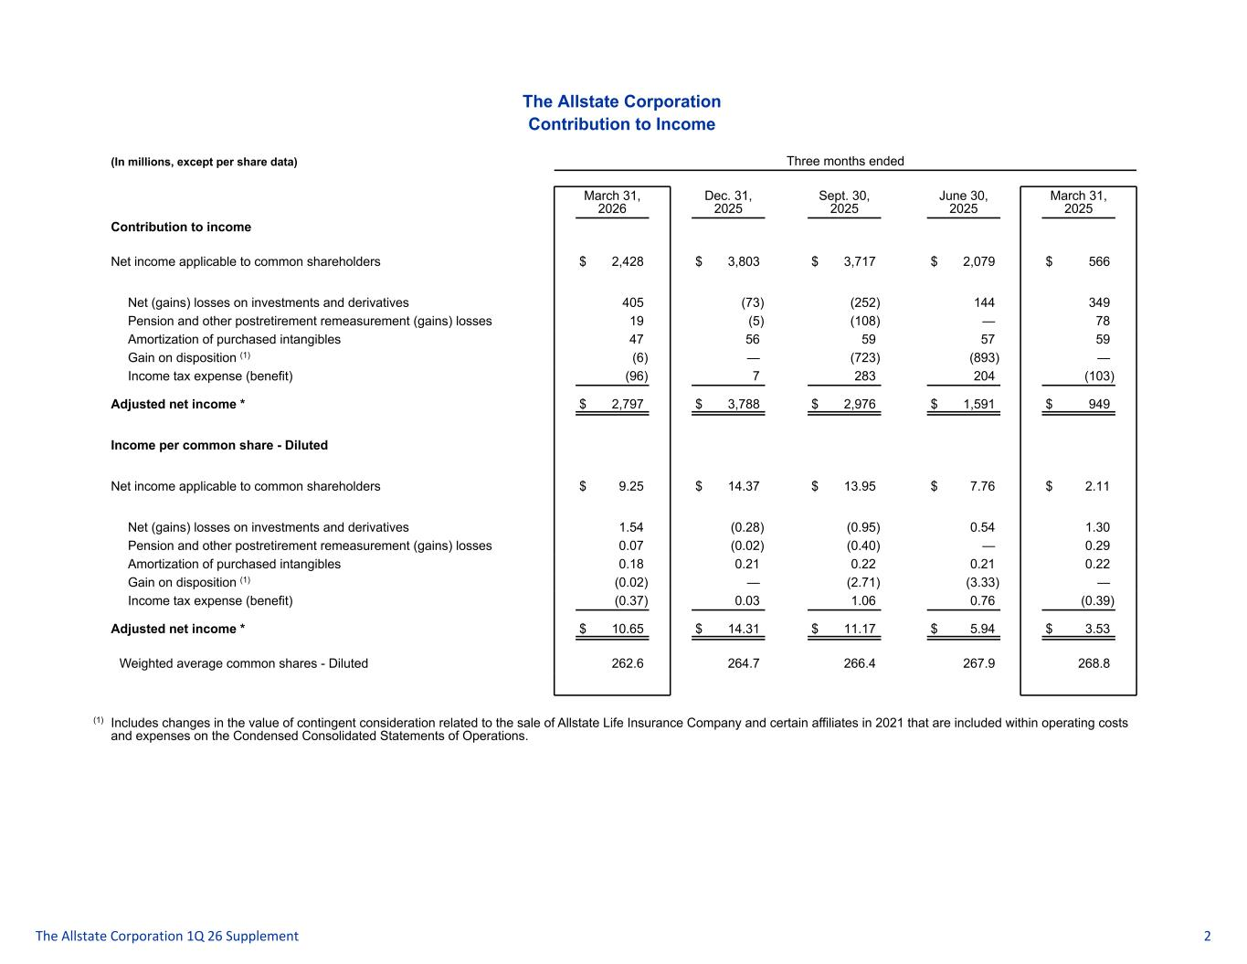
The Allstate Corporation Contribution to Income (In millions, except per share data) Three months ended March 31, 2026 Dec. 31, 2025 Sept. 30, 2025 June 30, 2025 March 31, 2025 Contribution to income Net income applicable to common shareholders $ 2,428 $ 3,803 $ 3,717 $ 2,079 $ 566 Net (gains) losses on investments and derivatives 405 (73) (252) 144 349 Pension and other postretirement remeasurement (gains) losses 19 (5) (108) — 78 Amortization of purchased intangibles 47 56 59 57 59 Gain on disposition (1) (6) — (723) (893) — Income tax expense (benefit) (96) 7 283 204 (103) Adjusted net income * $ 2,797 $ 3,788 $ 2,976 $ 1,591 $ 949 Income per common share - Diluted Net income applicable to common shareholders $ 9.25 $ 14.37 $ 13.95 $ 7.76 $ 2.11 Net (gains) losses on investments and derivatives 1.54 (0.28) (0.95) 0.54 1.30 Pension and other postretirement remeasurement (gains) losses 0.07 (0.02) (0.40) — 0.29 Amortization of purchased intangibles 0.18 0.21 0.22 0.21 0.22 Gain on disposition (1) (0.02) — (2.71) (3.33) — Income tax expense (benefit) (0.37) 0.03 1.06 0.76 (0.39) Adjusted net income * $ 10.65 $ 14.31 $ 11.17 $ 5.94 $ 3.53 Weighted average common shares - Diluted 262.6 264.7 266.4 267.9 268.8 (1) Includes changes in the value of contingent consideration related to the sale of Allstate Life Insurance Company and certain affiliates in 2021 that are included within operating costs and expenses on the Condensed Consolidated Statements of Operations. The Allstate Corporation 1Q 26 Supplement 2

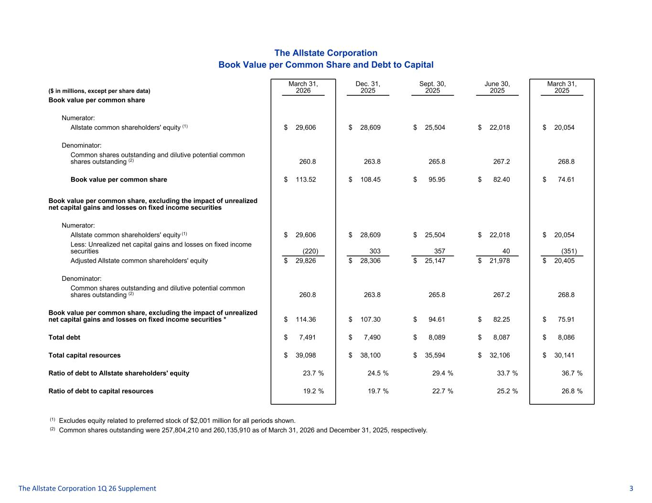
The Allstate Corporation Book Value per Common Share and Debt to Capital ($ in millions, except per share data) March 31, 2026 Dec. 31, 2025 Sept. 30, 2025 June 30, 2025 March 31, 2025 Book value per common share Numerator: Allstate common shareholders' equity (1) $ 29,606 $ 28,609 $ 25,504 $ 22,018 $ 20,054 Denominator: Common shares outstanding and dilutive potential common shares outstanding (2) 260.8 263.8 265.8 267.2 268.8 Book value per common share $ 113.52 $ 108.45 $ 95.95 $ 82.40 $ 74.61 Book value per common share, excluding the impact of unrealized net capital gains and losses on fixed income securities Numerator: Allstate common shareholders' equity (1) $ 29,606 $ 28,609 $ 25,504 $ 22,018 $ 20,054 Less: Unrealized net capital gains and losses on fixed income securities (220) 303 357 40 (351) Adjusted Allstate common shareholders' equity $ 29,826 $ 28,306 $ 25,147 $ 21,978 $ 20,405 Denominator: Common shares outstanding and dilutive potential common shares outstanding (2) 260.8 263.8 265.8 267.2 268.8 Book value per common share, excluding the impact of unrealized net capital gains and losses on fixed income securities * $ 114.36 $ 107.30 $ 94.61 $ 82.25 $ 75.91 Total debt $ 7,491 $ 7,490 $ 8,089 $ 8,087 $ 8,086 Total capital resources $ 39,098 $ 38,100 $ 35,594 $ 32,106 $ 30,141 Ratio of debt to Allstate shareholders' equity 23.7 % 24.5 % 29.4 % 33.7 % 36.7 % Ratio of debt to capital resources 19.2 % 19.7 % 22.7 % 25.2 % 26.8 % (1) Excludes equity related to preferred stock of $2,001 million for all periods shown. (2) Common shares outstanding were 257,804,210 and 260,135,910 as of March 31, 2026 and December 31, 2025, respectively. The Allstate Corporation 1Q 26 Supplement 3

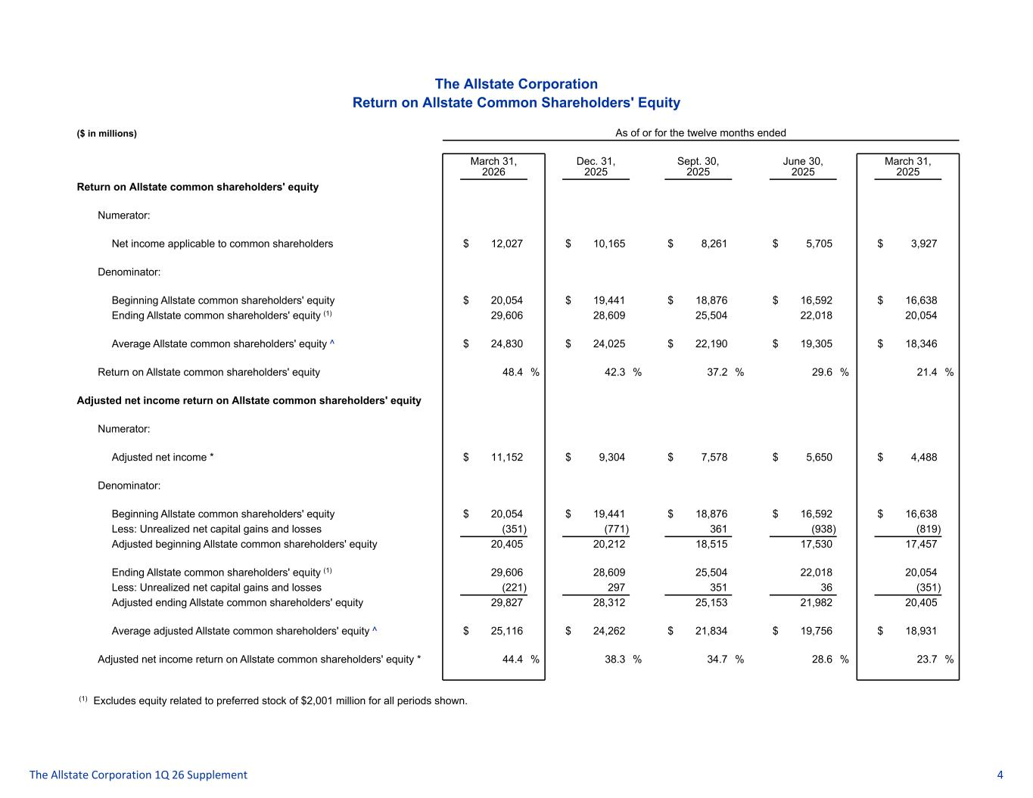
The Allstate Corporation Return on Allstate Common Shareholders' Equity ($ in millions) As of or for the twelve months ended March 31, 2026 Dec. 31, 2025 Sept. 30, 2025 June 30, 2025 March 31, 2025 Return on Allstate common shareholders' equity Numerator: Net income applicable to common shareholders $ 12,027 $ 10,165 $ 8,261 $ 5,705 $ 3,927 Denominator: Beginning Allstate common shareholders' equity $ 20,054 $ 19,441 $ 18,876 $ 16,592 $ 16,638 Ending Allstate common shareholders' equity (1) 29,606 28,609 25,504 22,018 20,054 Average Allstate common shareholders' equity ^ $ 24,830 $ 24,025 $ 22,190 $ 19,305 $ 18,346 Return on Allstate common shareholders' equity 48.4 % 42.3 % 37.2 % 29.6 % 21.4 % Adjusted net income return on Allstate common shareholders' equity Numerator: Adjusted net income * $ 11,152 $ 9,304 $ 7,578 $ 5,650 $ 4,488 Denominator: Beginning Allstate common shareholders' equity $ 20,054 $ 19,441 $ 18,876 $ 16,592 $ 16,638 Less: Unrealized net capital gains and losses (351) (771) 361 (938) (819) Adjusted beginning Allstate common shareholders' equity 20,405 20,212 18,515 17,530 17,457 Ending Allstate common shareholders' equity (1) 29,606 28,609 25,504 22,018 20,054 Less: Unrealized net capital gains and losses (221) 297 351 36 (351) Adjusted ending Allstate common shareholders' equity 29,827 28,312 25,153 21,982 20,405 Average adjusted Allstate common shareholders' equity ^ $ 25,116 $ 24,262 $ 21,834 $ 19,756 $ 18,931 Adjusted net income return on Allstate common shareholders' equity * 44.4 % 38.3 % 34.7 % 28.6 % 23.7 % (1) Excludes equity related to preferred stock of $2,001 million for all periods shown. The Allstate Corporation 1Q 26 Supplement 4

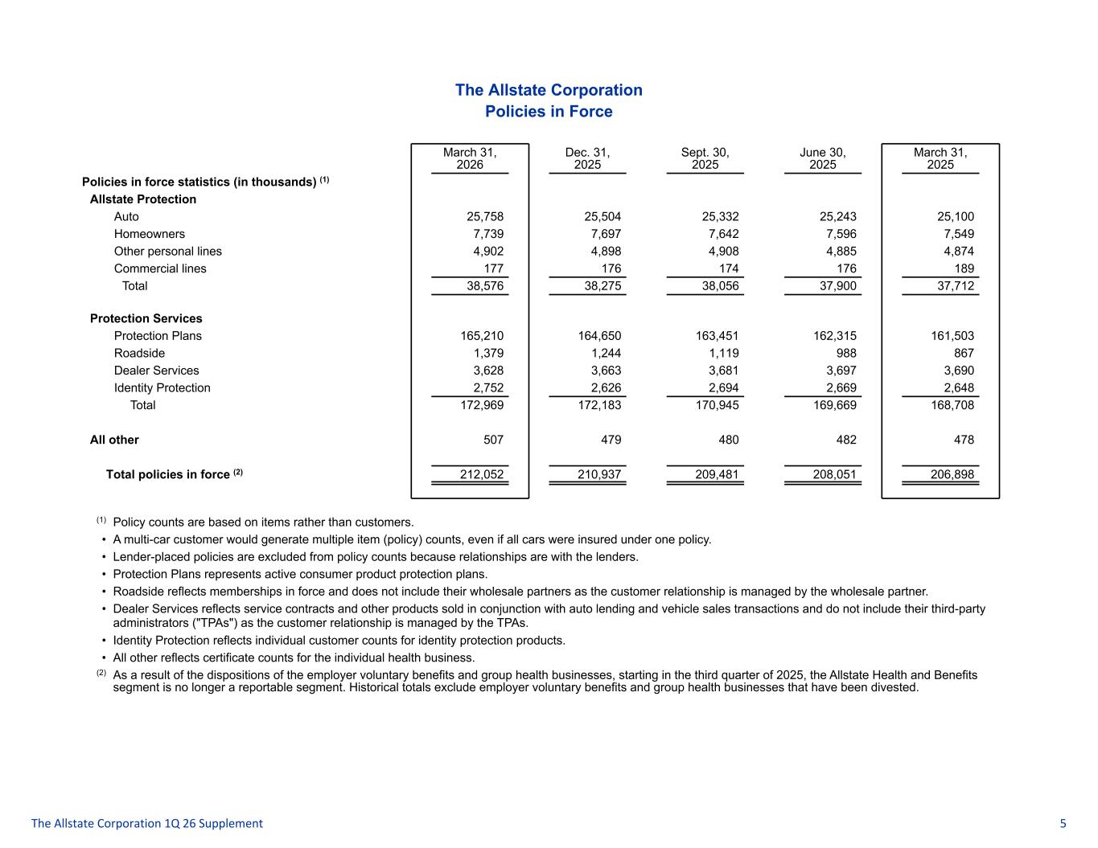
The Allstate Corporation Policies in Force March 31, 2026 Dec. 31, 2025 Sept. 30, 2025 June 30, 2025 March 31, 2025 Policies in force statistics (in thousands) (1) Allstate Protection Auto 25,758 25,504 25,332 25,243 25,100 Homeowners 7,739 7,697 7,642 7,596 7,549 Other personal lines 4,902 4,898 4,908 4,885 4,874 Commercial lines 177 176 174 176 189 Total 38,576 38,275 38,056 37,900 37,712 Protection Services Protection Plans 165,210 164,650 163,451 162,315 161,503 Roadside 1,379 1,244 1,119 988 867 Dealer Services 3,628 3,663 3,681 3,697 3,690 Identity Protection 2,752 2,626 2,694 2,669 2,648 Total 172,969 172,183 170,945 169,669 168,708 All other 507 479 480 482 478 Total policies in force (2) 212,052 210,937 209,481 208,051 206,898 (1) Policy counts are based on items rather than customers. • A multi-car customer would generate multiple item (policy) counts, even if all cars were insured under one policy. • Lender-placed policies are excluded from policy counts because relationships are with the lenders. • Protection Plans represents active consumer product protection plans. • Roadside reflects memberships in force and does not include their wholesale partners as the customer relationship is managed by the wholesale partner. • Dealer Services reflects service contracts and other products sold in conjunction with auto lending and vehicle sales transactions and do not include their third-party administrators ("TPAs") as the customer relationship is managed by the TPAs. • Identity Protection reflects individual customer counts for identity protection products. • All other reflects certificate counts for the individual health business. (2) As a result of the dispositions of the employer voluntary benefits and group health businesses, starting in the third quarter of 2025, the Allstate Health and Benefits segment is no longer a reportable segment. Historical totals exclude employer voluntary benefits and group health businesses that have been divested. The Allstate Corporation 1Q 26 Supplement 5

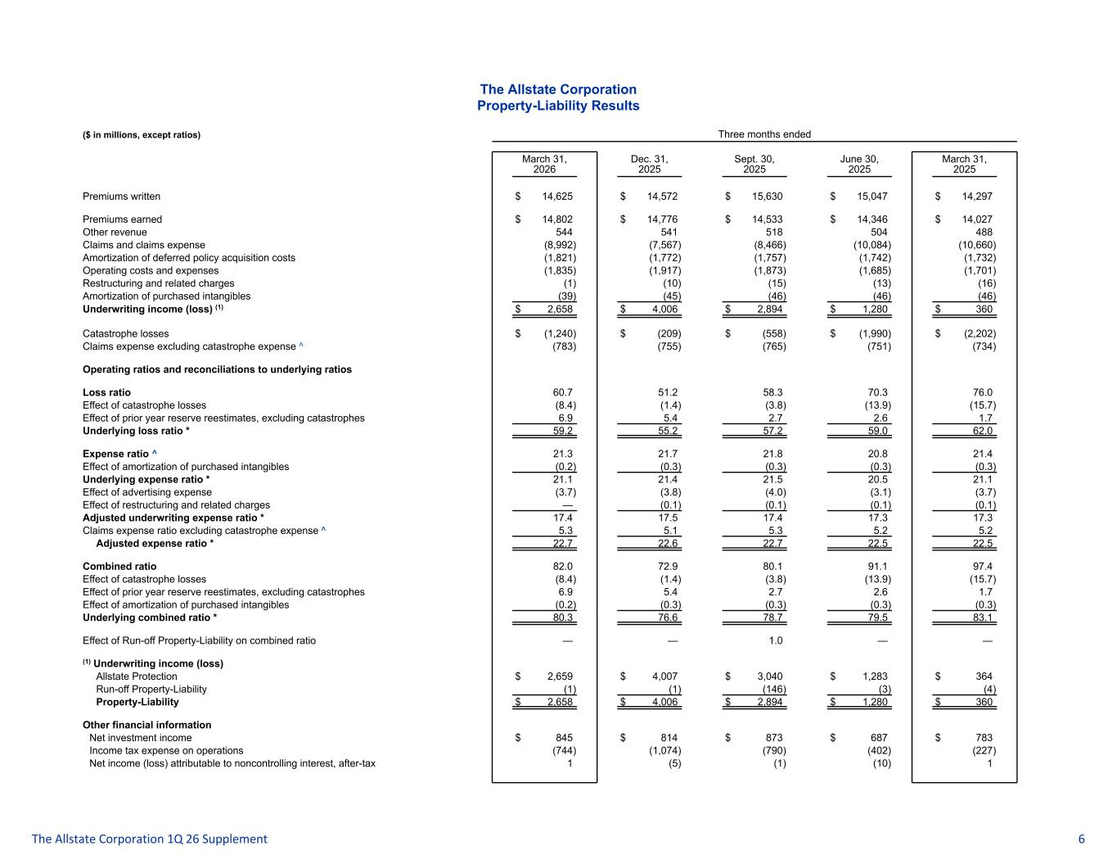
The Allstate Corporation Property-Liability Results ($ in millions, except ratios) Three months ended March 31, 2026 Dec. 31, 2025 Sept. 30, 2025 June 30, 2025 March 31, 2025 Premiums written $ 14,625 $ 14,572 $ 15,630 $ 15,047 $ 14,297 Premiums earned $ 14,802 $ 14,776 $ 14,533 $ 14,346 $ 14,027 Other revenue 544 541 518 504 488 Claims and claims expense (8,992) (7,567) (8,466) (10,084) (10,660) Amortization of deferred policy acquisition costs (1,821) (1,772) (1,757) (1,742) (1,732) Operating costs and expenses (1,835) (1,917) (1,873) (1,685) (1,701) Restructuring and related charges (1) (10) (15) (13) (16) Amortization of purchased intangibles (39) (45) (46) (46) (46) Underwriting income (loss) (1) $ 2,658 $ 4,006 $ 2,894 $ 1,280 $ 360 Catastrophe losses $ (1,240) $ (209) $ (558) $ (1,990) $ (2,202) Claims expense excluding catastrophe expense ^ (783) (755) (765) (751) (734) Operating ratios and reconciliations to underlying ratios Loss ratio 60.7 51.2 58.3 70.3 76.0 Effect of catastrophe losses (8.4) (1.4) (3.8) (13.9) (15.7) Effect of prior year reserve reestimates, excluding catastrophes 6.9 5.4 2.7 2.6 1.7 Underlying loss ratio * 59.2 55.2 57.2 59.0 62.0 Expense ratio ^ 21.3 21.7 21.8 20.8 21.4 Effect of amortization of purchased intangibles (0.2) (0.3) (0.3) (0.3) (0.3) Underlying expense ratio * 21.1 21.4 21.5 20.5 21.1 Effect of advertising expense (3.7) (3.8) (4.0) (3.1) (3.7) Effect of restructuring and related charges — (0.1) (0.1) (0.1) (0.1) Adjusted underwriting expense ratio * 17.4 17.5 17.4 17.3 17.3 Claims expense ratio excluding catastrophe expense ^ 5.3 5.1 5.3 5.2 5.2 Adjusted expense ratio * 22.7 22.6 22.7 22.5 22.5 Combined ratio 82.0 72.9 80.1 91.1 97.4 Effect of catastrophe losses (8.4) (1.4) (3.8) (13.9) (15.7) Effect of prior year reserve reestimates, excluding catastrophes 6.9 5.4 2.7 2.6 1.7 Effect of amortization of purchased intangibles (0.2) (0.3) (0.3) (0.3) (0.3) Underlying combined ratio * 80.3 76.6 78.7 79.5 83.1 Effect of Run-off Property-Liability on combined ratio — — 1.0 — — (1) Underwriting income (loss) Allstate Protection $ 2,659 $ 4,007 $ 3,040 $ 1,283 $ 364 Run-off Property-Liability (1) (1) (146) (3) (4) Property-Liability $ 2,658 $ 4,006 $ 2,894 $ 1,280 $ 360 Other financial information Net investment income $ 845 $ 814 $ 873 $ 687 $ 783 Income tax expense on operations (744) (1,074) (790) (402) (227) Net income (loss) attributable to noncontrolling interest, after-tax 1 (5) (1) (10) 1 The Allstate Corporation 1Q 26 Supplement 6

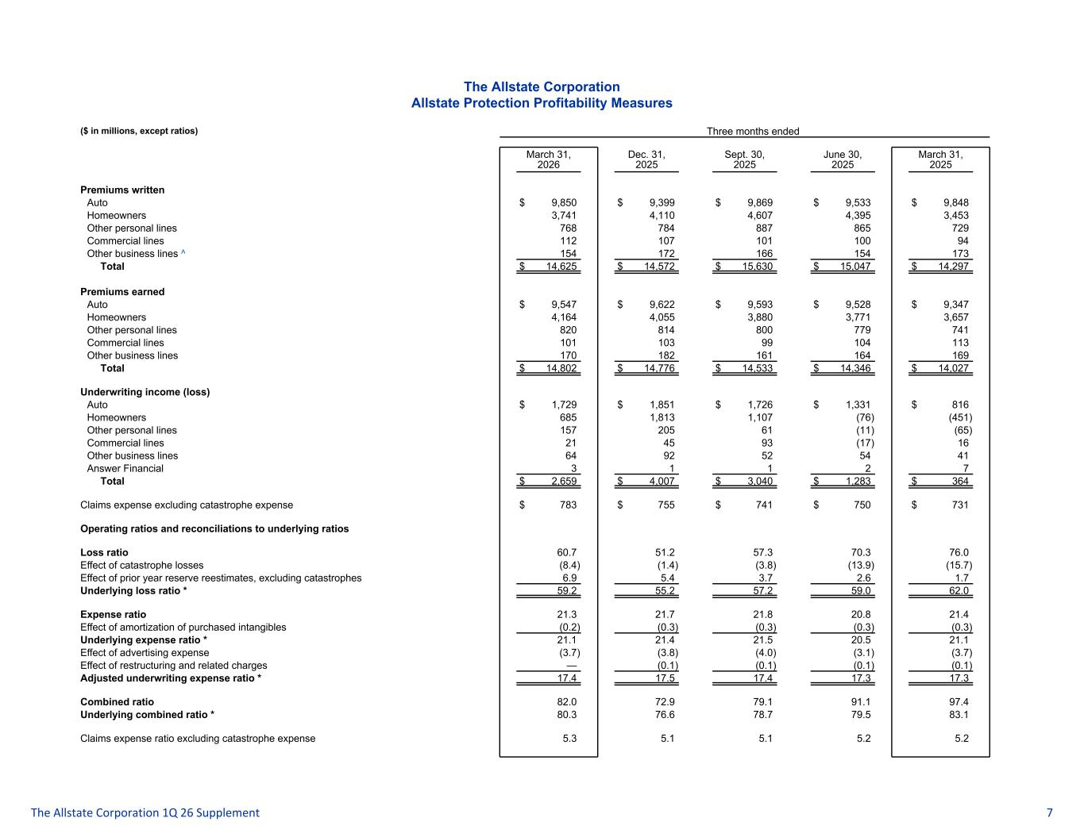
The Allstate Corporation Allstate Protection Profitability Measures ($ in millions, except ratios) Three months ended March 31, 2026 Dec. 31, 2025 Sept. 30, 2025 June 30, 2025 March 31, 2025 Premiums written Auto $ 9,850 $ 9,399 $ 9,869 $ 9,533 $ 9,848 Homeowners 3,741 4,110 4,607 4,395 3,453 Other personal lines 768 784 887 865 729 Commercial lines 112 107 101 100 94 Other business lines ^ 154 172 166 154 173 Total $ 14,625 $ 14,572 $ 15,630 $ 15,047 $ 14,297 Premiums earned Auto $ 9,547 $ 9,622 $ 9,593 $ 9,528 $ 9,347 Homeowners 4,164 4,055 3,880 3,771 3,657 Other personal lines 820 814 800 779 741 Commercial lines 101 103 99 104 113 Other business lines 170 182 161 164 169 Total $ 14,802 $ 14,776 $ 14,533 $ 14,346 $ 14,027 Underwriting income (loss) Auto $ 1,729 $ 1,851 $ 1,726 $ 1,331 $ 816 Homeowners 685 1,813 1,107 (76) (451) Other personal lines 157 205 61 (11) (65) Commercial lines 21 45 93 (17) 16 Other business lines 64 92 52 54 41 Answer Financial 3 1 1 2 7 Total $ 2,659 $ 4,007 $ 3,040 $ 1,283 $ 364 Claims expense excluding catastrophe expense $ 783 $ 755 $ 741 $ 750 $ 731 Operating ratios and reconciliations to underlying ratios Loss ratio 60.7 51.2 57.3 70.3 76.0 Effect of catastrophe losses (8.4) (1.4) (3.8) (13.9) (15.7) Effect of prior year reserve reestimates, excluding catastrophes 6.9 5.4 3.7 2.6 1.7 Underlying loss ratio * 59.2 55.2 57.2 59.0 62.0 Expense ratio 21.3 21.7 21.8 20.8 21.4 Effect of amortization of purchased intangibles (0.2) (0.3) (0.3) (0.3) (0.3) Underlying expense ratio * 21.1 21.4 21.5 20.5 21.1 Effect of advertising expense (3.7) (3.8) (4.0) (3.1) (3.7) Effect of restructuring and related charges — (0.1) (0.1) (0.1) (0.1) Adjusted underwriting expense ratio * 17.4 17.5 17.4 17.3 17.3 Combined ratio 82.0 72.9 79.1 91.1 97.4 Underlying combined ratio * 80.3 76.6 78.7 79.5 83.1 Claims expense ratio excluding catastrophe expense 5.3 5.1 5.1 5.2 5.2 The Allstate Corporation 1Q 26 Supplement 7

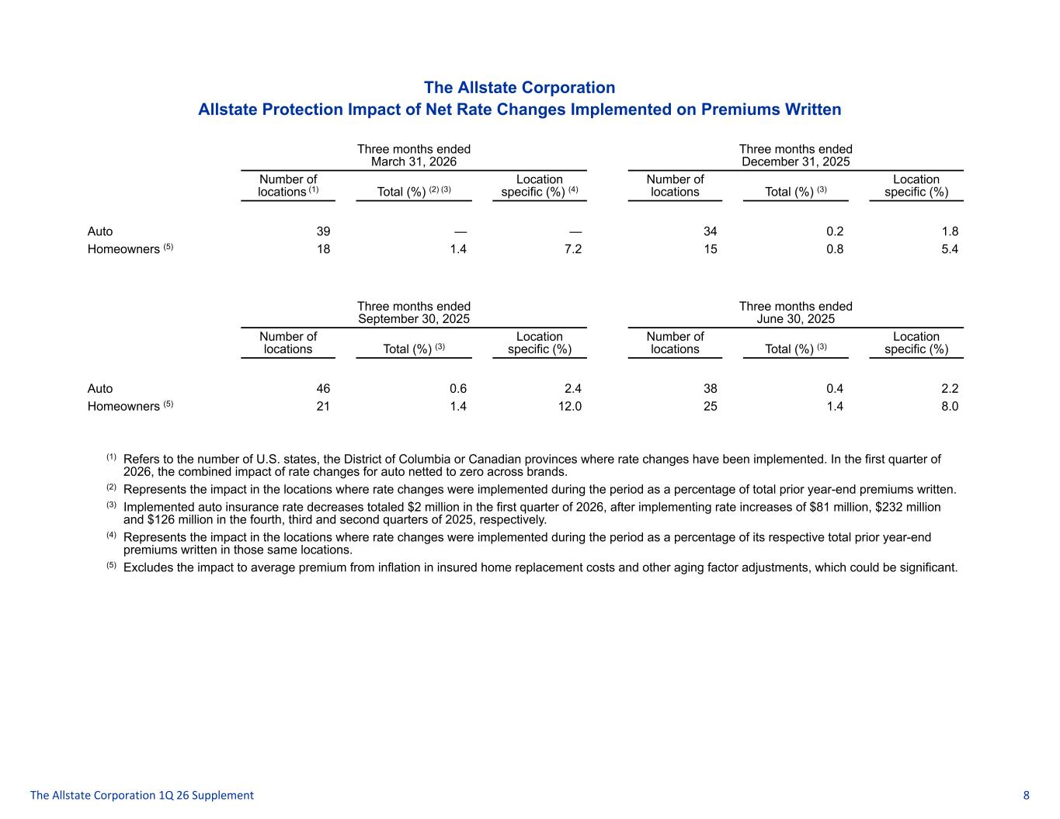
The Allstate Corporation Allstate Protection Impact of Net Rate Changes Implemented on Premiums Written Three months ended March 31, 2026 Three months ended December 31, 2025 Number of locations (1) Total (%) (2) (3) Location specific (%) (4) Number of locations Total (%) (3) Location specific (%) Auto 39 — — 34 0.2 1.8 Homeowners (5) 18 1.4 7.2 15 0.8 5.4 Three months ended September 30, 2025 Three months ended June 30, 2025 Number of locations Total (%) (3) Location specific (%) Number of locations Total (%) (3) Location specific (%) Auto 46 0.6 2.4 38 0.4 2.2 Homeowners (5) 21 1.4 12.0 25 1.4 8.0 (1) Refers to the number of U.S. states, the District of Columbia or Canadian provinces where rate changes have been implemented. In the first quarter of 2026, the combined impact of rate changes for auto netted to zero across brands. (2) Represents the impact in the locations where rate changes were implemented during the period as a percentage of total prior year-end premiums written. (3) Implemented auto insurance rate decreases totaled $2 million in the first quarter of 2026, after implementing rate increases of $81 million, $232 million and $126 million in the fourth, third and second quarters of 2025, respectively. (4) Represents the impact in the locations where rate changes were implemented during the period as a percentage of its respective total prior year-end premiums written in those same locations. (5) Excludes the impact to average premium from inflation in insured home replacement costs and other aging factor adjustments, which could be significant. The Allstate Corporation 1Q 26 Supplement 8

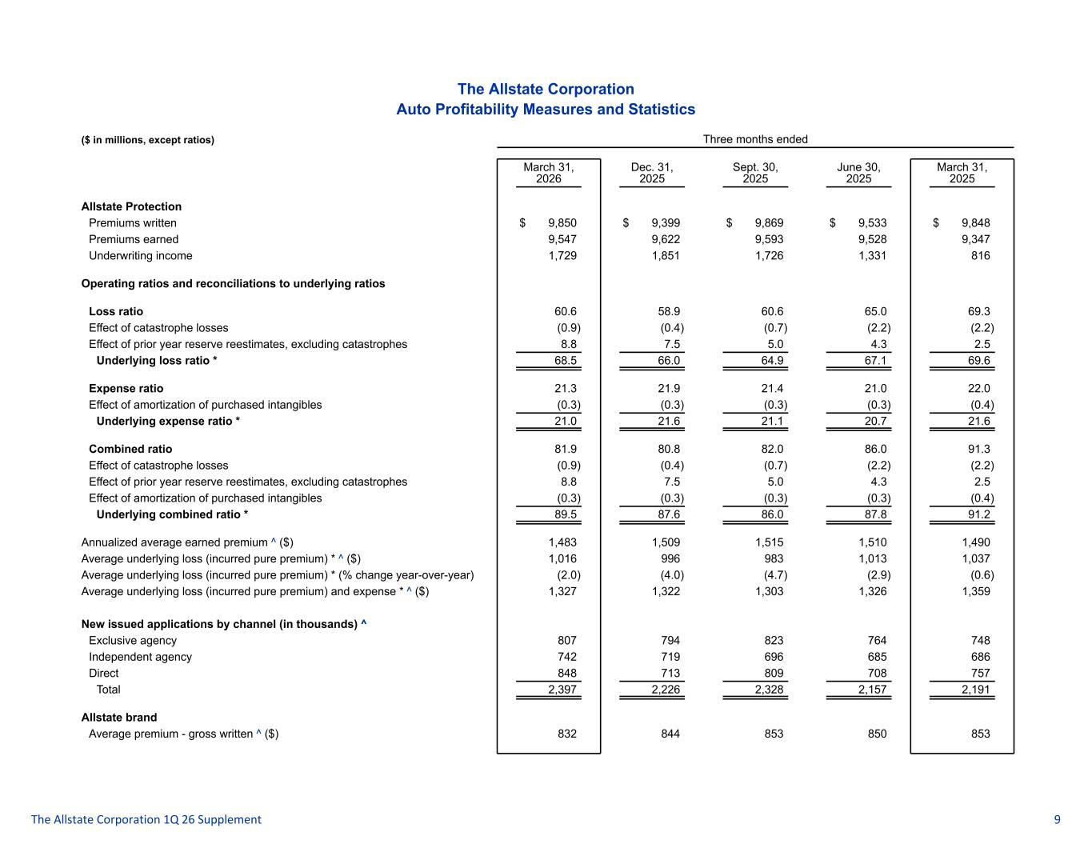
The Allstate Corporation Auto Profitability Measures and Statistics ($ in millions, except ratios) Three months ended March 31, 2026 Dec. 31, 2025 Sept. 30, 2025 June 30, 2025 March 31, 2025 Allstate Protection Premiums written $ 9,850 $ 9,399 $ 9,869 $ 9,533 $ 9,848 Premiums earned 9,547 9,622 9,593 9,528 9,347 Underwriting income 1,729 1,851 1,726 1,331 816 Operating ratios and reconciliations to underlying ratios Loss ratio 60.6 58.9 60.6 65.0 69.3 Effect of catastrophe losses (0.9) (0.4) (0.7) (2.2) (2.2) Effect of prior year reserve reestimates, excluding catastrophes 8.8 7.5 5.0 4.3 2.5 Underlying loss ratio * 68.5 66.0 64.9 67.1 69.6 Expense ratio 21.3 21.9 21.4 21.0 22.0 Effect of amortization of purchased intangibles (0.3) (0.3) (0.3) (0.3) (0.4) Underlying expense ratio * 21.0 21.6 21.1 20.7 21.6 Combined ratio 81.9 80.8 82.0 86.0 91.3 Effect of catastrophe losses (0.9) (0.4) (0.7) (2.2) (2.2) Effect of prior year reserve reestimates, excluding catastrophes 8.8 7.5 5.0 4.3 2.5 Effect of amortization of purchased intangibles (0.3) (0.3) (0.3) (0.3) (0.4) Underlying combined ratio * 89.5 87.6 86.0 87.8 91.2 Annualized average earned premium ^ ($) 1,483 1,509 1,515 1,510 1,490 Average underlying loss (incurred pure premium) * ^ ($) 1,016 996 983 1,013 1,037 Average underlying loss (incurred pure premium) * (% change year-over-year) (2.0) (4.0) (4.7) (2.9) (0.6) Average underlying loss (incurred pure premium) and expense * ^ ($) 1,327 1,322 1,303 1,326 1,359 New issued applications by channel (in thousands) ^ Exclusive agency 807 794 823 764 748 Independent agency 742 719 696 685 686 Direct 848 713 809 708 757 Total 2,397 2,226 2,328 2,157 2,191 Allstate brand Average premium - gross written ^ ($) 832 844 853 850 853 The Allstate Corporation 1Q 26 Supplement 9

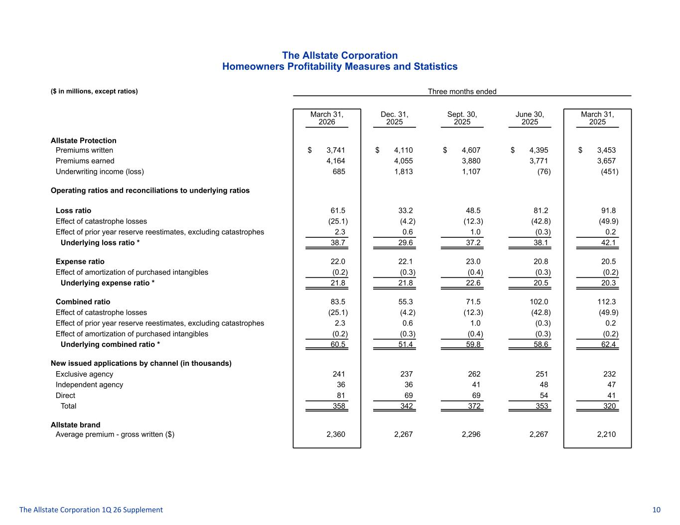
The Allstate Corporation Homeowners Profitability Measures and Statistics ($ in millions, except ratios) Three months ended March 31, 2026 Dec. 31, 2025 Sept. 30, 2025 June 30, 2025 March 31, 2025 Allstate Protection Premiums written $ 3,741 $ 4,110 $ 4,607 $ 4,395 $ 3,453 Premiums earned 4,164 4,055 3,880 3,771 3,657 Underwriting income (loss) 685 1,813 1,107 (76) (451) Operating ratios and reconciliations to underlying ratios Loss ratio 61.5 33.2 48.5 81.2 91.8 Effect of catastrophe losses (25.1) (4.2) (12.3) (42.8) (49.9) Effect of prior year reserve reestimates, excluding catastrophes 2.3 0.6 1.0 (0.3) 0.2 Underlying loss ratio * 38.7 29.6 37.2 38.1 42.1 Expense ratio 22.0 22.1 23.0 20.8 20.5 Effect of amortization of purchased intangibles (0.2) (0.3) (0.4) (0.3) (0.2) Underlying expense ratio * 21.8 21.8 22.6 20.5 20.3 Combined ratio 83.5 55.3 71.5 102.0 112.3 Effect of catastrophe losses (25.1) (4.2) (12.3) (42.8) (49.9) Effect of prior year reserve reestimates, excluding catastrophes 2.3 0.6 1.0 (0.3) 0.2 Effect of amortization of purchased intangibles (0.2) (0.3) (0.4) (0.3) (0.2) Underlying combined ratio * 60.5 51.4 59.8 58.6 62.4 New issued applications by channel (in thousands) Exclusive agency 241 237 262 251 232 Independent agency 36 36 41 48 47 Direct 81 69 69 54 41 Total 358 342 372 353 320 Allstate brand Average premium - gross written ($) 2,360 2,267 2,296 2,267 2,210 The Allstate Corporation 1Q 26 Supplement 10

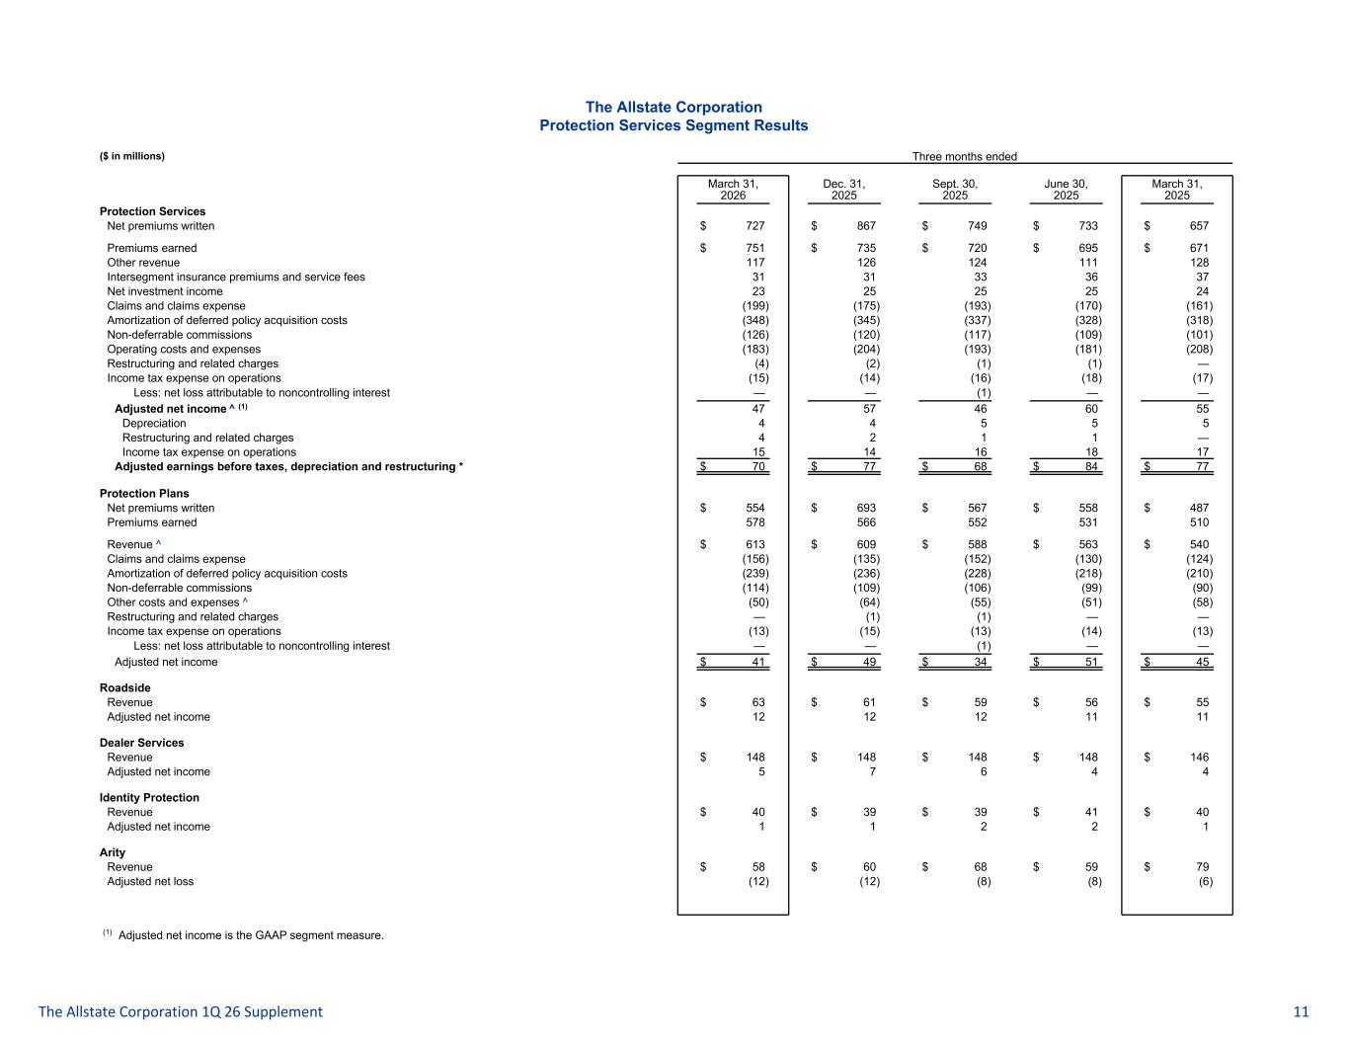
The Allstate Corporation Protection Services Segment Results ($ in millions) Three months ended March 31, 2026 Dec. 31, 2025 Sept. 30, 2025 June 30, 2025 March 31, 2025 Protection Services Net premiums written $ 727 $ 867 $ 749 $ 733 $ 657 Premiums earned $ 751 $ 735 $ 720 $ 695 $ 671 Other revenue 117 126 124 111 128 Intersegment insurance premiums and service fees 31 31 33 36 37 Net investment income 23 25 25 25 24 Claims and claims expense (199) (175) (193) (170) (161) Amortization of deferred policy acquisition costs (348) (345) (337) (328) (318) Non-deferrable commissions (126) (120) (117) (109) (101) Operating costs and expenses (183) (204) (193) (181) (208) Restructuring and related charges (4) (2) (1) (1) — Income tax expense on operations (15) (14) (16) (18) (17) Less: net loss attributable to noncontrolling interest — — (1) — — Adjusted net income ^ (1) 47 57 46 60 55 Depreciation 4 4 5 5 5 Restructuring and related charges 4 2 1 1 — Income tax expense on operations 15 14 16 18 17 Adjusted earnings before taxes, depreciation and restructuring * $ 70 $ 77 $ 68 $ 84 $ 77 Protection Plans Net premiums written $ 554 $ 693 $ 567 $ 558 $ 487 Premiums earned 578 566 552 531 510 Revenue ^ $ 613 $ 609 $ 588 $ 563 $ 540 Claims and claims expense (156) (135) (152) (130) (124) Amortization of deferred policy acquisition costs (239) (236) (228) (218) (210) Non-deferrable commissions (114) (109) (106) (99) (90) Other costs and expenses ^ (50) (64) (55) (51) (58) Restructuring and related charges — (1) (1) — — Income tax expense on operations (13) (15) (13) (14) (13) Less: net loss attributable to noncontrolling interest — — (1) — — Adjusted net income $ 41 $ 49 $ 34 $ 51 $ 45 Roadside Revenue $ 63 $ 61 $ 59 $ 56 $ 55 Adjusted net income 12 12 12 11 11 Dealer Services Revenue $ 148 $ 148 $ 148 $ 148 $ 146 Adjusted net income 5 7 6 4 4 Identity Protection Revenue $ 40 $ 39 $ 39 $ 41 $ 40 Adjusted net income 1 1 2 2 1 Arity Revenue $ 58 $ 60 $ 68 $ 59 $ 79 Adjusted net loss (12) (12) (8) (8) (6) (1) Adjusted net income is the GAAP segment measure. The Allstate Corporation 1Q 26 Supplement 11

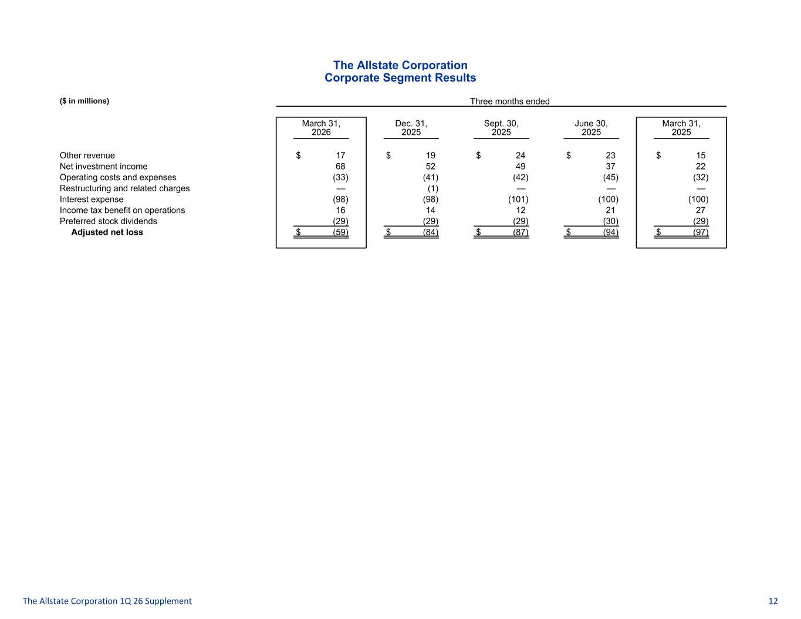
The Allstate Corporation Corporate Segment Results ($ in millions) Three months ended March 31, 2026 Dec. 31, 2025 Sept. 30, 2025 June 30, 2025 March 31, 2025 Other revenue $ 17 $ 19 $ 24 $ 23 $ 15 Net investment income 68 52 49 37 22 Operating costs and expenses (33) (41) (42) (45) (32) Restructuring and related charges — (1) — — — Interest expense (98) (98) (101) (100) (100) Income tax benefit on operations 16 14 12 21 27 Preferred stock dividends (29) (29) (29) (30) (29) Adjusted net loss $ (59) $ (84) $ (87) $ (94) $ (97) The Allstate Corporation 1Q 26 Supplement 12

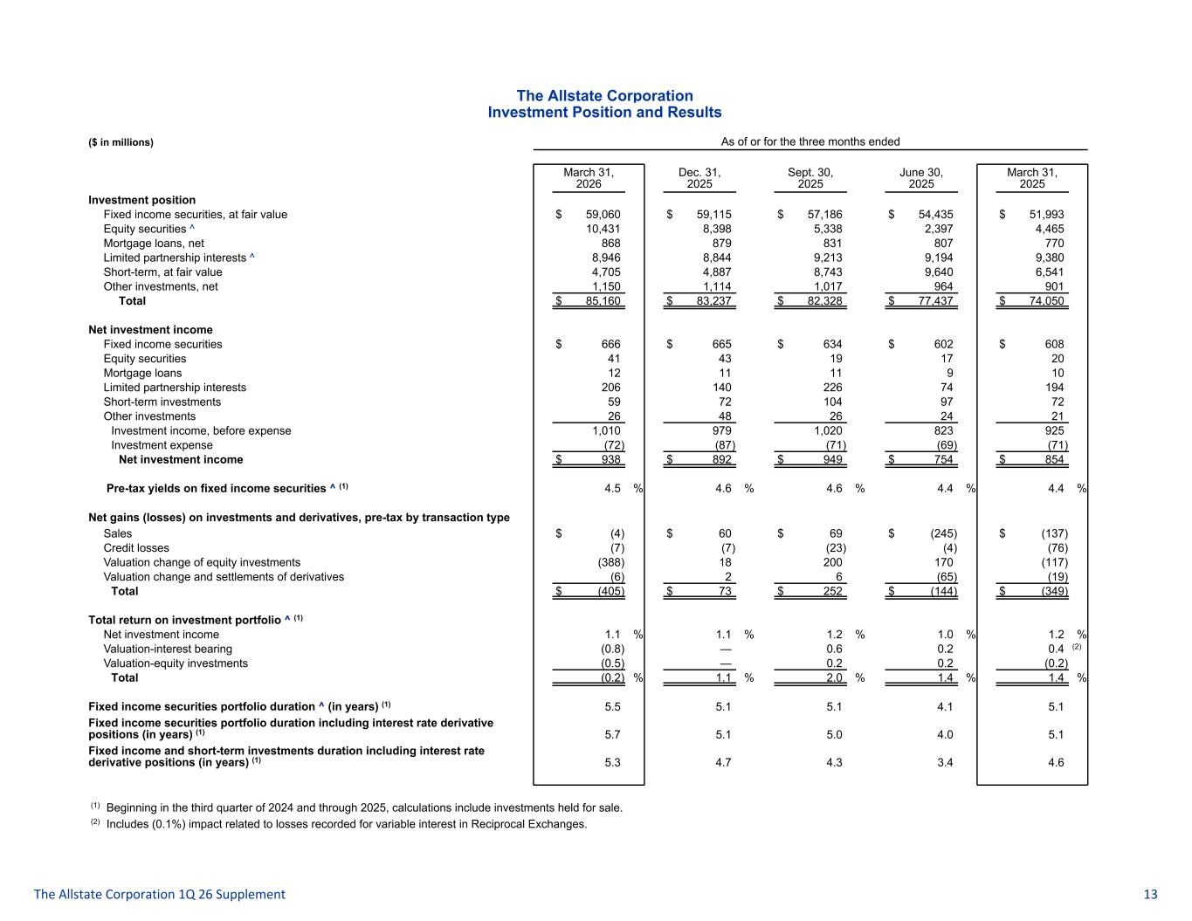
The Allstate Corporation Investment Position and Results ($ in millions) As of or for the three months ended March 31, 2026 Dec. 31, 2025 Sept. 30, 2025 June 30, 2025 March 31, 2025 Investment position Fixed income securities, at fair value $ 59,060 $ 59,115 $ 57,186 $ 54,435 $ 51,993 Equity securities ^ 10,431 8,398 5,338 2,397 4,465 Mortgage loans, net 868 879 831 807 770 Limited partnership interests ^ 8,946 8,844 9,213 9,194 9,380 Short-term, at fair value 4,705 4,887 8,743 9,640 6,541 Other investments, net 1,150 1,114 1,017 964 901 Total $ 85,160 $ 83,237 $ 82,328 $ 77,437 $ 74,050 Net investment income Fixed income securities $ 666 $ 665 $ 634 $ 602 $ 608 Equity securities 41 43 19 17 20 Mortgage loans 12 11 11 9 10 Limited partnership interests 206 140 226 74 194 Short-term investments 59 72 104 97 72 Other investments 26 48 26 24 21 Investment income, before expense 1,010 979 1,020 823 925 Investment expense (72) (87) (71) (69) (71) Net investment income $ 938 $ 892 $ 949 $ 754 $ 854 Pre-tax yields on fixed income securities ^ (1) 4.5 % 4.6 % 4.6 % 4.4 % 4.4 % Net gains (losses) on investments and derivatives, pre-tax by transaction type Sales $ (4) $ 60 $ 69 $ (245) $ (137) Credit losses (7) (7) (23) (4) (76) Valuation change of equity investments (388) 18 200 170 (117) Valuation change and settlements of derivatives (6) 2 6 (65) (19) Total $ (405) $ 73 $ 252 $ (144) $ (349) Total return on investment portfolio ^ (1) Net investment income 1.1 % 1.1 % 1.2 % 1.0 % 1.2 % Valuation-interest bearing (0.8) — 0.6 0.2 0.4 (2) Valuation-equity investments (0.5) — 0.2 0.2 (0.2) Total (0.2) % 1.1 % 2.0 % 1.4 % 1.4 % Fixed income securities portfolio duration ^ (in years) (1) 5.5 5.1 5.1 4.1 5.1 Fixed income securities portfolio duration including interest rate derivative positions (in years) (1) 5.7 5.1 5.0 4.0 5.1 Fixed income and short-term investments duration including interest rate derivative positions (in years) (1) 5.3 4.7 4.3 3.4 4.6 (1) Beginning in the third quarter of 2024 and through 2025, calculations include investments held for sale. (2) Includes (0.1%) impact related to losses recorded for variable interest in Reciprocal Exchanges. The Allstate Corporation 1Q 26 Supplement 13

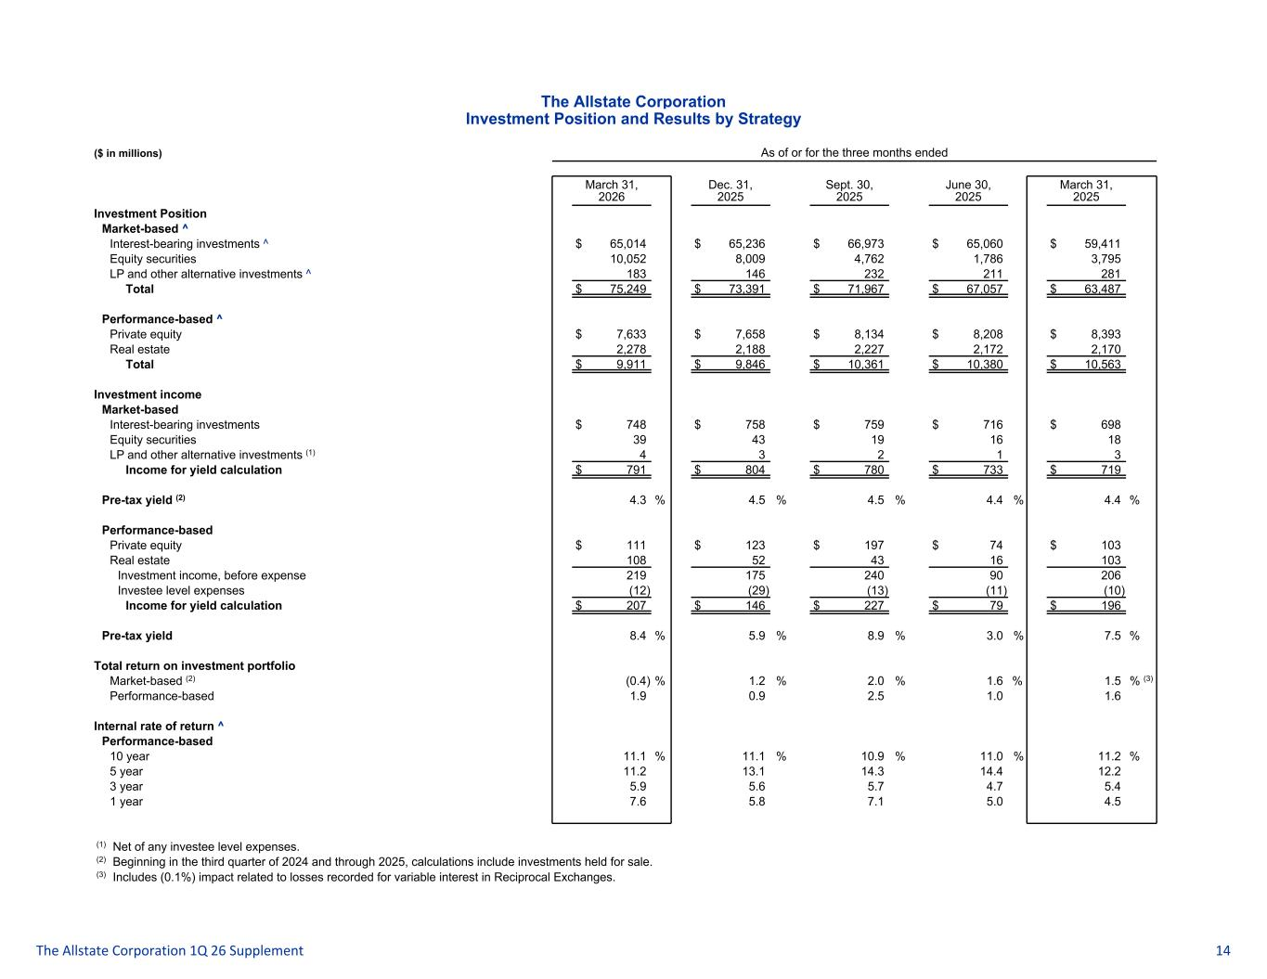
The Allstate Corporation Investment Position and Results by Strategy ($ in millions) As of or for the three months ended March 31, 2026 Dec. 31, 2025 Sept. 30, 2025 June 30, 2025 March 31, 2025 Investment Position Market-based ^ Interest-bearing investments ^ $ 65,014 $ 65,236 $ 66,973 $ 65,060 $ 59,411 Equity securities 10,052 8,009 4,762 1,786 3,795 LP and other alternative investments ^ 183 146 232 211 281 Total $ 75,249 $ 73,391 $ 71,967 $ 67,057 $ 63,487 Performance-based ^ Private equity $ 7,633 $ 7,658 $ 8,134 $ 8,208 $ 8,393 Real estate 2,278 2,188 2,227 2,172 2,170 Total $ 9,911 $ 9,846 $ 10,361 $ 10,380 $ 10,563 Investment income Market-based Interest-bearing investments $ 748 $ 758 $ 759 $ 716 $ 698 Equity securities 39 43 19 16 18 LP and other alternative investments (1) 4 3 2 1 3 Income for yield calculation $ 791 $ 804 $ 780 $ 733 $ 719 Pre-tax yield (2) 4.3 % 4.5 % 4.5 % 4.4 % 4.4 % Performance-based Private equity $ 111 $ 123 $ 197 $ 74 $ 103 Real estate 108 52 43 16 103 Investment income, before expense 219 175 240 90 206 Investee level expenses (12) (29) (13) (11) (10) Income for yield calculation $ 207 $ 146 $ 227 $ 79 $ 196 Pre-tax yield 8.4 % 5.9 % 8.9 % 3.0 % 7.5 % Total return on investment portfolio Market-based (2) (0.4) % 1.2 % 2.0 % 1.6 % 1.5 % (3) Performance-based 1.9 0.9 2.5 1.0 1.6 Internal rate of return ^ Performance-based 10 year 11.1 % 11.1 % 10.9 % 11.0 % 11.2 % 5 year 11.2 13.1 14.3 14.4 12.2 3 year 5.9 5.6 5.7 4.7 5.4 1 year 7.6 5.8 7.1 5.0 4.5 (1) Net of any investee level expenses. (2) Beginning in the third quarter of 2024 and through 2025, calculations include investments held for sale. (3) Includes (0.1%) impact related to losses recorded for variable interest in Reciprocal Exchanges. The Allstate Corporation 1Q 26 Supplement 14

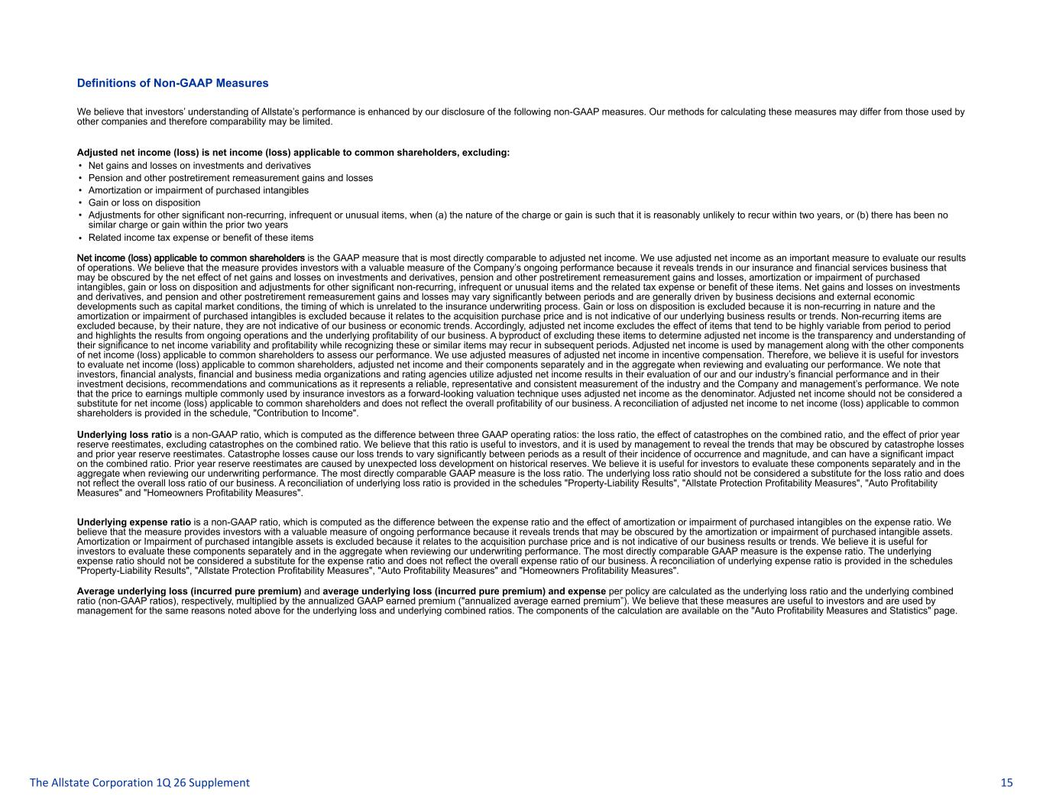
Definitions of Non-GAAP Measures We believe that investors’ understanding of Allstate’s performance is enhanced by our disclosure of the following non-GAAP measures. Our methods for calculating these measures may differ from those used by other companies and therefore comparability may be limited. Adjusted net income (loss) is net income (loss) applicable to common shareholders, excluding: • Net gains and losses on investments and derivatives • Pension and other postretirement remeasurement gains and losses • Amortization or impairment of purchased intangibles • Gain or loss on disposition • Adjustments for other significant non-recurring, infrequent or unusual items, when (a) the nature of the charge or gain is such that it is reasonably unlikely to recur within two years, or (b) there has been no similar charge or gain within the prior two years • Related income tax expense or benefit of these items Net income (loss) applicable to common shareholders is the GAAP measure that is most directly comparable to adjusted net income. We use adjusted net income as an important measure to evaluate our results of operations. We believe that the measure provides investors with a valuable measure of the Company’s ongoing performance because it reveals trends in our insurance and financial services business that may be obscured by the net effect of net gains and losses on investments and derivatives, pension and other postretirement remeasurement gains and losses, amortization or impairment of purchased intangibles, gain or loss on disposition and adjustments for other significant non-recurring, infrequent or unusual items and the related tax expense or benefit of these items. Net gains and losses on investments and derivatives, and pension and other postretirement remeasurement gains and losses may vary significantly between periods and are generally driven by business decisions and external economic developments such as capital market conditions, the timing of which is unrelated to the insurance underwriting process. Gain or loss on disposition is excluded because it is non-recurring in nature and the amortization or impairment of purchased intangibles is excluded because it relates to the acquisition purchase price and is not indicative of our underlying business results or trends. Non-recurring items are excluded because, by their nature, they are not indicative of our business or economic trends. Accordingly, adjusted net income excludes the effect of items that tend to be highly variable from period to period and highlights the results from ongoing operations and the underlying profitability of our business. A byproduct of excluding these items to determine adjusted net income is the transparency and understanding of their significance to net income variability and profitability while recognizing these or similar items may recur in subsequent periods. Adjusted net income is used by management along with the other components of net income (loss) applicable to common shareholders to assess our performance. We use adjusted measures of adjusted net income in incentive compensation. Therefore, we believe it is useful for investors to evaluate net income (loss) applicable to common shareholders, adjusted net income and their components separately and in the aggregate when reviewing and evaluating our performance. We note that investors, financial analysts, financial and business media organizations and rating agencies utilize adjusted net income results in their evaluation of our and our industry’s financial performance and in their investment decisions, recommendations and communications as it represents a reliable, representative and consistent measurement of the industry and the Company and management’s performance. We note that the price to earnings multiple commonly used by insurance investors as a forward-looking valuation technique uses adjusted net income as the denominator. Adjusted net income should not be considered a substitute for net income (loss) applicable to common shareholders and does not reflect the overall profitability of our business. A reconciliation of adjusted net income to net income (loss) applicable to common shareholders is provided in the schedule, "Contribution to Income". Underlying loss ratio is a non-GAAP ratio, which is computed as the difference between three GAAP operating ratios: the loss ratio, the effect of catastrophes on the combined ratio, and the effect of prior year reserve reestimates, excluding catastrophes on the combined ratio. We believe that this ratio is useful to investors, and it is used by management to reveal the trends that may be obscured by catastrophe losses and prior year reserve reestimates. Catastrophe losses cause our loss trends to vary significantly between periods as a result of their incidence of occurrence and magnitude, and can have a significant impact on the combined ratio. Prior year reserve reestimates are caused by unexpected loss development on historical reserves. We believe it is useful for investors to evaluate these components separately and in the aggregate when reviewing our underwriting performance. The most directly comparable GAAP measure is the loss ratio. The underlying loss ratio should not be considered a substitute for the loss ratio and does not reflect the overall loss ratio of our business. A reconciliation of underlying loss ratio is provided in the schedules "Property-Liability Results", "Allstate Protection Profitability Measures", "Auto Profitability Measures" and "Homeowners Profitability Measures". Underlying expense ratio is a non-GAAP ratio, which is computed as the difference between the expense ratio and the effect of amortization or impairment of purchased intangibles on the expense ratio. We believe that the measure provides investors with a valuable measure of ongoing performance because it reveals trends that may be obscured by the amortization or impairment of purchased intangible assets. Amortization or Impairment of purchased intangible assets is excluded because it relates to the acquisition purchase price and is not indicative of our business results or trends. We believe it is useful for investors to evaluate these components separately and in the aggregate when reviewing our underwriting performance. The most directly comparable GAAP measure is the expense ratio. The underlying expense ratio should not be considered a substitute for the expense ratio and does not reflect the overall expense ratio of our business. A reconciliation of underlying expense ratio is provided in the schedules "Property-Liability Results", "Allstate Protection Profitability Measures", "Auto Profitability Measures" and "Homeowners Profitability Measures". Average underlying loss (incurred pure premium) and average underlying loss (incurred pure premium) and expense per policy are calculated as the underlying loss ratio and the underlying combined ratio (non-GAAP ratios), respectively, multiplied by the annualized GAAP earned premium ("annualized average earned premium”). We believe that these measures are useful to investors and are used by management for the same reasons noted above for the underlying loss and underlying combined ratios. The components of the calculation are available on the "Auto Profitability Measures and Statistics" page. The Allstate Corporation 1Q 26 Supplement 15

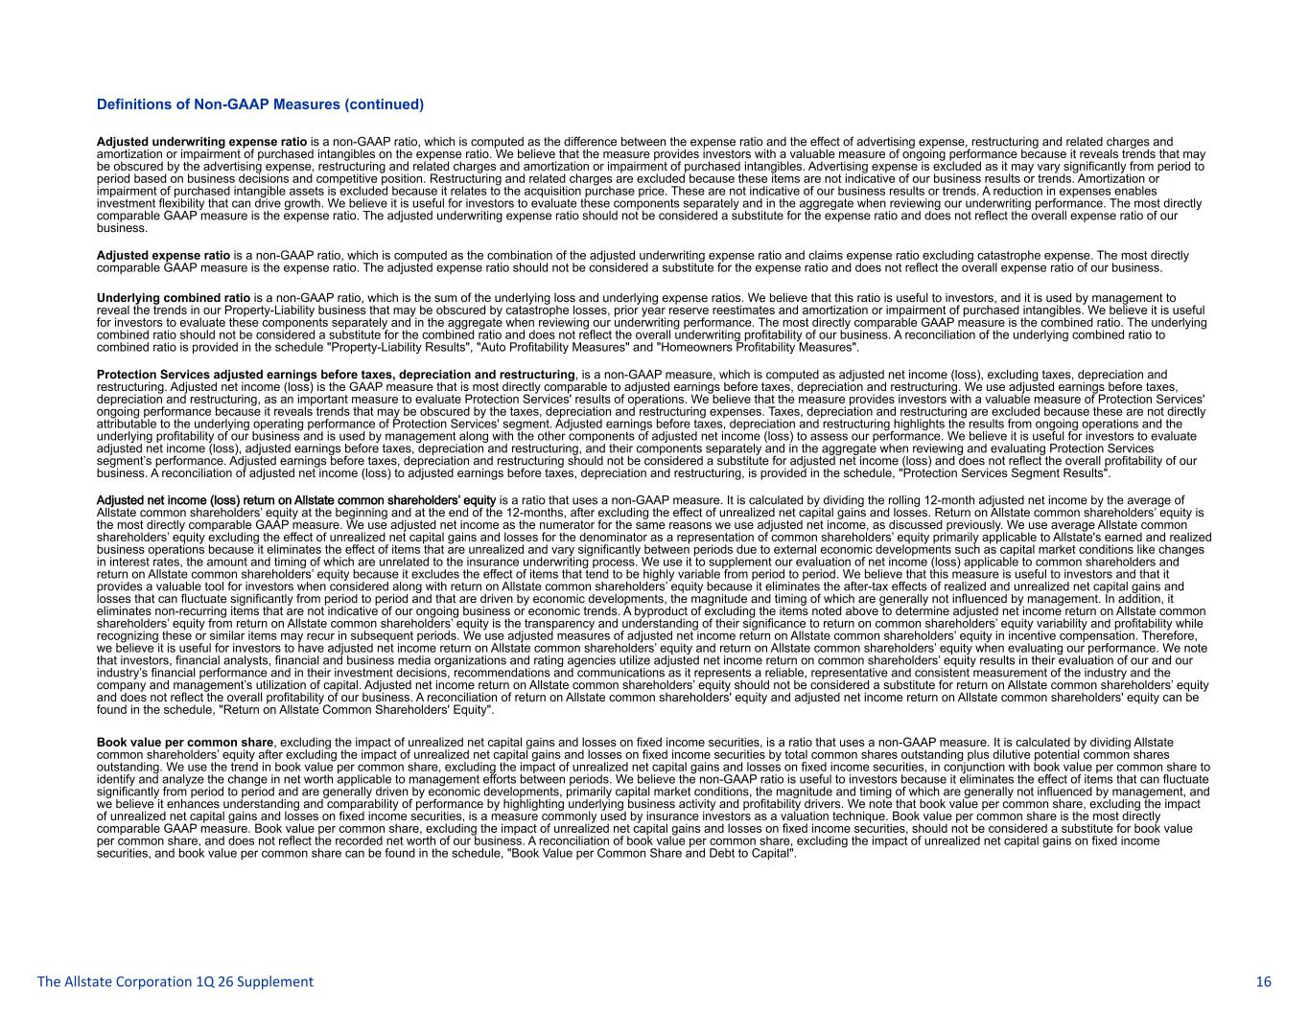
Definitions of Non-GAAP Measures (continued) Adjusted underwriting expense ratio is a non-GAAP ratio, which is computed as the difference between the expense ratio and the effect of advertising expense, restructuring and related charges and amortization or impairment of purchased intangibles on the expense ratio. We believe that the measure provides investors with a valuable measure of ongoing performance because it reveals trends that may be obscured by the advertising expense, restructuring and related charges and amortization or impairment of purchased intangibles. Advertising expense is excluded as it may vary significantly from period to period based on business decisions and competitive position. Restructuring and related charges are excluded because these items are not indicative of our business results or trends. Amortization or impairment of purchased intangible assets is excluded because it relates to the acquisition purchase price. These are not indicative of our business results or trends. A reduction in expenses enables investment flexibility that can drive growth. We believe it is useful for investors to evaluate these components separately and in the aggregate when reviewing our underwriting performance. The most directly comparable GAAP measure is the expense ratio. The adjusted underwriting expense ratio should not be considered a substitute for the expense ratio and does not reflect the overall expense ratio of our business. Adjusted expense ratio is a non-GAAP ratio, which is computed as the combination of the adjusted underwriting expense ratio and claims expense ratio excluding catastrophe expense. The most directly comparable GAAP measure is the expense ratio. The adjusted expense ratio should not be considered a substitute for the expense ratio and does not reflect the overall expense ratio of our business. Underlying combined ratio is a non-GAAP ratio, which is the sum of the underlying loss and underlying expense ratios. We believe that this ratio is useful to investors, and it is used by management to reveal the trends in our Property-Liability business that may be obscured by catastrophe losses, prior year reserve reestimates and amortization or impairment of purchased intangibles. We believe it is useful for investors to evaluate these components separately and in the aggregate when reviewing our underwriting performance. The most directly comparable GAAP measure is the combined ratio. The underlying combined ratio should not be considered a substitute for the combined ratio and does not reflect the overall underwriting profitability of our business. A reconciliation of the underlying combined ratio to combined ratio is provided in the schedule "Property-Liability Results", "Auto Profitability Measures" and "Homeowners Profitability Measures". Protection Services adjusted earnings before taxes, depreciation and restructuring, is a non-GAAP measure, which is computed as adjusted net income (loss), excluding taxes, depreciation and restructuring. Adjusted net income (loss) is the GAAP measure that is most directly comparable to adjusted earnings before taxes, depreciation and restructuring. We use adjusted earnings before taxes, depreciation and restructuring, as an important measure to evaluate Protection Services' results of operations. We believe that the measure provides investors with a valuable measure of Protection Services' ongoing performance because it reveals trends that may be obscured by the taxes, depreciation and restructuring expenses. Taxes, depreciation and restructuring are excluded because these are not directly attributable to the underlying operating performance of Protection Services' segment. Adjusted earnings before taxes, depreciation and restructuring highlights the results from ongoing operations and the underlying profitability of our business and is used by management along with the other components of adjusted net income (loss) to assess our performance. We believe it is useful for investors to evaluate adjusted net income (loss), adjusted earnings before taxes, depreciation and restructuring, and their components separately and in the aggregate when reviewing and evaluating Protection Services segment’s performance. Adjusted earnings before taxes, depreciation and restructuring should not be considered a substitute for adjusted net income (loss) and does not reflect the overall profitability of our business. A reconciliation of adjusted net income (loss) to adjusted earnings before taxes, depreciation and restructuring, is provided in the schedule, "Protection Services Segment Results". Adjusted net income (loss) return on Allstate common shareholders’ equity is a ratio that uses a non-GAAP measure. It is calculated by dividing the rolling 12-month adjusted net income by the average of Allstate common shareholders’ equity at the beginning and at the end of the 12-months, after excluding the effect of unrealized net capital gains and losses. Return on Allstate common shareholders’ equity is the most directly comparable GAAP measure. We use adjusted net income as the numerator for the same reasons we use adjusted net income, as discussed previously. We use average Allstate common shareholders’ equity excluding the effect of unrealized net capital gains and losses for the denominator as a representation of common shareholders’ equity primarily applicable to Allstate's earned and realized business operations because it eliminates the effect of items that are unrealized and vary significantly between periods due to external economic developments such as capital market conditions like changes in interest rates, the amount and timing of which are unrelated to the insurance underwriting process. We use it to supplement our evaluation of net income (loss) applicable to common shareholders and return on Allstate common shareholders’ equity because it excludes the effect of items that tend to be highly variable from period to period. We believe that this measure is useful to investors and that it provides a valuable tool for investors when considered along with return on Allstate common shareholders’ equity because it eliminates the after-tax effects of realized and unrealized net capital gains and losses that can fluctuate significantly from period to period and that are driven by economic developments, the magnitude and timing of which are generally not influenced by management. In addition, it eliminates non-recurring items that are not indicative of our ongoing business or economic trends. A byproduct of excluding the items noted above to determine adjusted net income return on Allstate common shareholders’ equity from return on Allstate common shareholders’ equity is the transparency and understanding of their significance to return on common shareholders’ equity variability and profitability while recognizing these or similar items may recur in subsequent periods. We use adjusted measures of adjusted net income return on Allstate common shareholders’ equity in incentive compensation. Therefore, we believe it is useful for investors to have adjusted net income return on Allstate common shareholders’ equity and return on Allstate common shareholders’ equity when evaluating our performance. We note that investors, financial analysts, financial and business media organizations and rating agencies utilize adjusted net income return on common shareholders’ equity results in their evaluation of our and our industry’s financial performance and in their investment decisions, recommendations and communications as it represents a reliable, representative and consistent measurement of the industry and the company and management’s utilization of capital. Adjusted net income return on Allstate common shareholders’ equity should not be considered a substitute for return on Allstate common shareholders’ equity and does not reflect the overall profitability of our business. A reconciliation of return on Allstate common shareholders' equity and adjusted net income return on Allstate common shareholders' equity can be found in the schedule, "Return on Allstate Common Shareholders' Equity". Book value per common share, excluding the impact of unrealized net capital gains and losses on fixed income securities, is a ratio that uses a non-GAAP measure. It is calculated by dividing Allstate common shareholders’ equity after excluding the impact of unrealized net capital gains and losses on fixed income securities by total common shares outstanding plus dilutive potential common shares outstanding. We use the trend in book value per common share, excluding the impact of unrealized net capital gains and losses on fixed income securities, in conjunction with book value per common share to identify and analyze the change in net worth applicable to management efforts between periods. We believe the non-GAAP ratio is useful to investors because it eliminates the effect of items that can fluctuate significantly from period to period and are generally driven by economic developments, primarily capital market conditions, the magnitude and timing of which are generally not influenced by management, and we believe it enhances understanding and comparability of performance by highlighting underlying business activity and profitability drivers. We note that book value per common share, excluding the impact of unrealized net capital gains and losses on fixed income securities, is a measure commonly used by insurance investors as a valuation technique. Book value per common share is the most directly comparable GAAP measure. Book value per common share, excluding the impact of unrealized net capital gains and losses on fixed income securities, should not be considered a substitute for book value per common share, and does not reflect the recorded net worth of our business. A reconciliation of book value per common share, excluding the impact of unrealized net capital gains on fixed income securities, and book value per common share can be found in the schedule, "Book Value per Common Share and Debt to Capital". The Allstate Corporation 1Q 26 Supplement 16

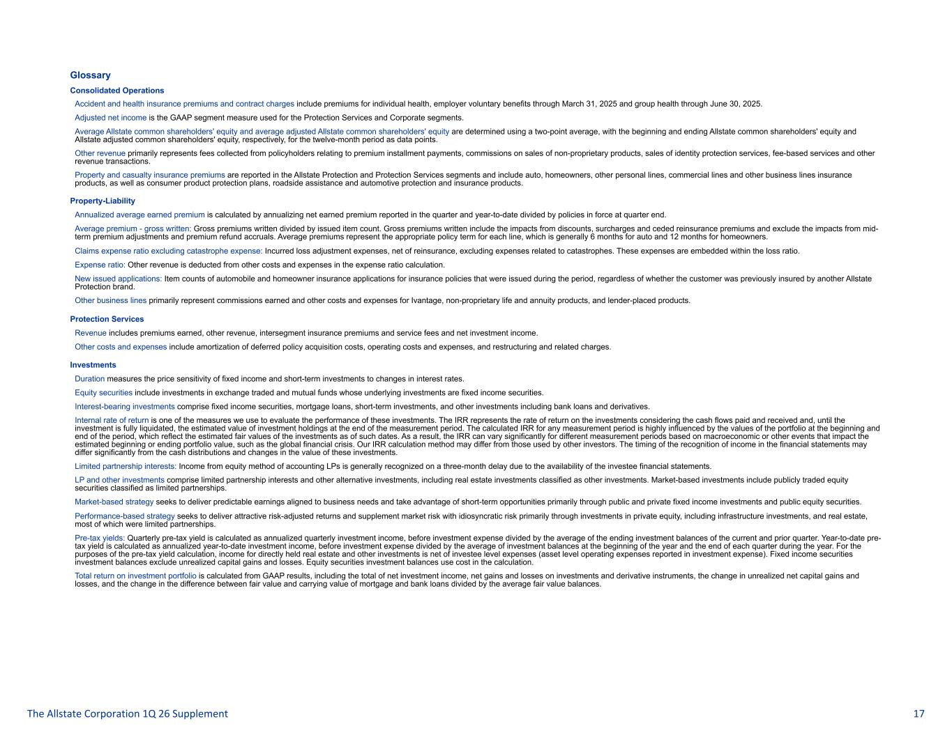
Glossary Consolidated Operations Accident and health insurance premiums and contract charges include premiums for individual health, employer voluntary benefits through March 31, 2025 and group health through June 30, 2025. Adjusted net income is the GAAP segment measure used for the Protection Services and Corporate segments. Average Allstate common shareholders' equity and average adjusted Allstate common shareholders' equity are determined using a two-point average, with the beginning and ending Allstate common shareholders' equity and Allstate adjusted common shareholders' equity, respectively, for the twelve-month period as data points. Other revenue primarily represents fees collected from policyholders relating to premium installment payments, commissions on sales of non-proprietary products, sales of identity protection services, fee-based services and other revenue transactions. Property and casualty insurance premiums are reported in the Allstate Protection and Protection Services segments and include auto, homeowners, other personal lines, commercial lines and other business lines insurance products, as well as consumer product protection plans, roadside assistance and automotive protection and insurance products. Property-Liability Annualized average earned premium is calculated by annualizing net earned premium reported in the quarter and year-to-date divided by policies in force at quarter end. Average premium - gross written: Gross premiums written divided by issued item count. Gross premiums written include the impacts from discounts, surcharges and ceded reinsurance premiums and exclude the impacts from mid- term premium adjustments and premium refund accruals. Average premiums represent the appropriate policy term for each line, which is generally 6 months for auto and 12 months for homeowners. Claims expense ratio excluding catastrophe expense: Incurred loss adjustment expenses, net of reinsurance, excluding expenses related to catastrophes. These expenses are embedded within the loss ratio. Expense ratio: Other revenue is deducted from other costs and expenses in the expense ratio calculation. New issued applications: Item counts of automobile and homeowner insurance applications for insurance policies that were issued during the period, regardless of whether the customer was previously insured by another Allstate Protection brand. Other business lines primarily represent commissions earned and other costs and expenses for Ivantage, non-proprietary life and annuity products, and lender-placed products. Protection Services Revenue includes premiums earned, other revenue, intersegment insurance premiums and service fees and net investment income. Other costs and expenses include amortization of deferred policy acquisition costs, operating costs and expenses, and restructuring and related charges. Investments Duration measures the price sensitivity of fixed income and short-term investments to changes in interest rates. Equity securities include investments in exchange traded and mutual funds whose underlying investments are fixed income securities. Interest-bearing investments comprise fixed income securities, mortgage loans, short-term investments, and other investments including bank loans and derivatives. Internal rate of return is one of the measures we use to evaluate the performance of these investments. The IRR represents the rate of return on the investments considering the cash flows paid and received and, until the investment is fully liquidated, the estimated value of investment holdings at the end of the measurement period. The calculated IRR for any measurement period is highly influenced by the values of the portfolio at the beginning and end of the period, which reflect the estimated fair values of the investments as of such dates. As a result, the IRR can vary significantly for different measurement periods based on macroeconomic or other events that impact the estimated beginning or ending portfolio value, such as the global financial crisis. Our IRR calculation method may differ from those used by other investors. The timing of the recognition of income in the financial statements may differ significantly from the cash distributions and changes in the value of these investments. Limited partnership interests: Income from equity method of accounting LPs is generally recognized on a three-month delay due to the availability of the investee financial statements. LP and other investments comprise limited partnership interests and other alternative investments, including real estate investments classified as other investments. Market-based investments include publicly traded equity securities classified as limited partnerships. Market-based strategy seeks to deliver predictable earnings aligned to business needs and take advantage of short-term opportunities primarily through public and private fixed income investments and public equity securities. Performance-based strategy seeks to deliver attractive risk-adjusted returns and supplement market risk with idiosyncratic risk primarily through investments in private equity, including infrastructure investments, and real estate, most of which were limited partnerships. Pre-tax yields: Quarterly pre-tax yield is calculated as annualized quarterly investment income, before investment expense divided by the average of the ending investment balances of the current and prior quarter. Year-to-date pre- tax yield is calculated as annualized year-to-date investment income, before investment expense divided by the average of investment balances at the beginning of the year and the end of each quarter during the year. For the purposes of the pre-tax yield calculation, income for directly held real estate and other investments is net of investee level expenses (asset level operating expenses reported in investment expense). Fixed income securities investment balances exclude unrealized capital gains and losses. Equity securities investment balances use cost in the calculation. Total return on investment portfolio is calculated from GAAP results, including the total of net investment income, net gains and losses on investments and derivative instruments, the change in unrealized net capital gains and losses, and the change in the difference between fair value and carrying value of mortgage and bank loans divided by the average fair value balances. The Allstate Corporation 1Q 26 Supplement 17

