UNITED STATES
SECURITIES AND EXCHANGE COMMISSION
Washington, D.C. 20549

FORM 8-K

CURRENT REPORT
PURSUANT TO SECTION 13 OR 15 (d) OF THE
SECURITIES EXCHANGE ACT OF 1934

Date of report (Date of earliest event reported): August 5, 2026
THE ALLSTATE CORPORATION
(Exact name of registrant as specified in its charter)

Delaware |  |  |  |  |  | 1-11840 |  |  |  |  |  | 36-3871531
(State or other  jurisdiction of incorporation) |  |  |  |  |  | (Commission  File Number) |  |  |  |  |  | (IRS Employer  Identification No.)
3100 Sanders Road, Northbrook, Illinois 60062
(Address of principal executive offices) (Zip Code)

Registrant’s telephone number, including area code (847) 402-2800

Check the appropriate box below if the Form 8-K filing is intended to simultaneously satisfy the filing obligation of the registrant under any of the following provisions:

☐ Written communications pursuant to Rule 425 under the Securities Act (17 CFR 230.425)
☐ Soliciting material pursuant to Rule 14a-12 under the Exchange Act (17 CFR 240.14a-12)
☐ Pre-commencement communications pursuant to Rule 14d-2(b) under the Exchange Act (17 CFR 240.14d-2(b))
☐ Pre-commencement communications pursuant to Rule 13e-4(c) under the Exchange Act (17 CFR 240.13e-4(c))

Securities registered pursuant to Section 12(b) of the Act:
Title of each class |  |  | Trading Symbols |  |  | Name of each exchange on which registered
Common Stock, par value $0.01 per share |  |  | ALL |  |  | New York Stock Exchange  NYSE Texas
5.100% Fixed-to-Floating Rate Subordinated Debentures due 2053 |  |  | ALL.PR.B |  |  | New York Stock Exchange
Depositary Shares represent 1/1,000th of a share of 5.100% Noncumulative Preferred Stock, Series H |  |  | ALL PR H |  |  | New York Stock Exchange
Depositary Shares represent 1/1,000th of a share of 4.750% Noncumulative Preferred Stock, Series I |  |  | ALL PR I |  |  | New York Stock Exchange
Depositary Shares represent 1/1,000th of a share of 7.375% Noncumulative Preferred Stock, Series J |  |  | ALL PR J |  |  | New York Stock Exchange

Indicate by check mark whether the registrant is an emerging growth company as defined in Rule 405 of the Securities Act of 1933 (§230.405 of this chapter) or Rule 12b-2 of the Securities Exchange Act of 1934 (§240.12b-2 of this chapter).
 |  |  |  |  |  | Emerging growth company |  |  | ☐

If an emerging growth company, indicate by check mark if the registrant has elected not to use the extended transition period for complying with any new or revised financial accounting standards provided pursuant to Section 13(a) of the Exchange Act. ☐

Section 2 – Financial Information

Item 2.02. Results of Operations and Financial Condition.

The Registrant’s press release dated August 5, 2026, announcing its financial results for the second quarter of 2026, and the Registrant’s second quarter 2026 investor supplement are furnished as Exhibits 99.1 and 99.2, respectively, to this report. The information contained in the press release and the investor supplement are furnished and not filed pursuant to instruction B.2 of Form 8-K.

Section 9 – Financial Statements and Exhibits

Item 9.01. Financial Statements and Exhibits.

(d) Exhibits

99.1 Registrant’s Press Release dated August 5, 2026
99.2 Second Quarter 2026 Investor Supplement of The Allstate Corporation
104 Cover Page Interactive Data File (formatted as inline XBRL)

2

SIGNATURES

Pursuant to the requirements of the Securities Exchange Act of 1934, the Registrant has duly caused this report to be signed on its behalf by the undersigned hereunto duly authorized.

 |  |  | THE ALLSTATE CORPORATION
 |  |  | (Registrant)
 |  |  | By: |  |  | /s/ Eric K. Ferren
 |  |  | Name: Eric K. Ferren
 |  |  | Title: Senior Vice President, Controller and Chief Accounting Officer

Date: August 5, 2026

Exhibit 99.1
3

FOR IMMEDIATE RELEASE

Contacts:
Nick Nottoli Allister Gobin
Media Relations Investor Relations
mediateam@allstate.com invrel@allstate.com

Allstate Reports Excellent Operating Results
NORTHBROOK, Ill., August 5, 2026 – The Allstate Corporation (NYSE: ALL) today reported financial results for the second quarter of 2026.
“Allstate delivered strong operating and financial results in the second quarter of 2026, while executing our strategic growth plans,” said Tom Wilson, who leads The Allstate Corporation. “Revenues increased to $18.6 billion reflecting increased policies in force, higher average homeowners insurance prices and strong investment results. Net income was $3.2 billion and adjusted net income* was $2.3 billion, or $8.99 per diluted share. Adjusted net income return on equity* was 44.2% over the last 12 months. Share repurchases were increased to $1.0 billion for the quarter.”

“Allstate creates shareholder value through operational excellence, sustainable growth and capital generation. Operational excellence is reflected in improving customer satisfaction while maintaining industry-leading Property-Liability returns. Transformative Growth is resulting in Property-Liability market share growth while Protection Services expands protection offerings. Capital generation supported organic growth, increased investment income and strong cash returns to shareholders, which were $3.5 billion, or 6.7% of market capitalization, over the last year,” concluded Wilson.

Second Quarter 2026 Results
•Total revenues of $18.6 billion in the second quarter of 2026 were $2.0 billion or 11.8% higher than the prior year quarter.
•Net income applicable to common shareholders was $3.2 billion in the second quarter of 2026, compared to $2.1 billion in the prior year quarter, reflecting strong underwriting results.
•Adjusted net income* was $2.3 billion, or $8.99 per diluted share, compared to $1.6 billion in the prior year quarter.

Exhibit 99.1
1
The Allstate Corporation Consolidated Highlights
 |  |  | As of or for the three months ended June 30, |  |  |  |  |  |  |  |  |  |  |  |  |  |  | As of or for the six months ended June 30,
($ in millions, except per share data and ratios) |  |  | 2026 |  |  |  |  |  | 2025 |  |  | % / pts  Change |  |  |  |  |  | 2026 |  |  |  |  |  | 2025 |  |  | % / pts  Change
Consolidated revenues |  |  | $ | 18,596 |  |  |  |  | $ | 16,633 |  | 11.8 |  | % |  |  |  | $ | 35,537 |  |  |  |  | $ | 33,085 |  | 7.4 |  | %
Net income applicable to common shareholders |  |  | 3,241 |  |  |  |  |  | 2,079 |  |  | 55.9 |  | % |  |  |  | 5,669 |  |  |  |  |  | 2,645 |  |  | 114.3 |  | %
per diluted common share |  |  | 12.51 |  |  |  |  |  | 7.76 |  |  | 61.2 |  | % |  |  |  | 21.73 |  |  |  |  |  | 9.85 |  |  | 120.6 |  | %
Adjusted net income* |  |  | 2,330 |  |  |  |  |  | 1,591 |  |  | 46.4 |  | % |  |  |  | 5,127 |  |  |  |  |  | 2,540 |  |  | 101.9 |  | %
per diluted common share* |  |  | 8.99 |  |  |  |  |  | 5.94 |  |  | 51.3 |  | % |  |  |  | 19.65 |  |  |  |  |  | 9.46 |  |  | 107.7 |  | %
Return on Allstate common shareholders’ equity (trailing twelve months)
Net income applicable to common shareholders |  |  |  |  |  |  |  |  |  |  |  |  |  |  |  |  |  | 49.1 |  | % |  |  |  | 29.6 |  | % | 19.5
Adjusted net income* |  |  |  |  |  |  |  |  |  |  |  |  |  |  |  |  |  | 44.2 |  | % |  |  |  | 28.6 |  | % | 15.6
Common shares outstanding (in millions) |  |  |  |  |  |  |  |  |  |  |  |  |  |  |  |  |  | 253.5 |  |  |  |  |  | 263.8 |  |  | (3.9) |  | %
Book value per common share |  |  |  |  |  |  |  |  |  |  |  |  |  |  |  |  |  | $ | 123.38 |  |  |  |  | $ | 82.40 |  | 49.7 |  | %
Total policies in force (in thousands) (1) |  |  |  |  |  |  |  |  |  |  |  |  |  |  |  |  |  | 215,935 |  |  |  |  |  | 208,051 |  |  | 3.8 |  | %
(1)Excludes policies in force related to the employer voluntary benefits and group health businesses sold in 2025.
* Measures used in this release that are not based on accounting principles generally accepted in the United States of America (“non-GAAP”) are denoted with an asterisk and defined and reconciled to the most directly comparable GAAP measure in the “Definitions of Non-GAAP Measures” section of this document.
----------------------------------------------------------------------------------------------------------------------------------------------------------

•Property-Liability earned premiums of $14.9 billion increased 4.0% in the second quarter of 2026 compared to the prior year, primarily driven by policy in force growth and higher homeowners insurance average premiums. Underwriting income was $2.0 billion compared to $1.3 billion in the prior year quarter.

Property-Liability Results
 |  |  | As of or for the three months ended June 30, |  |  |  |  |  |  |  |  |  |  |  | As of or for the six months ended June 30,
($ in millions) |  |  | 2026 |  |  | 2025 |  |  | % / pts  Change |  |  |  |  |  | 2026 |  |  | 2025 |  |  | % / pts  Change
Premiums written |  |  | $ | 15,431 |  | $ | 15,047 |  | 2.6 |  | % |  |  |  | $ | 30,056 |  | $ | 29,344 |  | 2.4 |  | %
Premiums earned |  |  | $ | 14,918 |  | $ | 14,346 |  | 4.0 |  | % |  |  |  | $ | 29,720 |  | $ | 28,373 |  | 4.7 |  | %
Recorded combined ratio |  |  | 86.6 |  |  | 91.1 |  |  | (4.5) |  |  |  |  |  | 84.3 |  |  | 94.2 |  |  | (9.9)
Underlying combined ratio* |  |  | 79.4 |  |  | 79.5 |  |  | (0.1) |  |  |  |  |  | 79.8 |  |  | 81.3 |  |  | (1.5)
Catastrophe losses |  |  | $ | 1,722 |  | $ | 1,990 |  | (13.5) |  | % |  |  |  | $ | 2,962 |  | $ | 4,192 |  | (29.3) |  | %
Underwriting income |  |  | $ | 2,006 |  | $ | 1,280 |  | 56.7 |  | % |  |  |  | $ | 4,664 |  | $ | 1,640 |  | 184.4 |  | %
Policies in force (in thousands) |  |  |  |  |  |  |  |  |  |  |  |  |  |  | 38,897 |  |  | 37,900 |  |  | 2.6 |  | %
◦Premiums written increased 2.6% compared to the prior year quarter, reflecting policy in force growth and higher homeowners insurance average premiums.

◦Property-Liability recorded combined ratio was 86.6 for the quarter, which was an improvement of 4.5 points versus the prior year quarter. The improvement was driven by lower catastrophe losses and more favorable prior year reserve releases, partially offset by higher legal expenses.

◦Policies in force increased by 2.6%, led by growth in auto and homeowners insurance policies.

◦Allstate-branded Affordable, Simple, Connected auto insurance products are now available in 45 states with the homeowners insurance product available in 41 states. Custom360® middle market standard and preferred auto and homeowners insurance products for the independent agent channel are available in 41 states.

Exhibit 99.1
2
◦Allstate Protection auto insurance results reflect Transformative Growth execution, with strong profitability and policy growth, driven by expanded distribution and increased customer value.

Allstate Protection Auto Results
 |  |  | As of or for the three months ended June 30, |  |  |  |  |  |  |  |  |  |  |  | As of or for the six months ended June 30,
($ in millions, except ratios) |  |  | 2026 |  |  | 2025 |  |  | % / pts  Change |  |  |  |  |  | 2026 |  |  | 2025 |  |  | % / pts  Change
Premiums written |  |  | $ | 9,572 |  | $ | 9,533 |  | 0.4 |  | % |  |  |  | $ | 19,422 |  | $ | 19,381 |  | 0.2 |  | %
Premiums earned |  |  | $ | 9,644 |  | $ | 9,528 |  | 1.2 |  | % |  |  |  | $ | 19,191 |  | $ | 18,875 |  | 1.7 |  | %
Recorded combined ratio |  |  | 83.3 |  |  | 86.0 |  |  | (2.7) |  |  |  |  |  | 82.6 |  |  | 88.6 |  |  | (6.0)
Underlying combined ratio* |  |  | 87.6 |  |  | 87.8 |  |  | (0.2) |  |  |  |  |  | 88.5 |  |  | 89.5 |  |  | (1.0)
Underwriting income |  |  | $ | 1,606 |  | $ | 1,331 |  | 20.7 |  | % |  |  |  | $ | 3,335 |  | $ | 2,147 |  | 55.3 |  | %
Policies in force (in thousands) |  |  |  |  |  |  |  |  |  |  |  |  |  |  | 25,951 |  |  | 25,243 |  |  | 2.8 |  | %

◦Written and earned premiums grew 0.4% and 1.2%, respectively, compared to the prior year quarter.

◦The recorded auto insurance combined ratio of 83.3 in the second quarter of 2026 was a 2.7 point improvement from the prior year quarter, due primarily to the benefit of prior year reserve releases and improvement in underlying losses.

◦The underlying auto insurance combined ratio* of 87.6 in the second quarter of 2026 was a 0.2 point improvement from the prior year quarter. This quarter benefited from 2.4 points of favorable development on claims reported in the first quarter of 2026.

◦Auto insurance policies in force grew by 2.8% with an 8.8% increase in new business, reflecting affordability initiatives, expanded distribution, increased marketing and new products.

◦Allstate Protection homeowners insurance remains a competitive advantage and continues to deliver profitable growth. Underwriting profit of $226 million increased from a loss of $76 million in the prior year quarter, reflecting higher earned premiums and lower catastrophe losses.

Allstate Protection Homeowners Results
 |  |  | As of or for the three months ended June 30, |  |  |  |  |  |  |  |  |  |  |  | As of or for the six months ended June 30,
($ in millions, except ratios) |  |  | 2026 |  |  | 2025 |  |  | % / pts  Change |  |  |  |  |  | 2026 |  |  | 2025 |  |  | % / pts  Change
Premiums written |  |  | $ | 4,752 |  | $ | 4,395 |  | 8.1 |  | % |  |  |  | $ | 8,493 |  | $ | 7,848 |  | 8.2 |  | %
Premiums earned |  |  | $ | 4,201 |  | $ | 3,771 |  | 11.4 |  | % |  |  |  | $ | 8,365 |  | $ | 7,428 |  | 12.6 |  | %
Recorded combined ratio |  |  | 94.6 |  |  | 102.0 |  |  | (7.4) |  |  |  |  |  | 89.1 |  |  | 107.1 |  |  | (18.0)
Catastrophe losses |  |  | $ | 1,408 |  | $ | 1,614 |  | (12.8) |  | % |  |  |  | $ | 2,454 |  | $ | 3,438 |  | (28.6) |  | %
Underlying combined ratio* |  |  | 61.5 |  |  | 58.6 |  |  | 2.9 |  |  |  |  |  | 61.0 |  |  | 60.5 |  |  | 0.5
Underwriting income (loss) |  |  | $ | 226 |  | $ | (76) |  | NM |  |  |  |  |  | $ | 911 |  | $ | (527) |  | NM
Policies in force (in thousands) |  |  |  |  |  |  |  |  |  |  |  |  |  |  | 7,819 |  |  | 7,596 |  |  | 2.9 |  | %
NM = not meaningful
◦Written premiums and earned premiums increased by 8.1% and 11.4% compared to the prior year quarter, respectively, due to higher average premiums and policy in force growth. A 5.8% increase in Allstate brand homeowners insurance average gross written premium compared to the prior year quarter reflects rate increases and higher home replacement costs.

◦The recorded homeowners insurance combined ratio of 94.6 was 7.4 points below the second quarter of 2025, due to higher average earned premiums and lower catastrophe losses.

◦Catastrophe losses of $1.4 billion in the quarter decreased 12.8% compared to the prior year.

◦The underlying combined ratio* of 61.5 was 2.9 points above the prior year quarter, reflecting higher loss costs.
Exhibit 99.1
3
◦Policies in force increased 2.9% compared to the prior year quarter, primarily driven by a 16.4% increase in new business, reflecting enhanced direct distribution capabilities and improved Allstate agent productivity.

----------------------------------------------------------------------------------------------------------------------------------------------------------

•Protection Services is comprised of five businesses that broaden protection through embedded product offerings. Revenues increased to $935 million in the second quarter of 2026, 7.8% higher than the prior year quarter, primarily due to continued Protection Plans growth. Adjusted net income of $53 million decreased by $7 million compared to the prior year quarter, primarily due to higher Protection Plans claim costs.

Protection Services Results
 |  |  | Three months ended June 30, |  |  |  |  |  |  |  |  |  |  |  | Six months ended June 30,
($ in millions) |  |  | 2026 |  |  | 2025 |  |  | % / $  Change |  |  |  |  |  | 2026 |  |  | 2025 |  |  | % / $  Change
Total revenues (1) |  |  | $ | 935 |  | $ | 867 |  | 7.8 |  | % |  |  |  | $ | 1,857 |  | $ | 1,727 |  | 7.5 |  | %
Protection Plans |  |  | 615 |  |  | 563 |  |  | 9.2 |  |  |  |  |  | 1,228 |  |  | 1,103 |  |  | 11.3
Roadside |  |  | 66 |  |  | 56 |  |  | 17.9 |  |  |  |  |  | 129 |  |  | 111 |  |  | 16.2
Dealer Services |  |  | 147 |  |  | 148 |  |  | (0.7) |  |  |  |  |  | 295 |  |  | 294 |  |  | 0.3
Identity Protection |  |  | 40 |  |  | 41 |  |  | (2.4) |  |  |  |  |  | 80 |  |  | 81 |  |  | (1.2)
Arity |  |  | 67 |  |  | 59 |  |  | 13.6 |  |  |  |  |  | 125 |  |  | 138 |  |  | (9.4)
Adjusted net income (loss) |  |  | $ | 53 |  | $ | 60 |  | $ | (7) |  |  |  |  | $ | 100 |  | $ | 115 |  | $ | (15)
Protection Plans |  |  | 42 |  |  | 51 |  |  | (9) |  |  |  |  |  | 83 |  |  | 96 |  |  | (13)
Roadside |  |  | 13 |  |  | 11 |  |  | 2 |  |  |  |  |  | 25 |  |  | 22 |  |  | 3
Dealer Services |  |  | 3 |  |  | 4 |  |  | (1) |  |  |  |  |  | 8 |  |  | 8 |  |  | —
Identity Protection |  |  | 2 |  |  | 2 |  |  | — |  |  |  |  |  | 3 |  |  | 3 |  |  | —
Arity |  |  | (7) |  |  | (8) |  |  | 1 |  |  |  |  |  | (19) |  |  | (14) |  |  | (5)
(1)Excludes net gains and losses on investments and derivatives.

◦Protection Plans continued to expand distribution relationships and product offerings. Revenue of $615 million increased $52 million, or 9.2%, compared to the prior year quarter primarily due to strong international and domestic growth. Adjusted net income of $42 million in the second quarter of 2026 decreased $9 million compared to the prior year quarter primarily reflecting lower margins on major appliances.

◦Roadside revenue of $66 million in the second quarter of 2026 increased 17.9% compared to the prior year quarter reflecting increased bundling with Allstate-branded Affordable, Simple, Connected auto insurance products and new partnerships. Adjusted net income of $13 million in the second quarter was $2 million higher than the prior year quarter.

◦Dealer Services generated revenue of $147 million, relatively flat compared to the prior year quarter. Adjusted net income was $3 million compared to $4 million in the prior year quarter.

◦Identity Protection revenue of $40 million in the second quarter of 2026 decreased 2.4% compared to the prior year quarter. Adjusted net income of $2 million in the second quarter of 2026 was in line with the prior year quarter.

◦Arity revenue of $67 million increased 13.6% compared to the prior year quarter driven by higher lead generation advertising sales. Adjusted net loss was $7 million in the second quarter of 2026 compared to a loss of $8 million in the prior year quarter.

-------------------------------------------------------------------------------------------------------------------------------------------------------

Exhibit 99.1
4
•Allstate Investments uses a proactive approach to balancing risk and return for the $87.8 billion portfolio. Net investment income of $1.0 billion in the second quarter of 2026 increased by $255 million from the prior year quarter with contributions from both market-based and performance-based investments.

Allstate Investment Results
 |  |  | Three months ended June 30, |  |  |  |  |  |  |  |  |  |  |  | Six months ended June 30,
($ in millions, except ratios) |  |  | 2026 |  |  | 2025 |  |  | $ / pts  Change |  |  |  |  |  | 2026 |  |  | 2025 |  |  | $ / pts  Change
Net investment income |  |  | $ | 1,009 |  | $ | 754 |  | $ | 255 |  |  |  |  | $ | 1,947 |  | $ | 1,608 |  | $ | 339
Market-based (1) |  |  | 837 |  |  | 733 |  |  | 104 |  |  |  |  |  | 1,628 |  |  | 1,452 |  |  | 176
Performance-based (1) |  |  | 239 |  |  | 79 |  |  | 160 |  |  |  |  |  | 446 |  |  | 275 |  |  | 171
Net gains (losses) on investments and derivatives |  |  | $ | 1,055 |  | $ | (144) |  | $ | 1,199 |  |  |  |  | $ | 650 |  | $ | (493) |  | $ | 1,143
Change in unrealized net capital gains and losses, pre-tax (2) |  |  | $ | 185 |  | $ | 492 |  | $ | (307) |  |  |  |  | $ | (479) |  | $ | 1,032 |  | $ | (1,511)
Total return on investment portfolio (2) |  |  | 2.6 |  | % | 1.4 |  | % | 1.2 |  |  |  |  |  | 2.5 |  | % | 2.8 |  | % | (0.3)
Total return on investment portfolio (2) (trailing twelve months) |  |  |  |  |  |  |  |  |  |  |  |  |  |  | 5.6 |  | % | 5.4 |  | % | 0.2
(1)Investment expenses are not allocated between market-based and performance-based portfolios with the exception of investee level expenses.
(2)Includes investments held for sale.

◦Market-based investment income was $837 million in the second quarter of 2026, an increase of $104 million, or 14.2%, compared to the prior year quarter, reflecting growth in asset balances to $78.0 billion and higher fixed income yields.

◦Performance-based investment income totaled $239 million in the second quarter of 2026, an increase of $160 million over the prior year quarter with higher private equity and real estate income. The overall portfolio allocation to performance-based assets provides a diversifying source of attractive long-term returns; quarterly volatility in reported results is expected.

◦Net gains on investments and derivatives were $1.1 billion in the second quarter of 2026, compared to losses of $144 million in the prior year quarter. Second quarter 2026 results primarily reflected valuation increases on public equity securities, partially offset by losses on repositioning sales and valuation and settlement of derivative instruments.

◦Unrealized net capital losses totaled $97 million (pre-tax), a $185 million increase to the prior quarter end.

◦Total return on the investment portfolio was 2.6% for the second quarter and 5.6% for the trailing twelve months.

Proactive Capital Management

“Consistent operating performance continues to generate attractive returns and deployable capital,” said John Dugenske, President, Investments and Corporate Strategy. “In the second quarter, we returned $1.3 billion to shareholders through $1.0 billion in share repurchases and $280 million in dividends. Allstate’s financial strength provides flexibility to continue creating shareholder value while maintaining a resilient balance sheet,” concluded Dugenske.

Visit www.allstateinvestors.com for additional information about Allstate’s results, including a webcast of its quarterly conference call and the call presentation. The conference call will be at 9 a.m. ET on Thursday, August 6. Financial information, including material announcements about The Allstate Corporation, is routinely posted on www.allstateinvestors.com.

Exhibit 99.1
5
Forward-Looking Statements
This news release contains “forward-looking statements” that anticipate results based on our estimates, assumptions and plans that are subject to uncertainty. These statements are made subject to the safe-harbor provisions of the Private Securities Litigation Reform Act of 1995. These forward-looking statements do not relate strictly to historical or current facts and may be identified by their use of words like “plans,” “seeks,” “expects,” “will,” “should,” “anticipates,” “estimates,” “intends,” “believes,” “likely,” “targets” and other words with similar meanings. We believe these statements are based on reasonable estimates, assumptions and plans. However, if the estimates, assumptions or plans underlying the forward-looking statements prove inaccurate or if other risks or uncertainties arise, actual results could differ materially from those communicated in these forward-looking statements. Factors that could cause actual results to differ materially from those expressed in, or implied by, the forward-looking statements may be found in our filings with the U.S. Securities and Exchange Commission, including the “Risk Factors” section in our most recent annual report on Form 10-K. Forward-looking statements are as of the date on which they are made, and we assume no obligation to update or revise any forward-looking statement.

About Allstate
The Allstate Corporation (NYSE: ALL) protects people from life’s uncertainties with affordable, simple and connected protection for autos, homes, electronic devices and identities. Products are available through a broad distribution network including Allstate agents, independent agents, major retailers, online and at the workplace. Allstate has 216 million policies in force and is widely known for the slogan “You’re in Good Hands with Allstate.” For more information, visit www.allstate.com.

6
THE ALLSTATE CORPORATION AND SUBSIDIARIES
CONDENSED CONSOLIDATED STATEMENTS OF FINANCIAL POSITION (UNAUDITED)
($ in millions, except par value data) |  |  | June 30, 2026 |  |  |  |  |  | December 31, 2025
Assets
Investments
Fixed income securities, at fair value (amortized cost, net $60,902 and $58,730) |  |  | $ | 60,809 |  |  |  |  | $ | 59,115
Equity securities, at fair value (cost $10,071 and $8,026) |  |  | 11,159 |  |  |  |  |  | 8,398
Mortgage loans, net |  |  | 842 |  |  |  |  |  | 879
Limited partnership interests |  |  | 8,967 |  |  |  |  |  | 8,844
Short-term, at fair value (amortized cost $4,874 and $4,888) |  |  | 4,872 |  |  |  |  |  | 4,887
Other investments, net |  |  | 1,153 |  |  |  |  |  | 1,114
Total investments |  |  | 87,802 |  |  |  |  |  | 83,237
Cash |  |  | 840 |  |  |  |  |  | 678
Premium installment receivables, net |  |  | 11,864 |  |  |  |  |  | 11,474
Deferred policy acquisition costs |  |  | 6,139 |  |  |  |  |  | 6,163
Reinsurance and indemnification recoverables, net |  |  | 7,880 |  |  |  |  |  | 8,501
Accrued investment income |  |  | 730 |  |  |  |  |  | 708
Property and equipment, net |  |  | 591 |  |  |  |  |  | 627
Goodwill |  |  | 3,118 |  |  |  |  |  | 3,118
Other assets, net |  |  | 5,792 |  |  |  |  |  | 5,252
Total assets |  |  | $ | 124,756 |  |  |  |  | $ | 119,758
Liabilities
Reserve for property and casualty insurance claims and claims expense |  |  | $ | 40,979 |  |  |  |  | $ | 41,079
Unearned premiums |  |  | 29,388 |  |  |  |  |  | 29,080
Claim payments outstanding |  |  | 1,552 |  |  |  |  |  | 1,419
Deferred income taxes |  |  | 172 |  |  |  |  |  | 227
Other liabilities and accrued expenses |  |  | 11,495 |  |  |  |  |  | 9,874
Debt |  |  | 7,492 |  |  |  |  |  | 7,490
Total liabilities |  |  | 91,078 |  |  |  |  |  | 89,169
Equity
Preferred stock and additional capital paid-in, $1 par value, 25 million shares authorized, 82.0 thousand shares issued and outstanding, $2,050 aggregate liquidation preference |  |  | 2,001 |  |  |  |  |  | 2,001
Common stock, $.01 par value, 2.0 billion shares authorized and 900 million issued, 254 million and 260 million shares outstanding |  |  | 9 |  |  |  |  |  | 9
Additional capital paid-in |  |  | 4,219 |  |  |  |  |  | 4,158
Retained income |  |  | 67,504 |  |  |  |  |  | 62,393
Treasury stock, at cost (646 million and 640 million shares) |  |  | (39,842) |  |  |  |  |  | (38,206)
Accumulated other comprehensive income (loss):
Unrealized net capital gains and losses |  |  | (79) |  |  |  |  |  | 297
Unrealized foreign currency translation adjustments |  |  | (126) |  |  |  |  |  | (55)
Unamortized pension and other postretirement prior service credit |  |  | 10 |  |  |  |  |  | 11
Discount rate for reserve for future policy benefits |  |  | 2 |  |  |  |  |  | 2
Total accumulated other comprehensive (loss) income |  |  | (193) |  |  |  |  |  | 255
Total Allstate shareholders’ equity |  |  | 33,698 |  |  |  |  |  | 30,610
Noncontrolling interest |  |  | (20) |  |  |  |  |  | (21)
Total equity |  |  | 33,678 |  |  |  |  |  | 30,589
Total liabilities and equity |  |  | $ | 124,756 |  |  |  |  | $ | 119,758

7
THE ALLSTATE CORPORATION AND SUBSIDIARIES
CONDENSED CONSOLIDATED STATEMENTS OF OPERATIONS (UNAUDITED)
($ in millions, except per share data) |  |  | Three months ended June 30, |  |  |  |  |  |  |  |  |  |  |  | Six months ended June 30,
 |  |  | 2026 |  |  |  |  |  | 2025 |  |  |  |  |  | 2026 |  |  |  |  |  | 2025
Revenues
Property and casualty insurance premiums |  |  | $ | 15,670 |  |  |  |  | $ | 15,041 |  |  |  |  | $ | 31,223 |  |  |  |  | $ | 29,739
Accident and health insurance premiums and contract charges |  |  | 134 |  |  |  |  |  | 235 |  |  |  |  |  | 270 |  |  |  |  |  | 722
Other revenue |  |  | 728 |  |  |  |  |  | 747 |  |  |  |  |  | 1,447 |  |  |  |  |  | 1,509
Net investment income |  |  | 1,009 |  |  |  |  |  | 754 |  |  |  |  |  | 1,947 |  |  |  |  |  | 1,608
Net gains (losses) on investments and derivatives |  |  | 1,055 |  |  |  |  |  | (144) |  |  |  |  |  | 650 |  |  |  |  |  | (493)
Total revenues |  |  | 18,596 |  |  |  |  |  | 16,633 |  |  |  |  |  | 35,537 |  |  |  |  |  | 33,085
Costs and expenses
Property and casualty insurance claims and claims expense |  |  | 9,862 |  |  |  |  |  | 10,249 |  |  |  |  |  | 19,047 |  |  |  |  |  | 21,064
Accident, health and other policy benefits |  |  | 72 |  |  |  |  |  | 188 |  |  |  |  |  | 148 |  |  |  |  |  | 521
Amortization of deferred policy acquisition costs |  |  | 2,202 |  |  |  |  |  | 2,076 |  |  |  |  |  | 4,380 |  |  |  |  |  | 4,163
Operating costs and expenses |  |  | 2,315 |  |  |  |  |  | 2,135 |  |  |  |  |  | 4,540 |  |  |  |  |  | 4,380
Pension and other postretirement remeasurement (gains) losses |  |  | (146) |  |  |  |  |  | — |  |  |  |  |  | (127) |  |  |  |  |  | 78
Restructuring and related charges |  |  | 7 |  |  |  |  |  | 15 |  |  |  |  |  | 12 |  |  |  |  |  | 31
Amortization of purchased intangibles |  |  | 46 |  |  |  |  |  | 57 |  |  |  |  |  | 93 |  |  |  |  |  | 116
Interest expense |  |  | 96 |  |  |  |  |  | 100 |  |  |  |  |  | 194 |  |  |  |  |  | 200
Total costs and expenses |  |  | 14,454 |  |  |  |  |  | 14,820 |  |  |  |  |  | 28,287 |  |  |  |  |  | 30,553
Gain on disposition of operations |  |  | — |  |  |  |  |  | 890 |  |  |  |  |  | — |  |  |  |  |  | 890
Income from operations before income tax expense |  |  | 4,142 |  |  |  |  |  | 2,703 |  |  |  |  |  | 7,250 |  |  |  |  |  | 3,422
Income tax expense |  |  | 871 |  |  |  |  |  | 604 |  |  |  |  |  | 1,521 |  |  |  |  |  | 727
Net income |  |  | 3,271 |  |  |  |  |  | 2,099 |  |  |  |  |  | 5,729 |  |  |  |  |  | 2,695
Less: Net income (loss) attributable to noncontrolling interest |  |  | — |  |  |  |  |  | (10) |  |  |  |  |  | 1 |  |  |  |  |  | (9)
Net income attributable to Allstate |  |  | 3,271 |  |  |  |  |  | 2,109 |  |  |  |  |  | 5,728 |  |  |  |  |  | 2,704
Less: Preferred stock dividends |  |  | 30 |  |  |  |  |  | 30 |  |  |  |  |  | 59 |  |  |  |  |  | 59
Net income applicable to common shareholders |  |  | $ | 3,241 |  |  |  |  | $ | 2,079 |  |  |  |  | $ | 5,669 |  |  |  |  | $ | 2,645
Earnings per common share:
Net income applicable to common shareholders per common share - Basic |  |  | $ | 12.66 |  |  |  |  | $ | 7.86 |  |  |  |  | $ | 22.00 |  |  |  |  | $ | 9.98
Weighted average common shares - Basic |  |  | 256.0 |  |  |  |  |  | 264.6 |  |  |  |  |  | 257.7 |  |  |  |  |  | 264.9
Net income applicable to common shareholders per common share - Diluted |  |  | $ | 12.51 |  |  |  |  | $ | 7.76 |  |  |  |  | $ | 21.73 |  |  |  |  | $ | 9.85
Weighted average common shares - Diluted |  |  | 259.1 |  |  |  |  |  | 267.9 |  |  |  |  |  | 260.9 |  |  |  |  |  | 268.4

8
Definitions of Non-GAAP Measures
We believe that investors’ understanding of Allstate’s performance is enhanced by our disclosure of the following non-GAAP measures. Our methods for calculating these measures may differ from those used by other companies and therefore comparability may be limited.
Adjusted net income (loss) is net income (loss) applicable to common shareholders, excluding:
◦Net gains and losses on investments and derivatives
◦Pension and other postretirement remeasurement gains and losses
◦Amortization or impairment of purchased intangibles
◦Gain or loss on disposition
◦Adjustments for other significant non-recurring, infrequent or unusual items, when (a) the nature of the charge or gain is such that it is reasonably unlikely to recur within two years, or (b) there has been no similar charge or gain within the prior two years
◦Related income tax expense or benefit of these items
Net income (loss) applicable to common shareholders is the GAAP measure that is most directly comparable to adjusted net income.
We use adjusted net income as an important measure to evaluate our results of operations. We believe that the measure provides investors with a valuable measure of the Company’s ongoing performance because it reveals trends in our insurance and financial services business that may be obscured by the net effect of net gains and losses on investments and derivatives, pension and other postretirement remeasurement gains and losses, amortization or impairment of purchased intangibles, gain or loss on disposition and adjustments for other significant non-recurring, infrequent or unusual items and the related tax expense or benefit of these items. Net gains and losses on investments and derivatives, and pension and other postretirement remeasurement gains and losses may vary significantly between periods and are generally driven by business decisions and external economic developments such as capital market conditions, the timing of which is unrelated to the insurance underwriting process. Gain or loss on disposition is excluded because it is non-recurring in nature and the amortization or impairment of purchased intangibles is excluded because it relates to the acquisition purchase price and is not indicative of our underlying business results or trends. Non-recurring items are excluded because, by their nature, they are not indicative of our business or economic trends. Accordingly, adjusted net income excludes the effect of items that tend to be highly variable from period to period and highlights the results from ongoing operations and the underlying profitability of our business. A byproduct of excluding these items to determine adjusted net income is the transparency and understanding of their significance to net income variability and profitability while recognizing these or similar items may recur in subsequent periods. Adjusted net income is used by management along with the other components of net income (loss) applicable to common shareholders to assess our performance. We use adjusted measures of adjusted net income in incentive compensation. Therefore, we believe it is useful for investors to evaluate net income (loss) applicable to common shareholders, adjusted net income and their components separately and in the aggregate when reviewing and evaluating our performance. We note that investors, financial analysts, financial and business media organizations and rating agencies utilize adjusted net income results in their evaluation of our and our industry’s financial performance and in their investment decisions, recommendations and communications as it represents a reliable, representative and consistent measurement of the industry and the Company and management’s performance. We note that the price to earnings multiple commonly used by insurance investors as a forward-looking valuation technique uses adjusted net income as the denominator. Adjusted net income should not be considered a substitute for net income (loss) applicable to common shareholders and does not reflect the overall profitability of our business.
The following tables reconcile net income (loss) applicable to common shareholders and adjusted net income (loss). Taxes on adjustments to reconcile net income (loss) applicable to common shareholders and adjusted net income (loss) generally use a 21% effective tax rate.
($ in millions, except per share data) |  |  | Three months ended June 30,
 |  |  | 2026 |  |  |  |  |  | 2025 |  |  |  |  |  | 2026 |  |  |  |  |  | 2025
 |  |  | Consolidated |  |  |  |  |  |  |  |  |  |  |  | Per diluted common share
Net income applicable to common shareholders |  |  | $ | 3,241 |  |  |  |  | $ | 2,079 |  |  |  |  | $ | 12.51 |  |  |  |  | $ | 7.76
Net (gains) losses on investments and derivatives |  |  | (1,055) |  |  |  |  |  | 144 |  |  |  |  |  | (4.07) |  |  |  |  |  | 0.54
Pension and other postretirement remeasurement (gains) losses |  |  | (146) |  |  |  |  |  | — |  |  |  |  |  | (0.57) |  |  |  |  |  | —
Amortization of purchased intangibles |  |  | 46 |  |  |  |  |  | 57 |  |  |  |  |  | 0.18 |  |  |  |  |  | 0.21
Gain on disposition |  |  | (1) |  |  |  |  |  | (893) |  |  |  |  |  | — |  |  |  |  |  | (3.33)
Income tax expense (benefit) |  |  | 245 |  |  |  |  |  | 204 |  |  |  |  |  | 0.94 |  |  |  |  |  | 0.76
Adjusted net income * |  |  | $ | 2,330 |  |  |  |  | $ | 1,591 |  |  |  |  | $ | 8.99 |  |  |  |  | $ | 5.94
 |  |  | Six months ended June 30,
 |  |  | 2026 |  |  |  |  |  | 2025 |  |  |  |  |  | 2026 |  |  |  |  |  | 2025
 |  |  | Consolidated |  |  |  |  |  |  |  |  |  |  |  | Per diluted common share
Net income applicable to common shareholders |  |  | $ | 5,669 |  |  |  |  | $ | 2,645 |  |  |  |  | $ | 21.73 |  |  |  |  | $ | 9.85
Net (gains) losses on investments and derivatives |  |  | (650) |  |  |  |  |  | 493 |  |  |  |  |  | (2.49) |  |  |  |  |  | 1.84
Pension and other postretirement remeasurement (gains) losses |  |  | (127) |  |  |  |  |  | 78 |  |  |  |  |  | (0.49) |  |  |  |  |  | 0.29
Amortization of purchased intangibles |  |  | 93 |  |  |  |  |  | 116 |  |  |  |  |  | 0.36 |  |  |  |  |  | 0.43
Gain on disposition |  |  | (7) |  |  |  |  |  | (893) |  |  |  |  |  | (0.03) |  |  |  |  |  | (3.33)
Income tax expense (benefit) |  |  | 149 |  |  |  |  |  | 101 |  |  |  |  |  | 0.57 |  |  |  |  |  | 0.38
Adjusted net income * |  |  | $ | 5,127 |  |  |  |  | $ | 2,540 |  |  |  |  | $ | 19.65 |  |  |  |  | $ | 9.46

9
Adjusted net income (loss) return on Allstate common shareholders’ equity is a ratio that uses a non-GAAP measure. It is calculated by dividing the rolling 12-month adjusted net income by the average of Allstate common shareholders’ equity at the beginning and at the end of the 12-months, after excluding the effect of unrealized net capital gains and losses. Return on Allstate common shareholders’ equity is the most directly comparable GAAP measure. We use adjusted net income as the numerator for the same reasons we use adjusted net income, as discussed previously. We use average Allstate common shareholders’ equity excluding the effect of unrealized net capital gains and losses for the denominator as a representation of common shareholders’ equity primarily applicable to Allstate's earned and realized business operations because it eliminates the effect of items that are unrealized and vary significantly between periods due to external economic developments such as capital market conditions like changes in interest rates, the amount and timing of which are unrelated to the insurance underwriting process. We use it to supplement our evaluation of net income (loss) applicable to common shareholders and return on Allstate common shareholders’ equity because it excludes the effect of items that tend to be highly variable from period to period. We believe that this measure is useful to investors and that it provides a valuable tool for investors when considered along with return on Allstate common shareholders’ equity because it eliminates the after-tax effects of realized and unrealized net capital gains and losses that can fluctuate significantly from period to period and that are driven by economic developments, the magnitude and timing of which are generally not influenced by management. In addition, it eliminates non-recurring items that are not indicative of our ongoing business or economic trends. A byproduct of excluding the items noted above to determine adjusted net income return on Allstate common shareholders’ equity from return on Allstate common shareholders’ equity is the transparency and understanding of their significance to return on common shareholders’ equity variability and profitability while recognizing these or similar items may recur in subsequent periods. We use adjusted measures of adjusted net income return on Allstate common shareholders’ equity in incentive compensation. Therefore, we believe it is useful for investors to have adjusted net income return on Allstate common shareholders’ equity and return on Allstate common shareholders’ equity when evaluating our performance. We note that investors, financial analysts, financial and business media organizations and rating agencies utilize adjusted net income return on common shareholders’ equity results in their evaluation of our and our industry’s financial performance and in their investment decisions, recommendations and communications as it represents a reliable, representative and consistent measurement of the industry and the company and management’s utilization of capital. We also provide it to facilitate a comparison to our long-term adjusted net income return on Allstate common shareholders’ equity goal. Adjusted net income return on Allstate common shareholders’ equity should not be considered a substitute for return on Allstate common shareholders’ equity and does not reflect the overall profitability of our business.
The following tables reconcile return on Allstate common shareholders’ equity and adjusted net income (loss) return on Allstate common shareholders’ equity.
($ in millions) |  |  | For the twelve months ended June 30,
 |  |  | 2026 |  |  |  |  |  | 2025
Return on Allstate common shareholders’ equity
Numerator:
Net income applicable to common shareholders |  |  | $ | 13,189 |  |  |  |  | $ | 5,705
Denominator:
Beginning Allstate common shareholders’ equity |  |  | $ | 22,018 |  |  |  |  | $ | 16,592
Ending Allstate common shareholders’ equity (1) |  |  | 31,697 |  |  |  |  |  | 22,018
Average Allstate common shareholders’ equity |  |  | $ | 26,858 |  |  |  |  | $ | 19,305
Return on Allstate common shareholders’ equity |  |  | 49.1 |  | % |  |  |  | 29.6 |  | %

($ in millions) |  |  | For the twelve months ended June 30,
 |  |  | 2026 |  |  |  |  |  | 2025
Adjusted net income return on Allstate common shareholders’ equity
Numerator:
Adjusted net income * |  |  | $ | 11,891 |  |  |  |  | $ | 5,650
Denominator:
Beginning Allstate common shareholders’ equity |  |  | $ | 22,018 |  |  |  |  | $ | 16,592
Less: Unrealized net capital gains and losses |  |  | 36 |  |  |  |  |  | (938)
Adjusted beginning Allstate common shareholders’ equity |  |  | 21,982 |  |  |  |  |  | 17,530
Ending Allstate common shareholders’ equity (1) |  |  | 31,697 |  |  |  |  |  | 22,018
Less: Unrealized net capital gains and losses |  |  | (79) |  |  |  |  |  | 36
Adjusted ending Allstate common shareholders’ equity |  |  | 31,776 |  |  |  |  |  | 21,982
Average adjusted Allstate common shareholders’ equity |  |  | $ | 26,879 |  |  |  |  | $ | 19,756
Adjusted net income return on Allstate common shareholders’ equity * |  |  | 44.2 |  | % |  |  |  | 28.6 |  | %
_____________
(1) Excludes equity related to preferred stock of $2,001 million for both periods shown.
10
Combined ratio excluding the effect of catastrophes, prior year reserve reestimates and amortization or impairment of purchased intangibles (“underlying combined ratio”) is a non-GAAP ratio, which is computed as the difference between four GAAP operating ratios: the combined ratio, the effect of catastrophes on the combined ratio, the effect of prior year reserve reestimates, excluding catastrophes on the combined ratio, and the effect of amortization or impairment of purchased intangibles on the combined ratio. We believe that this ratio is useful to investors, and it is used by management to reveal the trends in our Property-Liability business that may be obscured by catastrophe losses, prior year reserve reestimates and amortization or impairment of purchased intangibles. Catastrophe losses cause our loss trends to vary significantly between periods as a result of their incidence of occurrence and magnitude, and can have a significant impact on the combined ratio. Prior year reserve reestimates are caused by unexpected loss development on historical reserves, which could increase or decrease current year net income. Amortization or impairment of purchased intangibles relates to the acquisition purchase price and is not indicative of our underlying insurance business results or trends. We believe it is useful for investors to evaluate these components separately and in the aggregate when reviewing our underwriting performance. The most directly comparable GAAP measure is the combined ratio. The underlying combined ratio should not be considered a substitute for the combined ratio and does not reflect the overall underwriting profitability of our business.
The following tables reconcile the respective combined ratio to the underlying combined ratio. Underwriting margin is calculated as 100% minus the combined ratio.
Property-Liability |  |  | Three months ended June 30, |  |  |  |  |  |  |  |  |  |  |  | Six months ended June 30,
 |  |  | 2026 |  |  |  |  |  | 2025 |  |  |  |  |  | 2026 |  |  |  |  |  | 2025
Combined ratio |  |  | 86.6 |  |  |  |  |  | 91.1 |  |  |  |  |  | 84.3 |  |  |  |  |  | 94.2
Effect of catastrophe losses |  |  | (11.5) |  |  |  |  |  | (13.9) |  |  |  |  |  | (10.0) |  |  |  |  |  | (14.8)
Effect of prior year reserve reestimates, excluding catastrophes |  |  | 4.6 |  |  |  |  |  | 2.6 |  |  |  |  |  | 5.8 |  |  |  |  |  | 2.2
Effect of amortization of purchased intangibles |  |  | (0.3) |  |  |  |  |  | (0.3) |  |  |  |  |  | (0.3) |  |  |  |  |  | (0.3)
Underlying combined ratio* |  |  | 79.4 |  |  |  |  |  | 79.5 |  |  |  |  |  | 79.8 |  |  |  |  |  | 81.3
Effect of prior year catastrophe reserve reestimates |  |  | 0.3 |  |  |  |  |  | — |  |  |  |  |  | 0.2 |  |  |  |  |  | —
Allstate Protection - Auto Insurance |  |  | Three months ended June 30, |  |  |  |  |  |  |  |  |  |  |  | Six months ended June 30,
 |  |  | 2026 |  |  |  |  |  | 2025 |  |  |  |  |  | 2026 |  |  |  |  |  | 2025
Combined ratio |  |  | 83.3 |  |  |  |  |  | 86.0 |  |  |  |  |  | 82.6 |  |  |  |  |  | 88.6
Effect of catastrophe losses |  |  | (2.2) |  |  |  |  |  | (2.2) |  |  |  |  |  | (1.6) |  |  |  |  |  | (2.2)
Effect of prior year reserve reestimates, excluding catastrophes |  |  | 6.6 |  |  |  |  |  | 4.3 |  |  |  |  |  | 7.7 |  |  |  |  |  | 3.4
Effect of amortization of purchased intangibles |  |  | (0.1) |  |  |  |  |  | (0.3) |  |  |  |  |  | (0.2) |  |  |  |  |  | (0.3)
Underlying combined ratio* |  |  | 87.6 |  |  |  |  |  | 87.8 |  |  |  |  |  | 88.5 |  |  |  |  |  | 89.5
Effect of prior year catastrophe reserve reestimates |  |  | (0.1) |  |  |  |  |  | (0.2) |  |  |  |  |  | (0.1) |  |  |  |  |  | (0.2)
Allstate Protection - Homeowners Insurance |  |  | Three months ended June 30, |  |  |  |  |  |  |  |  |  |  |  | Six months ended June 30,
 |  |  | 2026 |  |  |  |  |  | 2025 |  |  |  |  |  | 2026 |  |  |  |  |  | 2025
Combined ratio |  |  | 94.6 |  |  |  |  |  | 102.0 |  |  |  |  |  | 89.1 |  |  |  |  |  | 107.1
Effect of catastrophe losses |  |  | (33.5) |  |  |  |  |  | (42.8) |  |  |  |  |  | (29.3) |  |  |  |  |  | (46.3)
Effect of prior year reserve reestimates, excluding catastrophes |  |  | 0.7 |  |  |  |  |  | (0.3) |  |  |  |  |  | 1.5 |  |  |  |  |  | —
Effect of amortization of purchased intangibles |  |  | (0.3) |  |  |  |  |  | (0.3) |  |  |  |  |  | (0.3) |  |  |  |  |  | (0.3)
Underlying combined ratio* |  |  | 61.5 |  |  |  |  |  | 58.6 |  |  |  |  |  | 61.0 |  |  |  |  |  | 60.5
Effect of prior year catastrophe reserve reestimates |  |  | 1.6 |  |  |  |  |  | 0.5 |  |  |  |  |  | 0.6 |  |  |  |  |  | 0.3

# # # # #


11
The Allstate Corporation Investor Supplement Second Quarter 2026 The condensed consolidated financial statements and financial exhibits included herein are unaudited and should be read in conjunction with the consolidated financial statements and notes thereto included in the most recent Annual Report on Form 10-K and Quarterly Reports on Form 10-Q. The results of operations for interim periods should not be considered indicative of results to be expected for the full year. Measures used in these financial statements and exhibits that are not based on generally accepted accounting principles ("non-GAAP") are denoted with an asterisk (*). These measures are defined on the pages "Definitions of Non-GAAP Measures" and are reconciled to the most directly comparable generally accepted accounting principles ("GAAP") measure herein. Exhibit 99.2

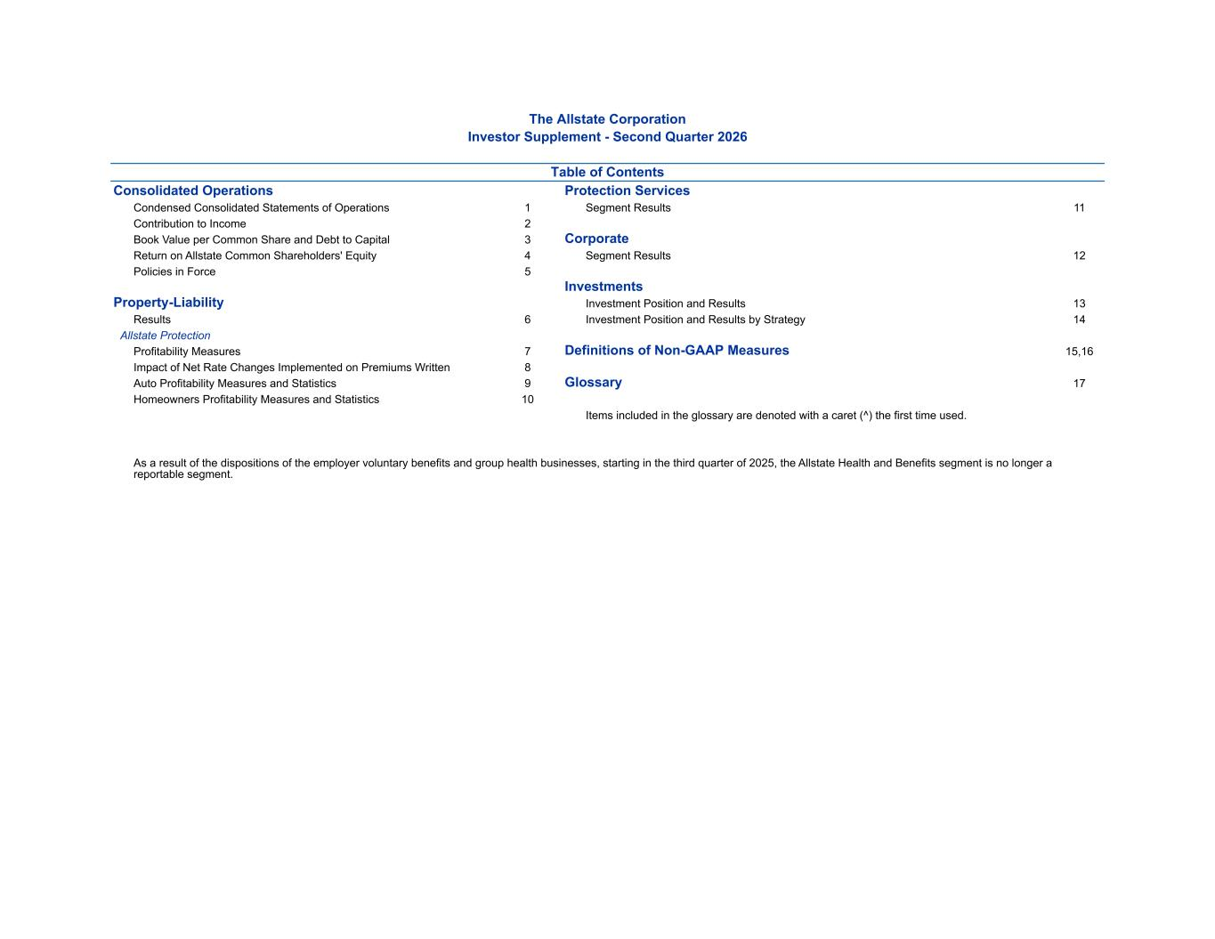
The Allstate Corporation Investor Supplement - Second Quarter 2026 Table of Contents Consolidated Operations Protection Services Condensed Consolidated Statements of Operations 1 Segment Results 11 Contribution to Income 2 Book Value per Common Share and Debt to Capital 3 Corporate Return on Allstate Common Shareholders' Equity 4 Segment Results 12 Policies in Force 5 Investments Property-Liability Investment Position and Results 13 Results 6 Investment Position and Results by Strategy 14 Allstate Protection Profitability Measures 7 Definitions of Non-GAAP Measures 15,16 Impact of Net Rate Changes Implemented on Premiums Written 8 Auto Profitability Measures and Statistics 9 Glossary 17 Homeowners Profitability Measures and Statistics 10 Items included in the glossary are denoted with a caret (^) the first time used. As a result of the dispositions of the employer voluntary benefits and group health businesses, starting in the third quarter of 2025, the Allstate Health and Benefits segment is no longer a reportable segment.

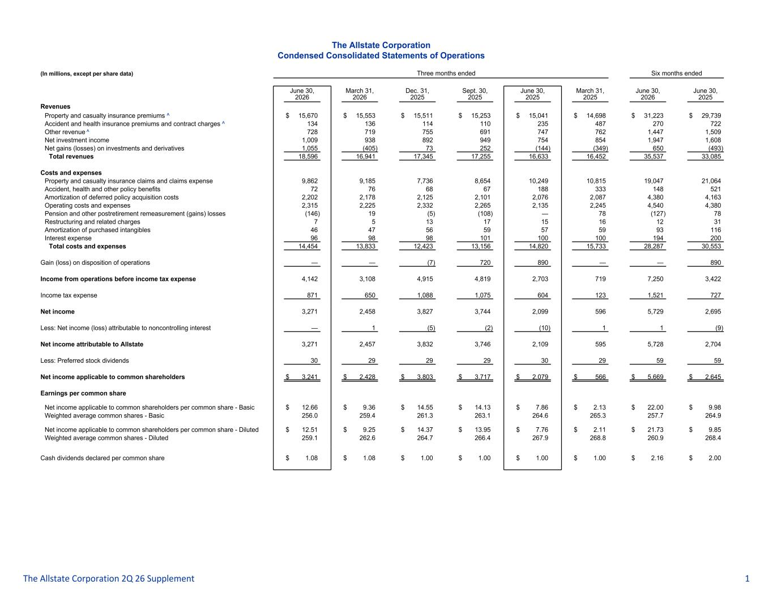
The Allstate Corporation Condensed Consolidated Statements of Operations (In millions, except per share data) Three months ended Six months ended June 30, 2026 March 31, 2026 Dec. 31, 2025 Sept. 30, 2025 June 30, 2025 March 31, 2025 June 30, 2026 June 30, 2025 Revenues Property and casualty insurance premiums ^ $ 15,670 $ 15,553 $ 15,511 $ 15,253 $ 15,041 $ 14,698 $ 31,223 $ 29,739 Accident and health insurance premiums and contract charges ^ 134 136 114 110 235 487 270 722 Other revenue ^ 728 719 755 691 747 762 1,447 1,509 Net investment income 1,009 938 892 949 754 854 1,947 1,608 Net gains (losses) on investments and derivatives 1,055 (405) 73 252 (144) (349) 650 (493) Total revenues 18,596 16,941 17,345 17,255 16,633 16,452 35,537 33,085 Costs and expenses Property and casualty insurance claims and claims expense 9,862 9,185 7,736 8,654 10,249 10,815 19,047 21,064 Accident, health and other policy benefits 72 76 68 67 188 333 148 521 Amortization of deferred policy acquisition costs 2,202 2,178 2,125 2,101 2,076 2,087 4,380 4,163 Operating costs and expenses 2,315 2,225 2,332 2,265 2,135 2,245 4,540 4,380 Pension and other postretirement remeasurement (gains) losses (146) 19 (5) (108) — 78 (127) 78 Restructuring and related charges 7 5 13 17 15 16 12 31 Amortization of purchased intangibles 46 47 56 59 57 59 93 116 Interest expense 96 98 98 101 100 100 194 200 Total costs and expenses 14,454 13,833 12,423 13,156 14,820 15,733 28,287 30,553 Gain (loss) on disposition of operations — — (7) 720 890 — — 890 Income from operations before income tax expense 4,142 3,108 4,915 4,819 2,703 719 7,250 3,422 Income tax expense 871 650 1,088 1,075 604 123 1,521 727 Net income 3,271 2,458 3,827 3,744 2,099 596 5,729 2,695 Less: Net income (loss) attributable to noncontrolling interest — 1 (5) (2) (10) 1 1 (9) Net income attributable to Allstate 3,271 2,457 3,832 3,746 2,109 595 5,728 2,704 Less: Preferred stock dividends 30 29 29 29 30 29 59 59 Net income applicable to common shareholders $ 3,241 $ 2,428 $ 3,803 $ 3,717 $ 2,079 $ 566 $ 5,669 $ 2,645 Earnings per common share Net income applicable to common shareholders per common share - Basic $ 12.66 $ 9.36 $ 14.55 $ 14.13 $ 7.86 $ 2.13 $ 22.00 $ 9.98 Weighted average common shares - Basic 256.0 259.4 261.3 263.1 264.6 265.3 257.7 264.9 Net income applicable to common shareholders per common share - Diluted $ 12.51 $ 9.25 $ 14.37 $ 13.95 $ 7.76 $ 2.11 $ 21.73 $ 9.85 Weighted average common shares - Diluted 259.1 262.6 264.7 266.4 267.9 268.8 260.9 268.4 Cash dividends declared per common share $ 1.08 $ 1.08 $ 1.00 $ 1.00 $ 1.00 $ 1.00 $ 2.16 $ 2.00 The Allstate Corporation 2Q 26 Supplement 1

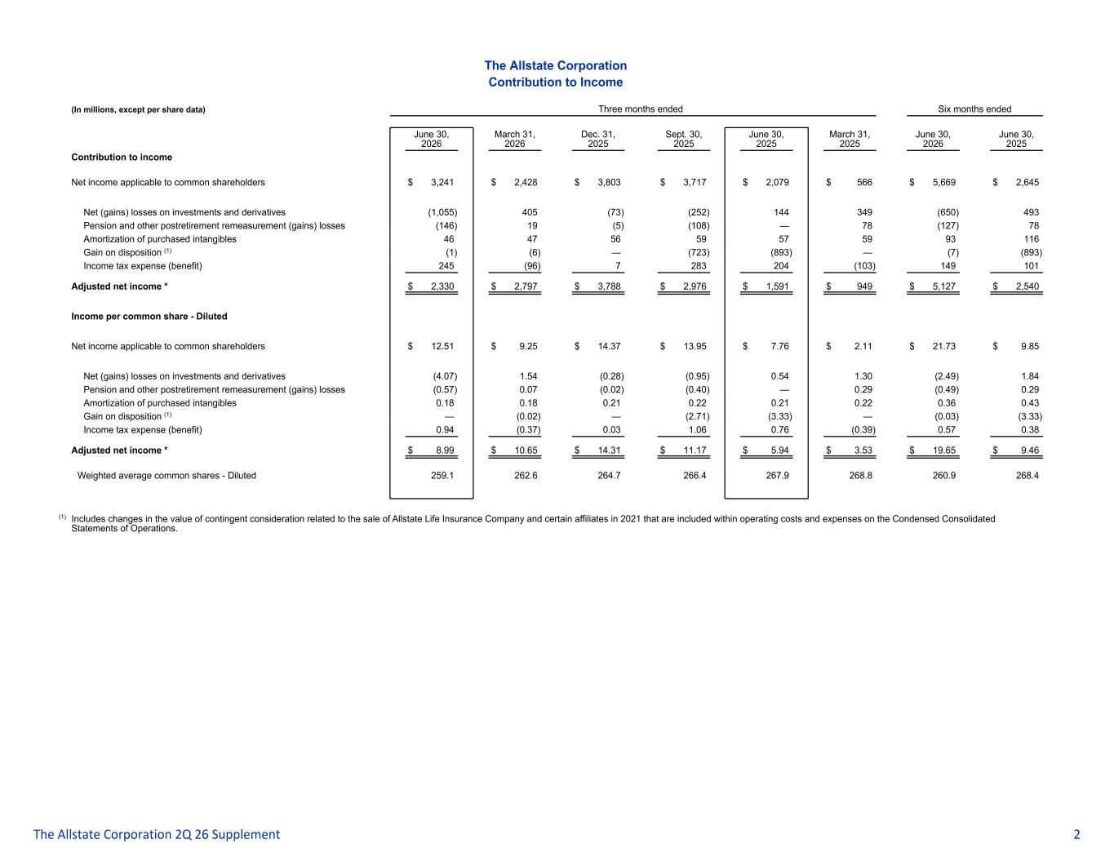
The Allstate Corporation Contribution to Income (In millions, except per share data) Three months ended Six months ended June 30, 2026 March 31, 2026 Dec. 31, 2025 Sept. 30, 2025 June 30, 2025 March 31, 2025 June 30, 2026 June 30, 2025 Contribution to income Net income applicable to common shareholders $ 3,241 $ 2,428 $ 3,803 $ 3,717 $ 2,079 $ 566 $ 5,669 $ 2,645 Net (gains) losses on investments and derivatives (1,055) 405 (73) (252) 144 349 (650) 493 Pension and other postretirement remeasurement (gains) losses (146) 19 (5) (108) — 78 (127) 78 Amortization of purchased intangibles 46 47 56 59 57 59 93 116 Gain on disposition (1) (1) (6) — (723) (893) — (7) (893) Income tax expense (benefit) 245 (96) 7 283 204 (103) 149 101 Adjusted net income * $ 2,330 $ 2,797 $ 3,788 $ 2,976 $ 1,591 $ 949 $ 5,127 $ 2,540 Income per common share - Diluted Net income applicable to common shareholders $ 12.51 $ 9.25 $ 14.37 $ 13.95 $ 7.76 $ 2.11 $ 21.73 $ 9.85 Net (gains) losses on investments and derivatives (4.07) 1.54 (0.28) (0.95) 0.54 1.30 (2.49) 1.84 Pension and other postretirement remeasurement (gains) losses (0.57) 0.07 (0.02) (0.40) — 0.29 (0.49) 0.29 Amortization of purchased intangibles 0.18 0.18 0.21 0.22 0.21 0.22 0.36 0.43 Gain on disposition (1) — (0.02) — (2.71) (3.33) — (0.03) (3.33) Income tax expense (benefit) 0.94 (0.37) 0.03 1.06 0.76 (0.39) 0.57 0.38 Adjusted net income * $ 8.99 $ 10.65 $ 14.31 $ 11.17 $ 5.94 $ 3.53 $ 19.65 $ 9.46 Weighted average common shares - Diluted 259.1 262.6 264.7 266.4 267.9 268.8 260.9 268.4 (1) Includes changes in the value of contingent consideration related to the sale of Allstate Life Insurance Company and certain affiliates in 2021 that are included within operating costs and expenses on the Condensed Consolidated Statements of Operations. The Allstate Corporation 2Q 26 Supplement 2

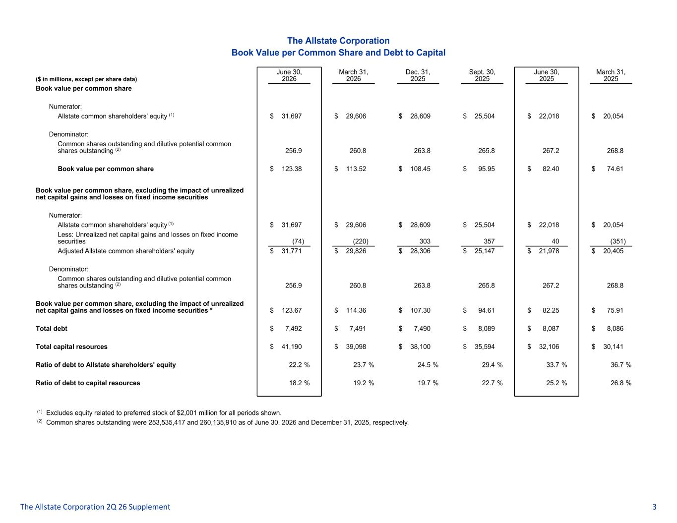
The Allstate Corporation Book Value per Common Share and Debt to Capital ($ in millions, except per share data) June 30, 2026 March 31, 2026 Dec. 31, 2025 Sept. 30, 2025 June 30, 2025 March 31, 2025 Book value per common share Numerator: Allstate common shareholders' equity (1) $ 31,697 $ 29,606 $ 28,609 $ 25,504 $ 22,018 $ 20,054 Denominator: Common shares outstanding and dilutive potential common shares outstanding (2) 256.9 260.8 263.8 265.8 267.2 268.8 Book value per common share $ 123.38 $ 113.52 $ 108.45 $ 95.95 $ 82.40 $ 74.61 Book value per common share, excluding the impact of unrealized net capital gains and losses on fixed income securities Numerator: Allstate common shareholders' equity (1) $ 31,697 $ 29,606 $ 28,609 $ 25,504 $ 22,018 $ 20,054 Less: Unrealized net capital gains and losses on fixed income securities (74) (220) 303 357 40 (351) Adjusted Allstate common shareholders' equity $ 31,771 $ 29,826 $ 28,306 $ 25,147 $ 21,978 $ 20,405 Denominator: Common shares outstanding and dilutive potential common shares outstanding (2) 256.9 260.8 263.8 265.8 267.2 268.8 Book value per common share, excluding the impact of unrealized net capital gains and losses on fixed income securities * $ 123.67 $ 114.36 $ 107.30 $ 94.61 $ 82.25 $ 75.91 Total debt $ 7,492 $ 7,491 $ 7,490 $ 8,089 $ 8,087 $ 8,086 Total capital resources $ 41,190 $ 39,098 $ 38,100 $ 35,594 $ 32,106 $ 30,141 Ratio of debt to Allstate shareholders' equity 22.2 % 23.7 % 24.5 % 29.4 % 33.7 % 36.7 % Ratio of debt to capital resources 18.2 % 19.2 % 19.7 % 22.7 % 25.2 % 26.8 % (1) Excludes equity related to preferred stock of $2,001 million for all periods shown. (2) Common shares outstanding were 253,535,417 and 260,135,910 as of June 30, 2026 and December 31, 2025, respectively. The Allstate Corporation 2Q 26 Supplement 3

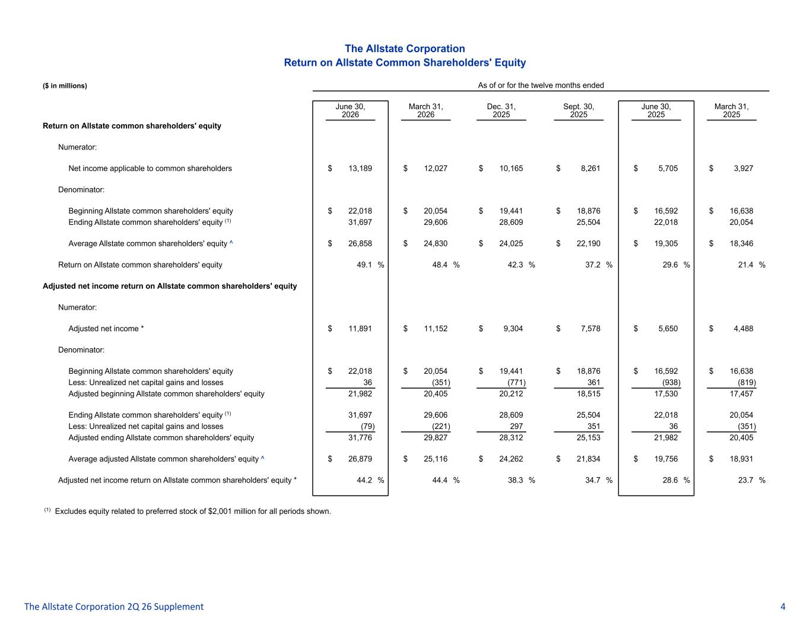
The Allstate Corporation Return on Allstate Common Shareholders' Equity ($ in millions) As of or for the twelve months ended June 30, 2026 March 31, 2026 Dec. 31, 2025 Sept. 30, 2025 June 30, 2025 March 31, 2025 Return on Allstate common shareholders' equity Numerator: Net income applicable to common shareholders $ 13,189 $ 12,027 $ 10,165 $ 8,261 $ 5,705 $ 3,927 Denominator: Beginning Allstate common shareholders' equity $ 22,018 $ 20,054 $ 19,441 $ 18,876 $ 16,592 $ 16,638 Ending Allstate common shareholders' equity (1) 31,697 29,606 28,609 25,504 22,018 20,054 Average Allstate common shareholders' equity ^ $ 26,858 $ 24,830 $ 24,025 $ 22,190 $ 19,305 $ 18,346 Return on Allstate common shareholders' equity 49.1 % 48.4 % 42.3 % 37.2 % 29.6 % 21.4 % Adjusted net income return on Allstate common shareholders' equity Numerator: Adjusted net income * $ 11,891 $ 11,152 $ 9,304 $ 7,578 $ 5,650 $ 4,488 Denominator: Beginning Allstate common shareholders' equity $ 22,018 $ 20,054 $ 19,441 $ 18,876 $ 16,592 $ 16,638 Less: Unrealized net capital gains and losses 36 (351) (771) 361 (938) (819) Adjusted beginning Allstate common shareholders' equity 21,982 20,405 20,212 18,515 17,530 17,457 Ending Allstate common shareholders' equity (1) 31,697 29,606 28,609 25,504 22,018 20,054 Less: Unrealized net capital gains and losses (79) (221) 297 351 36 (351) Adjusted ending Allstate common shareholders' equity 31,776 29,827 28,312 25,153 21,982 20,405 Average adjusted Allstate common shareholders' equity ^ $ 26,879 $ 25,116 $ 24,262 $ 21,834 $ 19,756 $ 18,931 Adjusted net income return on Allstate common shareholders' equity * 44.2 % 44.4 % 38.3 % 34.7 % 28.6 % 23.7 % (1) Excludes equity related to preferred stock of $2,001 million for all periods shown. The Allstate Corporation 2Q 26 Supplement 4

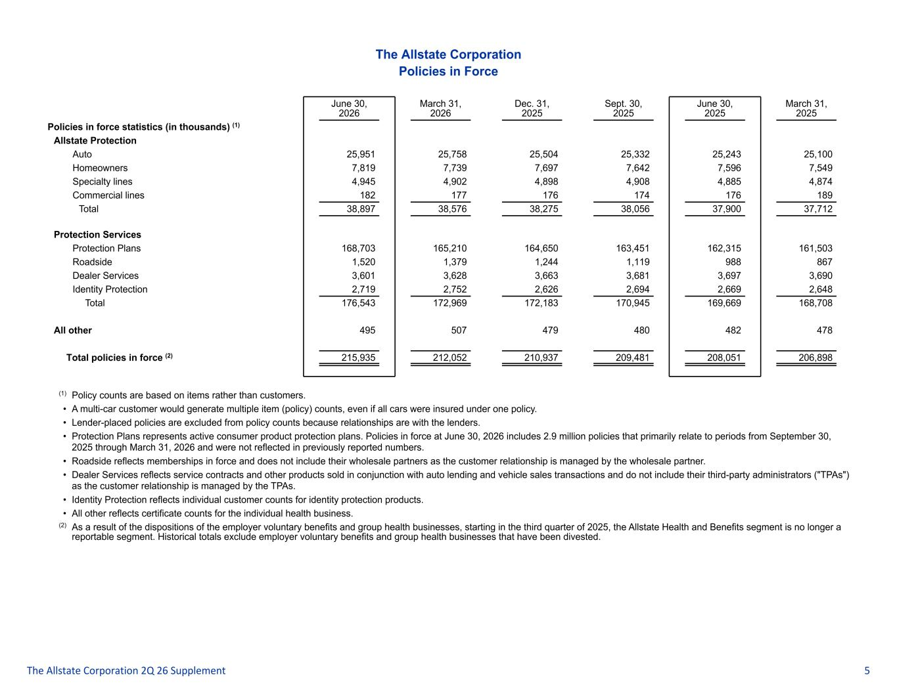
The Allstate Corporation Policies in Force June 30, 2026 March 31, 2026 Dec. 31, 2025 Sept. 30, 2025 June 30, 2025 March 31, 2025 Policies in force statistics (in thousands) (1) Allstate Protection Auto 25,951 25,758 25,504 25,332 25,243 25,100 Homeowners 7,819 7,739 7,697 7,642 7,596 7,549 Specialty lines 4,945 4,902 4,898 4,908 4,885 4,874 Commercial lines 182 177 176 174 176 189 Total 38,897 38,576 38,275 38,056 37,900 37,712 Protection Services Protection Plans 168,703 165,210 164,650 163,451 162,315 161,503 Roadside 1,520 1,379 1,244 1,119 988 867 Dealer Services 3,601 3,628 3,663 3,681 3,697 3,690 Identity Protection 2,719 2,752 2,626 2,694 2,669 2,648 Total 176,543 172,969 172,183 170,945 169,669 168,708 All other 495 507 479 480 482 478 Total policies in force (2) 215,935 212,052 210,937 209,481 208,051 206,898 (1) Policy counts are based on items rather than customers. • A multi-car customer would generate multiple item (policy) counts, even if all cars were insured under one policy. • Lender-placed policies are excluded from policy counts because relationships are with the lenders. • Protection Plans represents active consumer product protection plans. Policies in force at June 30, 2026 includes 2.9 million policies that primarily relate to periods from September 30, 2025 through March 31, 2026 and were not reflected in previously reported numbers. • Roadside reflects memberships in force and does not include their wholesale partners as the customer relationship is managed by the wholesale partner. • Dealer Services reflects service contracts and other products sold in conjunction with auto lending and vehicle sales transactions and do not include their third-party administrators ("TPAs") as the customer relationship is managed by the TPAs. • Identity Protection reflects individual customer counts for identity protection products. • All other reflects certificate counts for the individual health business. (2) As a result of the dispositions of the employer voluntary benefits and group health businesses, starting in the third quarter of 2025, the Allstate Health and Benefits segment is no longer a reportable segment. Historical totals exclude employer voluntary benefits and group health businesses that have been divested. The Allstate Corporation 2Q 26 Supplement 5

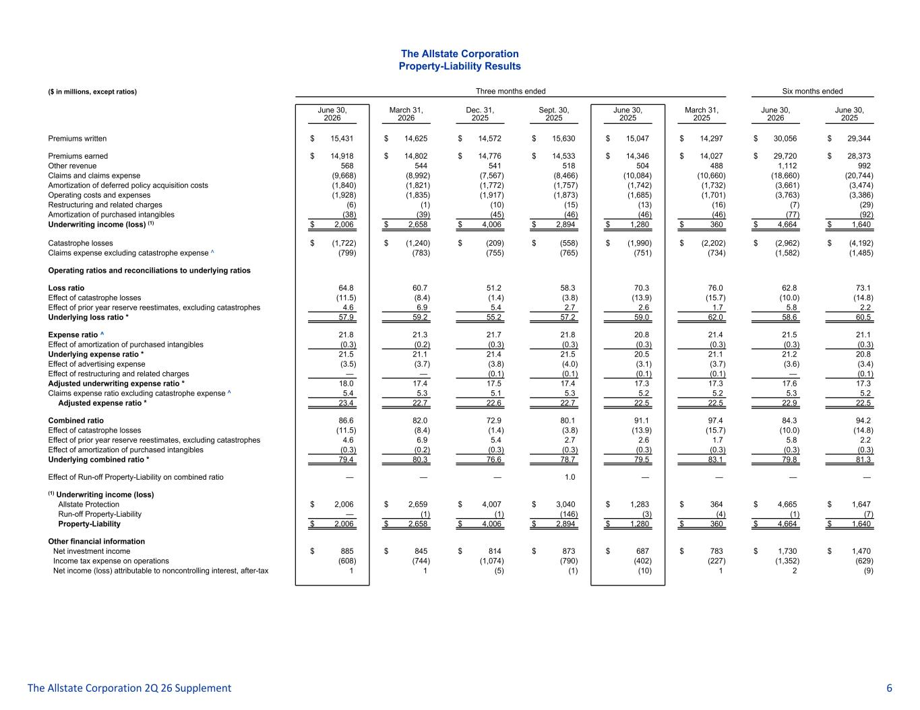
The Allstate Corporation Property-Liability Results ($ in millions, except ratios) Three months ended Six months ended June 30, 2026 March 31, 2026 Dec. 31, 2025 Sept. 30, 2025 June 30, 2025 March 31, 2025 June 30, 2026 June 30, 2025 Premiums written $ 15,431 $ 14,625 $ 14,572 $ 15,630 $ 15,047 $ 14,297 $ 30,056 $ 29,344 Premiums earned $ 14,918 $ 14,802 $ 14,776 $ 14,533 $ 14,346 $ 14,027 $ 29,720 $ 28,373 Other revenue 568 544 541 518 504 488 1,112 992 Claims and claims expense (9,668) (8,992) (7,567) (8,466) (10,084) (10,660) (18,660) (20,744) Amortization of deferred policy acquisition costs (1,840) (1,821) (1,772) (1,757) (1,742) (1,732) (3,661) (3,474) Operating costs and expenses (1,928) (1,835) (1,917) (1,873) (1,685) (1,701) (3,763) (3,386) Restructuring and related charges (6) (1) (10) (15) (13) (16) (7) (29) Amortization of purchased intangibles (38) (39) (45) (46) (46) (46) (77) (92) Underwriting income (loss) (1) $ 2,006 $ 2,658 $ 4,006 $ 2,894 $ 1,280 $ 360 $ 4,664 $ 1,640 Catastrophe losses $ (1,722) $ (1,240) $ (209) $ (558) $ (1,990) $ (2,202) $ (2,962) $ (4,192) Claims expense excluding catastrophe expense ^ (799) (783) (755) (765) (751) (734) (1,582) (1,485) Operating ratios and reconciliations to underlying ratios Loss ratio 64.8 60.7 51.2 58.3 70.3 76.0 62.8 73.1 Effect of catastrophe losses (11.5) (8.4) (1.4) (3.8) (13.9) (15.7) (10.0) (14.8) Effect of prior year reserve reestimates, excluding catastrophes 4.6 6.9 5.4 2.7 2.6 1.7 5.8 2.2 Underlying loss ratio * 57.9 59.2 55.2 57.2 59.0 62.0 58.6 60.5 Expense ratio ^ 21.8 21.3 21.7 21.8 20.8 21.4 21.5 21.1 Effect of amortization of purchased intangibles (0.3) (0.2) (0.3) (0.3) (0.3) (0.3) (0.3) (0.3) Underlying expense ratio * 21.5 21.1 21.4 21.5 20.5 21.1 21.2 20.8 Effect of advertising expense (3.5) (3.7) (3.8) (4.0) (3.1) (3.7) (3.6) (3.4) Effect of restructuring and related charges — — (0.1) (0.1) (0.1) (0.1) — (0.1) Adjusted underwriting expense ratio * 18.0 17.4 17.5 17.4 17.3 17.3 17.6 17.3 Claims expense ratio excluding catastrophe expense ^ 5.4 5.3 5.1 5.3 5.2 5.2 5.3 5.2 Adjusted expense ratio * 23.4 22.7 22.6 22.7 22.5 22.5 22.9 22.5 Combined ratio 86.6 82.0 72.9 80.1 91.1 97.4 84.3 94.2 Effect of catastrophe losses (11.5) (8.4) (1.4) (3.8) (13.9) (15.7) (10.0) (14.8) Effect of prior year reserve reestimates, excluding catastrophes 4.6 6.9 5.4 2.7 2.6 1.7 5.8 2.2 Effect of amortization of purchased intangibles (0.3) (0.2) (0.3) (0.3) (0.3) (0.3) (0.3) (0.3) Underlying combined ratio * 79.4 80.3 76.6 78.7 79.5 83.1 79.8 81.3 Effect of Run-off Property-Liability on combined ratio — — — 1.0 — — — — (1) Underwriting income (loss) Allstate Protection $ 2,006 $ 2,659 $ 4,007 $ 3,040 $ 1,283 $ 364 $ 4,665 $ 1,647 Run-off Property-Liability — (1) (1) (146) (3) (4) (1) (7) Property-Liability $ 2,006 $ 2,658 $ 4,006 $ 2,894 $ 1,280 $ 360 $ 4,664 $ 1,640 Other financial information Net investment income $ 885 $ 845 $ 814 $ 873 $ 687 $ 783 $ 1,730 $ 1,470 Income tax expense on operations (608) (744) (1,074) (790) (402) (227) (1,352) (629) Net income (loss) attributable to noncontrolling interest, after-tax 1 1 (5) (1) (10) 1 2 (9) The Allstate Corporation 2Q 26 Supplement 6

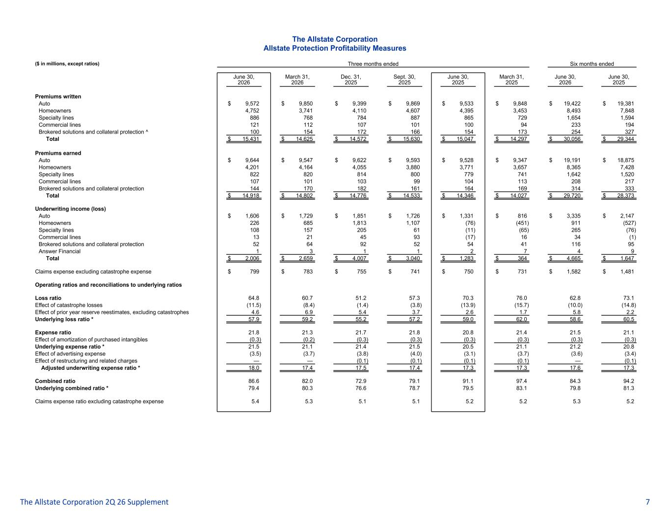
The Allstate Corporation Allstate Protection Profitability Measures ($ in millions, except ratios) Three months ended Six months ended June 30, 2026 March 31, 2026 Dec. 31, 2025 Sept. 30, 2025 June 30, 2025 March 31, 2025 June 30, 2026 June 30, 2025 Premiums written Auto $ 9,572 $ 9,850 $ 9,399 $ 9,869 $ 9,533 $ 9,848 $ 19,422 $ 19,381 Homeowners 4,752 3,741 4,110 4,607 4,395 3,453 8,493 7,848 Specialty lines 886 768 784 887 865 729 1,654 1,594 Commercial lines 121 112 107 101 100 94 233 194 Brokered solutions and collateral protection ^ 100 154 172 166 154 173 254 327 Total $ 15,431 $ 14,625 $ 14,572 $ 15,630 $ 15,047 $ 14,297 $ 30,056 $ 29,344 Premiums earned Auto $ 9,644 $ 9,547 $ 9,622 $ 9,593 $ 9,528 $ 9,347 $ 19,191 $ 18,875 Homeowners 4,201 4,164 4,055 3,880 3,771 3,657 8,365 7,428 Specialty lines 822 820 814 800 779 741 1,642 1,520 Commercial lines 107 101 103 99 104 113 208 217 Brokered solutions and collateral protection 144 170 182 161 164 169 314 333 Total $ 14,918 $ 14,802 $ 14,776 $ 14,533 $ 14,346 $ 14,027 $ 29,720 $ 28,373 Underwriting income (loss) Auto $ 1,606 $ 1,729 $ 1,851 $ 1,726 $ 1,331 $ 816 $ 3,335 $ 2,147 Homeowners 226 685 1,813 1,107 (76) (451) 911 (527) Specialty lines 108 157 205 61 (11) (65) 265 (76) Commercial lines 13 21 45 93 (17) 16 34 (1) Brokered solutions and collateral protection 52 64 92 52 54 41 116 95 Answer Financial 1 3 1 1 2 7 4 9 $ 2,006 $ 2,659 $ 4,007 $ 3,040 $ 1,283 $ 364 $ 4,665 $ 1,647 $ 799 $ 783 $ 755 $ 741 $ 750 $ 731 $ 1,582 $ 1,481 64.8 60.7 51.2 57.3 70.3 76.0 62.8 73.1 (11.5) (8.4) (1.4) (3.8) (13.9) (15.7) (10.0) (14.8) 4.6 6.9 5.4 3.7 2.6 1.7 5.8 2.2 57.9 59.2 55.2 57.2 59.0 62.0 58.6 60.5 21.8 21.3 21.7 21.8 20.8 21.4 21.5 21.1 (0.3) (0.2) (0.3) (0.3) (0.3) (0.3) (0.3) (0.3) 21.5 21.1 21.4 21.5 20.5 21.1 21.2 20.8 (3.5) (3.7) (3.8) (4.0) (3.1) (3.7) (3.6) (3.4) — — (0.1) (0.1) (0.1) (0.1) — (0.1) 18.0 17.4 17.5 17.4 17.3 17.3 17.6 17.3 86.6 82.0 72.9 79.1 91.1 97.4 84.3 94.2 79.4 80.3 76.6 78.7 79.5 83.1 79.8 81.3 Total Claims expense excluding catastrophe expense Operating ratios and reconciliations to underlying ratios Loss ratio Effect of catastrophe losses Effect of prior year reserve reestimates, excluding catastrophes Underlying loss ratio * Expense ratio Effect of amortization of purchased intangibles Underlying expense ratio * Effect of advertising expense Effect of restructuring and related charges Adjusted underwriting expense ratio * Combined ratio Underlying combined ratio * Claims expense ratio excluding catastrophe expense 5.4 5.3 5.1 5.1 5.2 5.2 5.3 5.2 The Allstate Corporation 2Q 26 Supplement 7

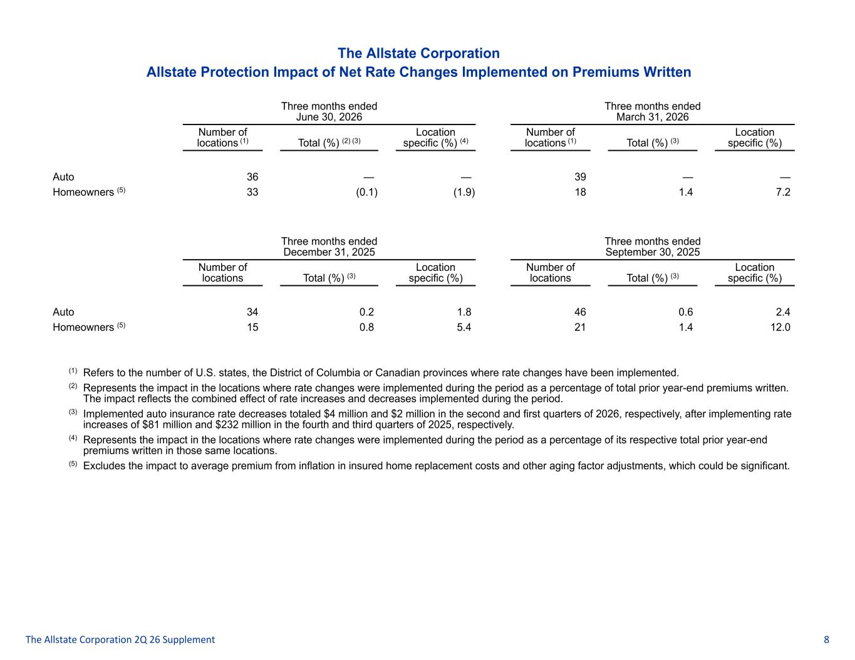
The Allstate Corporation Allstate Protection Impact of Net Rate Changes Implemented on Premiums Written Three months ended June 30, 2026 Three months ended March 31, 2026 Number of locations (1) Total (%) (2) (3) Location specific (%) (4) Number of locations (1) Total (%) (3) Location specific (%) Auto 36 — — 39 — — Homeowners (5) 33 (0.1) (1.9) 18 1.4 7.2 Three months ended December 31, 2025 Three months ended September 30, 2025 Number of locations Total (%) (3) Location specific (%) Number of locations Total (%) (3) Location specific (%) Auto 34 0.2 1.8 46 0.6 2.4 Homeowners (5) 15 0.8 5.4 21 1.4 12.0 (1) Refers to the number of U.S. states, the District of Columbia or Canadian provinces where rate changes have been implemented. (2) Represents the impact in the locations where rate changes were implemented during the period as a percentage of total prior year-end premiums written. The impact reflects the combined effect of rate increases and decreases implemented during the period. (3) Implemented auto insurance rate decreases totaled $4 million and $2 million in the second and first quarters of 2026, respectively, after implementing rate increases of $81 million and $232 million in the fourth and third quarters of 2025, respectively. (4) Represents the impact in the locations where rate changes were implemented during the period as a percentage of its respective total prior year-end premiums written in those same locations. (5) Excludes the impact to average premium from inflation in insured home replacement costs and other aging factor adjustments, which could be significant. The Allstate Corporation 2Q 26 Supplement 8

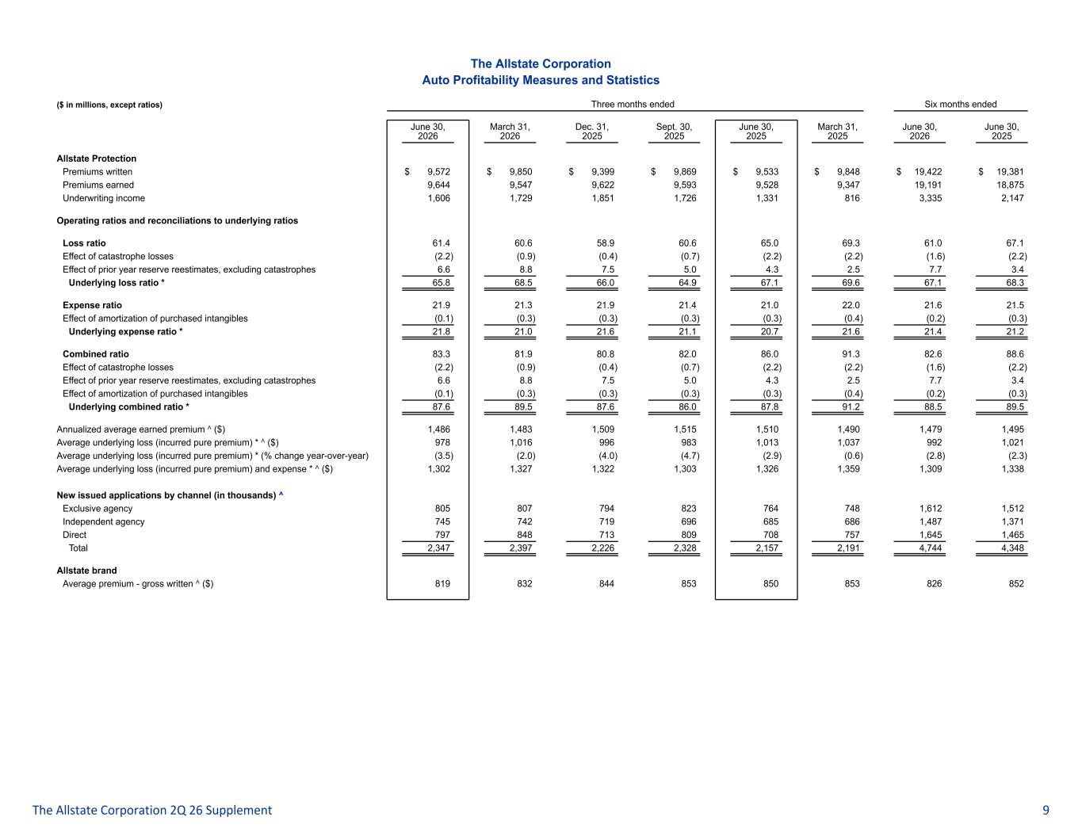
The Allstate Corporation Auto Profitability Measures and Statistics ($ in millions, except ratios) Three months ended Six months ended June 30, 2026 March 31, 2026 Dec. 31, 2025 Sept. 30, 2025 June 30, 2025 March 31, 2025 June 30, 2026 June 30, 2025 Allstate Protection Premiums written $ 9,572 $ 9,850 $ 9,399 $ 9,869 $ 9,533 $ 9,848 $ 19,422 $ 19,381 Premiums earned 9,644 9,547 9,622 9,593 9,528 9,347 19,191 18,875 Underwriting income 1,606 1,729 1,851 1,726 1,331 816 3,335 2,147 Operating ratios and reconciliations to underlying ratios Loss ratio 61.4 60.6 58.9 60.6 65.0 69.3 61.0 67.1 Effect of catastrophe losses (2.2) (0.9) (0.4) (0.7) (2.2) (2.2) (1.6) (2.2) Effect of prior year reserve reestimates, excluding catastrophes 6.6 8.8 7.5 5.0 4.3 2.5 7.7 3.4 Underlying loss ratio * 65.8 68.5 66.0 64.9 67.1 69.6 67.1 68.3 Expense ratio 21.9 21.3 21.9 21.4 21.0 22.0 21.6 21.5 Effect of amortization of purchased intangibles (0.1) (0.3) (0.3) (0.3) (0.3) (0.4) (0.2) (0.3) Underlying expense ratio * 21.8 21.0 21.6 21.1 20.7 21.6 21.4 21.2 Combined ratio 83.3 81.9 80.8 82.0 86.0 91.3 82.6 88.6 Effect of catastrophe losses (2.2) (0.9) (0.4) (0.7) (2.2) (2.2) (1.6) (2.2) Effect of prior year reserve reestimates, excluding catastrophes 6.6 8.8 7.5 5.0 4.3 2.5 7.7 3.4 Effect of amortization of purchased intangibles (0.1) (0.3) (0.3) (0.3) (0.3) (0.4) (0.2) (0.3) Underlying combined ratio * 87.6 89.5 87.6 86.0 87.8 91.2 88.5 89.5 Annualized average earned premium ^ ($) 1,486 1,483 1,509 1,515 1,510 1,490 1,479 1,495 Average underlying loss (incurred pure premium) * ^ ($) 978 1,016 996 983 1,013 1,037 992 1,021 Average underlying loss (incurred pure premium) * (% change year-over-year) (3.5) (2.0) (4.0) (4.7) (2.9) (0.6) (2.8) (2.3) Average underlying loss (incurred pure premium) and expense * ^ ($) 1,302 1,327 1,322 1,303 1,326 1,359 1,309 1,338 New issued applications by channel (in thousands) ^ Exclusive agency 805 807 794 823 764 748 1,612 1,512 Independent agency 745 742 719 696 685 686 1,487 1,371 Direct 797 848 713 809 708 757 1,645 1,465 Total 2,347 2,397 2,226 2,328 2,157 2,191 4,744 4,348 Allstate brand Average premium - gross written ^ ($) 819 832 844 853 850 853 826 852 The Allstate Corporation 2Q 26 Supplement 9

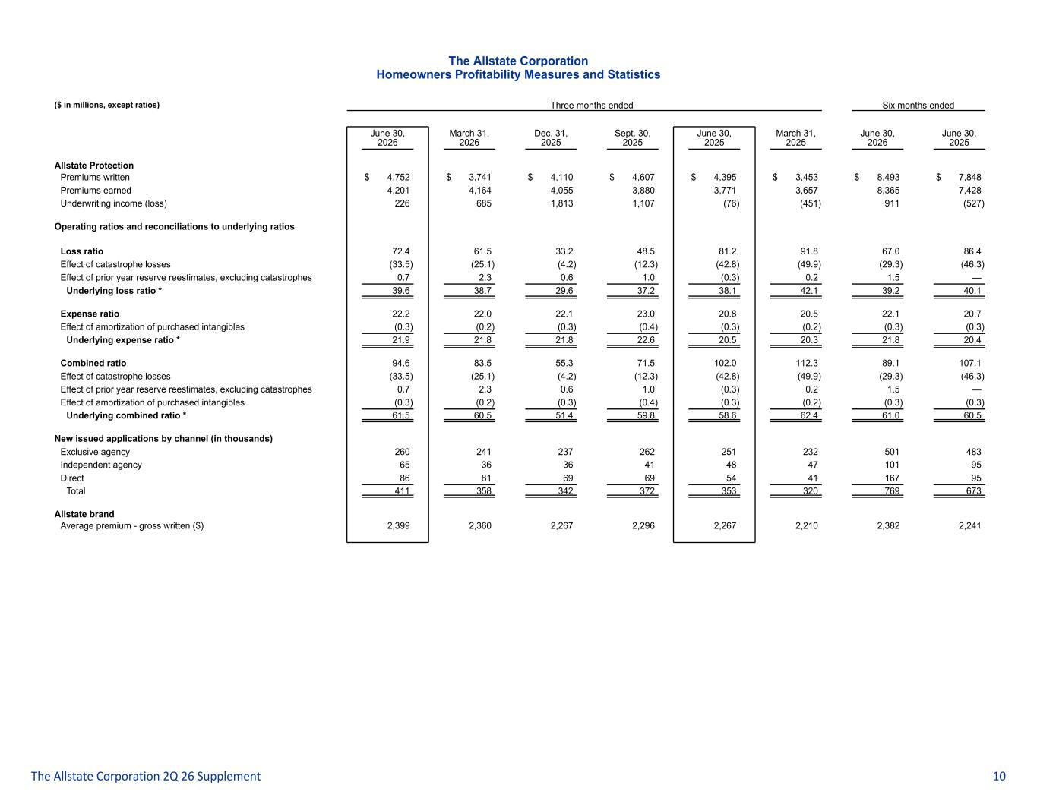
The Allstate Corporation Homeowners Profitability Measures and Statistics ($ in millions, except ratios) Three months ended Six months ended June 30, 2026 March 31, 2026 Dec. 31, 2025 Sept. 30, 2025 June 30, 2025 March 31, 2025 June 30, 2026 June 30, 2025 Allstate Protection Premiums written $ 4,752 $ 3,741 $ 4,110 $ 4,607 $ 4,395 $ 3,453 $ 8,493 $ 7,848 Premiums earned 4,201 4,164 4,055 3,880 3,771 3,657 8,365 7,428 Underwriting income (loss) 226 685 1,813 1,107 (76) (451) 911 (527) Operating ratios and reconciliations to underlying ratios Loss ratio 72.4 61.5 33.2 48.5 81.2 91.8 67.0 86.4 Effect of catastrophe losses (33.5) (25.1) (4.2) (12.3) (42.8) (49.9) (29.3) (46.3) Effect of prior year reserve reestimates, excluding catastrophes 0.7 2.3 0.6 1.0 (0.3) 0.2 1.5 — Underlying loss ratio * 39.6 38.7 29.6 37.2 38.1 42.1 39.2 40.1 Expense ratio 22.2 22.0 22.1 23.0 20.8 20.5 22.1 20.7 Effect of amortization of purchased intangibles (0.3) (0.2) (0.3) (0.4) (0.3) (0.2) (0.3) (0.3) Underlying expense ratio * 21.9 21.8 21.8 22.6 20.5 20.3 21.8 20.4 Combined ratio 94.6 83.5 55.3 71.5 102.0 112.3 89.1 107.1 Effect of catastrophe losses (33.5) (25.1) (4.2) (12.3) (42.8) (49.9) (29.3) (46.3) Effect of prior year reserve reestimates, excluding catastrophes 0.7 2.3 0.6 1.0 (0.3) 0.2 1.5 — Effect of amortization of purchased intangibles (0.3) (0.2) (0.3) (0.4) (0.3) (0.2) (0.3) (0.3) Underlying combined ratio * 61.5 60.5 51.4 59.8 58.6 62.4 61.0 60.5 New issued applications by channel (in thousands) Exclusive agency 260 241 237 262 251 232 501 483 Independent agency 65 36 36 41 48 47 101 95 Direct 86 81 69 69 54 41 167 95 Total 411 358 342 372 353 320 769 673 Allstate brand Average premium - gross written ($) 2,399 2,360 2,267 2,296 2,267 2,210 2,382 2,241 The Allstate Corporation 2Q 26 Supplement 10

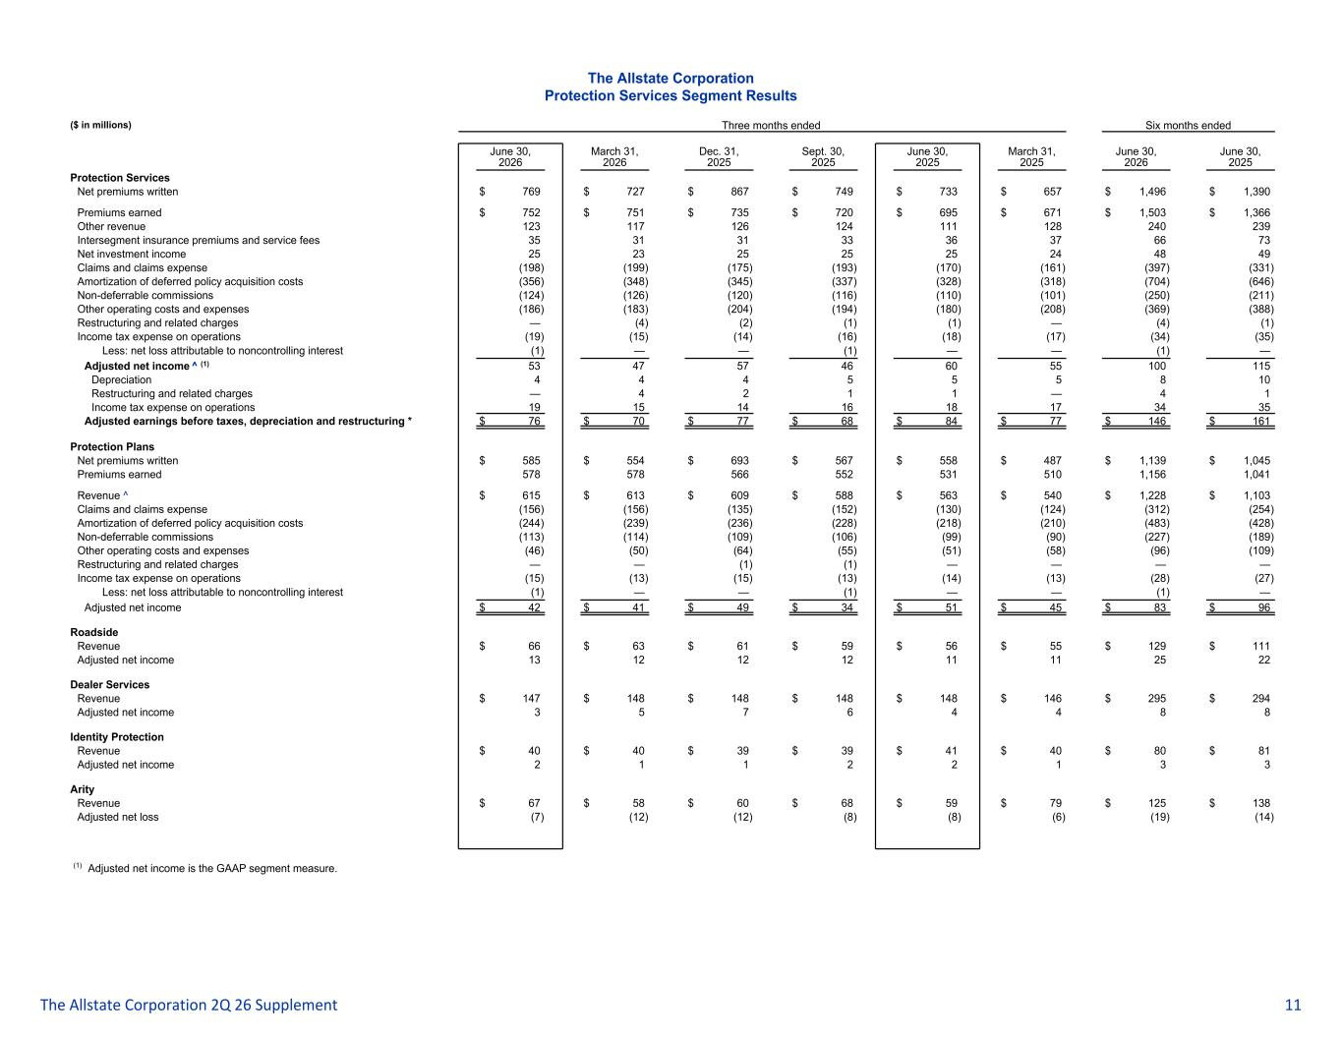
The Allstate Corporation Protection Services Segment Results ($ in millions) Three months ended Six months ended June 30, 2026 March 31, 2026 Dec. 31, 2025 Sept. 30, 2025 June 30, 2025 March 31, 2025 June 30, 2026 June 30, 2025 Protection Services Net premiums written $ 769 $ 727 $ 867 $ 749 $ 733 $ 657 $ 1,496 $ 1,390 Premiums earned $ 752 $ 751 $ 735 $ 720 $ 695 $ 671 $ 1,503 $ 1,366 Other revenue 123 117 126 124 111 128 240 239 Intersegment insurance premiums and service fees 35 31 31 33 36 37 66 73 Net investment income 25 23 25 25 25 24 48 49 Claims and claims expense (198) (199) (175) (193) (170) (161) (397) (331) Amortization of deferred policy acquisition costs (356) (348) (345) (337) (328) (318) (704) (646) Non-deferrable commissions (124) (126) (120) (116) (110) (101) (250) (211) Other operating costs and expenses (186) (183) (204) (194) (180) (208) (369) (388) Restructuring and related charges — (4) (2) (1) (1) — (4) (1) Income tax expense on operations (19) (15) (14) (16) (18) (17) (34) (35) Less: net loss attributable to noncontrolling interest (1) — — (1) — — (1) — Adjusted net income ^ (1) 53 47 57 46 60 55 100 115 Depreciation 4 4 4 5 5 5 8 10 Restructuring and related charges — 4 2 1 1 — 4 1 Income tax expense on operations 19 15 14 16 18 17 34 35 Adjusted earnings before taxes, depreciation and restructuring * $ 76 $ 70 $ 77 $ 68 $ 84 $ 77 $ 146 $ 161 Protection Plans Net premiums written $ 585 $ 554 $ 693 $ 567 $ 558 $ 487 $ 1,139 $ 1,045 Premiums earned 578 578 566 552 531 510 1,156 1,041 Revenue ^ $ 615 $ 613 $ 609 $ 588 $ 563 $ 540 $ 1,228 $ 1,103 Claims and claims expense (156) (156) (135) (152) (130) (124) (312) (254) Amortization of deferred policy acquisition costs (244) (239) (236) (228) (218) (210) (483) (428) Non-deferrable commissions (113) (114) (109) (106) (99) (90) (227) (189) Other operating costs and expenses (46) (50) (64) (55) (51) (58) (96) (109) Restructuring and related charges — — (1) (1) — — — — Income tax expense on operations (15) (13) (15) (13) (14) (13) (28) (27) Less: net loss attributable to noncontrolling interest (1) — — (1) — — (1) — Adjusted net income $ 42 $ 41 $ 49 $ 34 $ 51 $ 45 $ 83 $ 96 Roadside Revenue $ 66 $ 63 $ 61 $ 59 $ 56 $ 55 $ 129 $ 111 Adjusted net income 13 12 12 12 11 11 25 22 Dealer Services Revenue $ 147 $ 148 $ 148 $ 148 $ 148 $ 146 $ 295 $ 294 Adjusted net income 3 5 7 6 4 4 8 8 Identity Protection Revenue $ 40 $ 40 $ 39 $ 39 $ 41 $ 40 $ 80 $ 81 Adjusted net income 2 1 1 2 2 1 3 3 Arity Revenue $ 67 $ 58 $ 60 $ 68 $ 59 $ 79 $ 125 $ 138 Adjusted net loss (7) (12) (12) (8) (8) (6) (19) (14) (1) Adjusted net income is the GAAP segment measure. The Allstate Corporation 2Q 26 Supplement 11

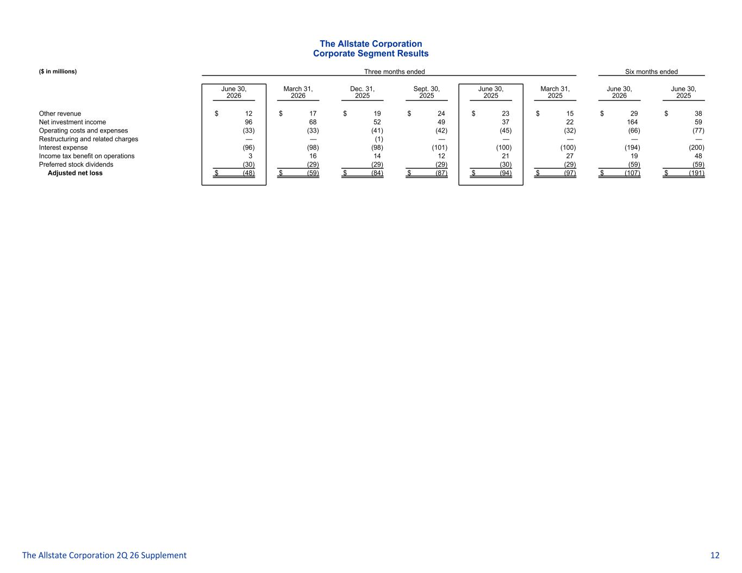
The Allstate Corporation Corporate Segment Results ($ in millions) Three months ended Six months ended June 30, 2026 March 31, 2026 Dec. 31, 2025 Sept. 30, 2025 June 30, 2025 March 31, 2025 June 30, 2026 June 30, 2025 Other revenue $ 12 $ 17 $ 19 $ 24 $ 23 $ 15 $ 29 $ 38 Net investment income 96 68 52 49 37 22 164 59 Operating costs and expenses (33) (33) (41) (42) (45) (32) (66) (77) Restructuring and related charges — — (1) — — — — — Interest expense (96) (98) (98) (101) (100) (100) (194) (200) Income tax benefit on operations 3 16 14 12 21 27 19 48 Preferred stock dividends (30) (29) (29) (29) (30) (29) (59) (59) Adjusted net loss $ (48) $ (59) $ (84) $ (87) $ (94) $ (97) $ (107) $ (191) The Allstate Corporation 2Q 26 Supplement 12

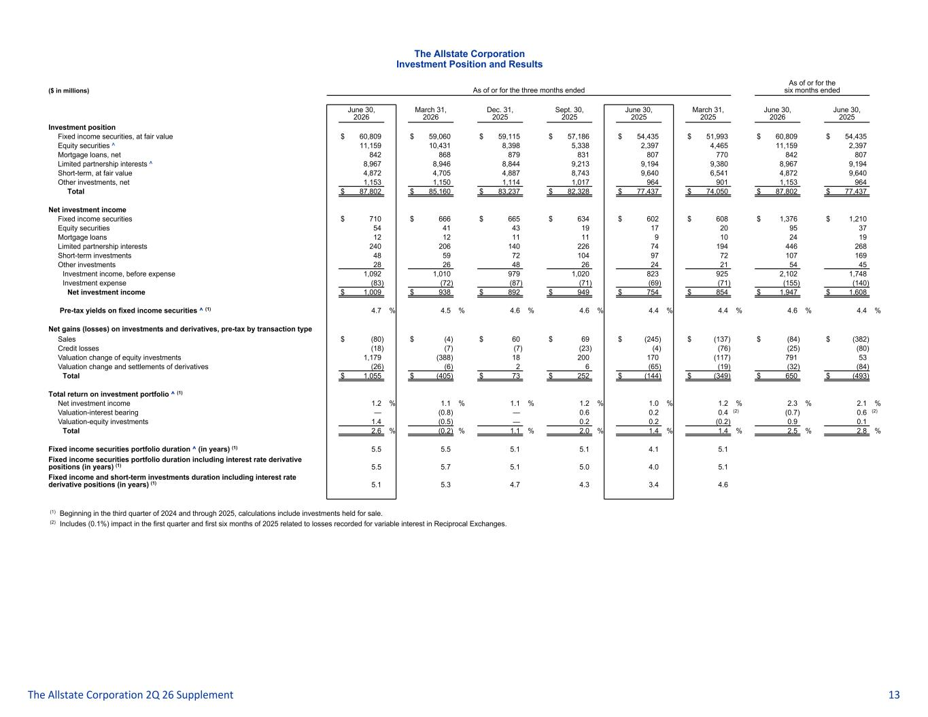
The Allstate Corporation Investment Position and Results ($ in millions) As of or for the three months ended As of or for the six months ended June 30, 2026 March 31, 2026 Dec. 31, 2025 Sept. 30, 2025 June 30, 2025 March 31, 2025 June 30, 2026 June 30, 2025 Investment position Fixed income securities, at fair value $ 60,809 $ 59,060 $ 59,115 $ 57,186 $ 54,435 $ 51,993 $ 60,809 $ 54,435 Equity securities ^ 11,159 10,431 8,398 5,338 2,397 4,465 11,159 2,397 Mortgage loans, net 842 868 879 831 807 770 842 807 Limited partnership interests ^ 8,967 8,946 8,844 9,213 9,194 9,380 8,967 9,194 Short-term, at fair value 4,872 4,705 4,887 8,743 9,640 6,541 4,872 9,640 Other investments, net 1,153 1,150 1,114 1,017 964 901 1,153 964 Total $ 87,802 $ 85,160 $ 83,237 $ 82,328 $ 77,437 $ 74,050 $ 87,802 $ 77,437 Net investment income Fixed income securities $ 710 $ 666 $ 665 $ 634 $ 602 $ 608 $ 1,376 $ 1,210 Equity securities 54 41 43 19 17 20 95 37 Mortgage loans 12 12 11 11 9 10 24 19 Limited partnership interests 240 206 140 226 74 194 446 268 Short-term investments 48 59 72 104 97 72 107 169 Other investments 28 26 48 26 24 21 54 45 Investment income, before expense 1,092 1,010 979 1,020 823 925 2,102 1,748 Investment expense (83) (72) (87) (71) (69) (71) (155) (140) Net investment income $ 1,009 $ 938 $ 892 $ 949 $ 754 $ 854 $ 1,947 $ 1,608 Pre-tax yields on fixed income securities ^ (1) 4.7 % 4.5 % 4.6 % 4.6 % 4.4 % 4.4 % 4.6 % 4.4 % Net gains (losses) on investments and derivatives, pre-tax by transaction type Sales $ (80) $ (4) $ 60 $ 69 $ (245) $ (137) $ (84) $ (382) Credit losses (18) (7) (7) (23) (4) (76) (25) (80) Valuation change of equity investments 1,179 (388) 18 200 170 (117) 791 53 Valuation change and settlements of derivatives (26) (6) 2 6 (65) (19) (32) (84) Total $ 1,055 $ (405) $ 73 $ 252 $ (144) $ (349) $ 650 $ (493) Total return on investment portfolio ^ (1) Net investment income 1.2 % 1.1 % 1.1 % 1.2 % 1.0 % 1.2 % 2.3 % 2.1 % Valuation-interest bearing — (0.8) — 0.6 0.2 0.4 (2) (0.7) 0.6 (2) Valuation-equity investments 1.4 (0.5) — 0.2 0.2 (0.2) 0.9 0.1 Total 2.6 % (0.2) % 1.1 % 2.0 % 1.4 % 1.4 % 2.5 % 2.8 % Fixed income securities portfolio duration ^ (in years) (1) 5.5 5.5 5.1 5.1 4.1 5.1 Fixed income securities portfolio duration including interest rate derivative positions (in years) (1) 5.5 5.7 5.1 5.0 4.0 5.1 Fixed income and short-term investments duration including interest rate derivative positions (in years) (1) 5.1 5.3 4.7 4.3 3.4 4.6 (1) Beginning in the third quarter of 2024 and through 2025, calculations include investments held for sale. (2) Includes (0.1%) impact in the first quarter and first six months of 2025 related to losses recorded for variable interest in Reciprocal Exchanges. The Allstate Corporation 2Q 26 Supplement 13

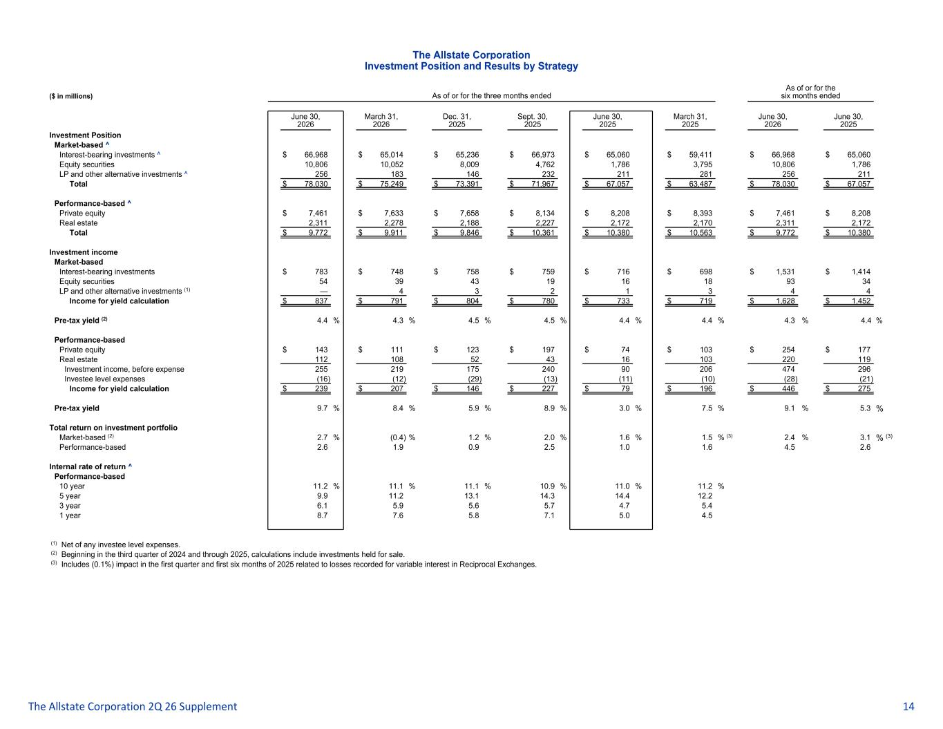
The Allstate Corporation Investment Position and Results by Strategy ($ in millions) As of or for the three months ended As of or for the six months ended June 30, 2026 March 31, 2026 Dec. 31, 2025 Sept. 30, 2025 June 30, 2025 March 31, 2025 June 30, 2026 June 30, 2025 Investment Position Market-based ^ Interest-bearing investments ^ $ 66,968 $ 65,014 $ 65,236 $ 66,973 $ 65,060 $ 59,411 $ 66,968 $ 65,060 Equity securities 10,806 10,052 8,009 4,762 1,786 3,795 10,806 1,786 LP and other alternative investments ^ 256 183 146 232 211 281 256 211 Total $ 78,030 $ 75,249 $ 73,391 $ 71,967 $ 67,057 $ 63,487 $ 78,030 $ 67,057 Performance-based ^ Private equity $ 7,461 $ 7,633 $ 7,658 $ 8,134 $ 8,208 $ 8,393 $ 7,461 $ 8,208 Real estate 2,311 2,278 2,188 2,227 2,172 2,170 2,311 2,172 Total $ 9,772 $ 9,911 $ 9,846 $ 10,361 $ 10,380 $ 10,563 $ 9,772 $ 10,380 Investment income Market-based Interest-bearing investments $ 783 $ 748 $ 758 $ 759 $ 716 $ 698 $ 1,531 $ 1,414 Equity securities 54 39 43 19 16 18 93 34 LP and other alternative investments (1) — 4 3 2 1 3 4 4 Income for yield calculation $ 837 $ 791 $ 804 $ 780 $ 733 $ 719 $ 1,628 $ 1,452 Pre-tax yield (2) 4.4 % 4.3 % 4.5 % 4.5 % 4.4 % 4.4 % 4.3 % 4.4 % Performance-based Private equity $ 143 $ 111 $ 123 $ 197 $ 74 $ 103 $ 254 $ 177 Real estate 112 108 52 43 16 103 220 119 Investment income, before expense 255 219 175 240 90 206 474 296 Investee level expenses (16) (12) (29) (13) (11) (10) (28) (21) Income for yield calculation $ 239 $ 207 $ 146 $ 227 $ 79 $ 196 $ 446 $ 275 Pre-tax yield 9.7 % 8.4 % 5.9 % 8.9 % 3.0 % 7.5 % 9.1 % 5.3 % Total return on investment portfolio Market-based (2) 2.7 % (0.4) % 1.2 % 2.0 % 1.6 % 1.5 % (3) 2.4 % 3.1 % (3) Performance-based 2.6 1.9 0.9 2.5 1.0 1.6 4.5 2.6 Internal rate of return ^ Performance-based 10 year 11.2 % 11.1 % 11.1 % 10.9 % 11.0 % 11.2 % 5 year 9.9 11.2 13.1 14.3 14.4 12.2 3 year 6.1 5.9 5.6 5.7 4.7 5.4 1 year 8.7 7.6 5.8 7.1 5.0 4.5 (1) Net of any investee level expenses. (2) Beginning in the third quarter of 2024 and through 2025, calculations include investments held for sale. (3) Includes (0.1%) impact in the first quarter and first six months of 2025 related to losses recorded for variable interest in Reciprocal Exchanges. The Allstate Corporation 2Q 26 Supplement 14

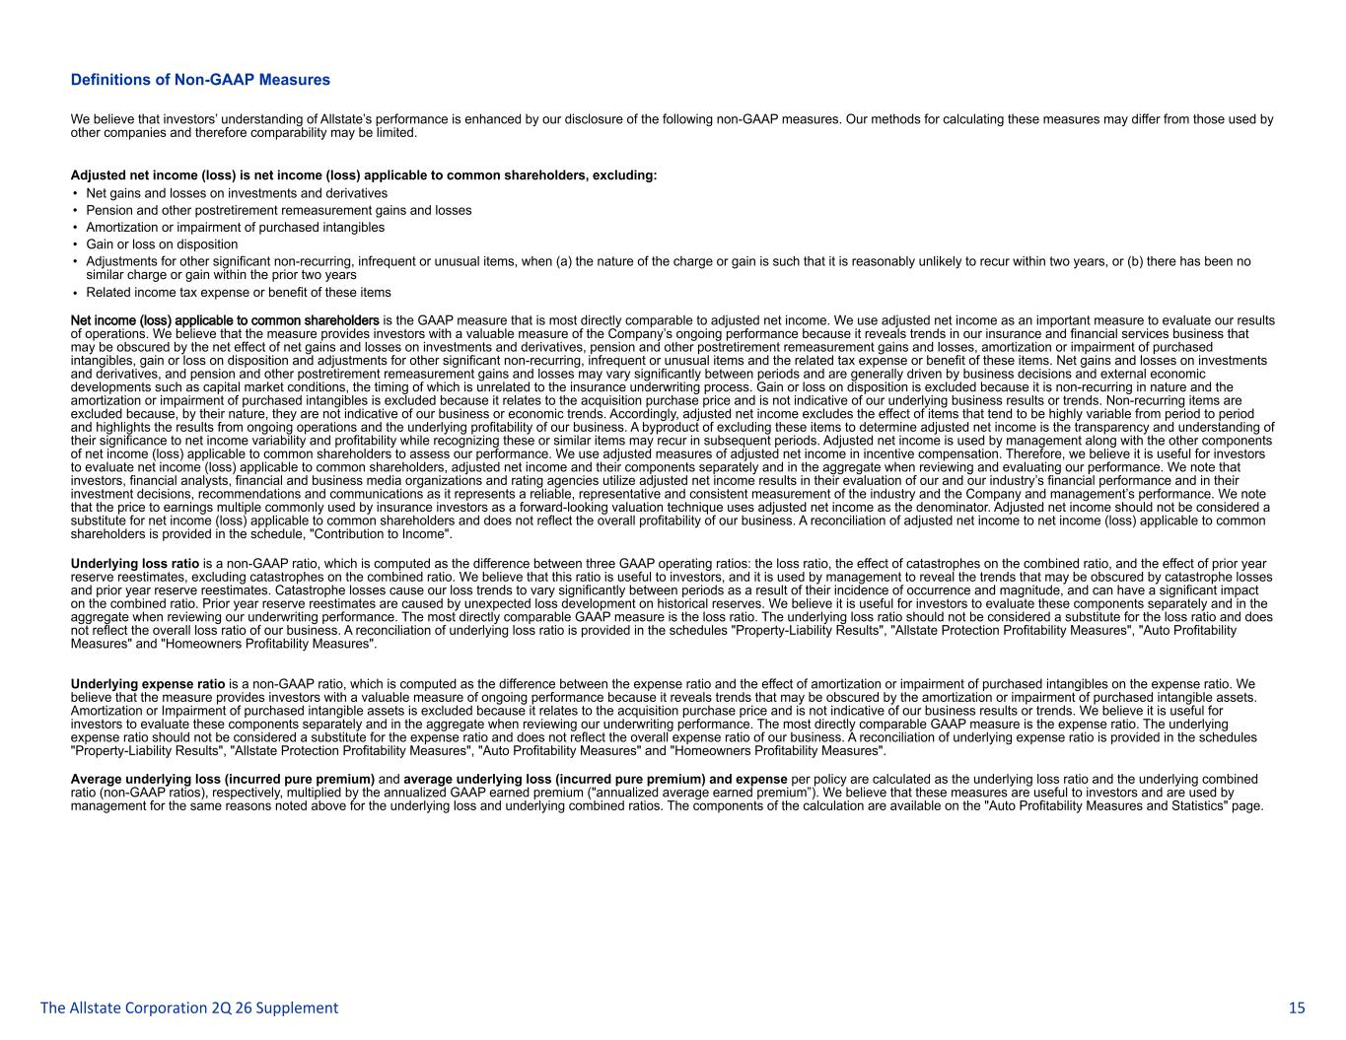
Definitions of Non-GAAP Measures We believe that investors’ understanding of Allstate’s performance is enhanced by our disclosure of the following non-GAAP measures. Our methods for calculating these measures may differ from those used by other companies and therefore comparability may be limited. Adjusted net income (loss) is net income (loss) applicable to common shareholders, excluding: • Net gains and losses on investments and derivatives • Pension and other postretirement remeasurement gains and losses • Amortization or impairment of purchased intangibles • Gain or loss on disposition • Adjustments for other significant non-recurring, infrequent or unusual items, when (a) the nature of the charge or gain is such that it is reasonably unlikely to recur within two years, or (b) there has been no similar charge or gain within the prior two years • Related income tax expense or benefit of these items Net income (loss) applicable to common shareholders is the GAAP measure that is most directly comparable to adjusted net income. We use adjusted net income as an important measure to evaluate our results of operations. We believe that the measure provides investors with a valuable measure of the Company’s ongoing performance because it reveals trends in our insurance and financial services business that may be obscured by the net effect of net gains and losses on investments and derivatives, pension and other postretirement remeasurement gains and losses, amortization or impairment of purchased intangibles, gain or loss on disposition and adjustments for other significant non-recurring, infrequent or unusual items and the related tax expense or benefit of these items. Net gains and losses on investments and derivatives, and pension and other postretirement remeasurement gains and losses may vary significantly between periods and are generally driven by business decisions and external economic developments such as capital market conditions, the timing of which is unrelated to the insurance underwriting process. Gain or loss on disposition is excluded because it is non-recurring in nature and the amortization or impairment of purchased intangibles is excluded because it relates to the acquisition purchase price and is not indicative of our underlying business results or trends. Non-recurring items are excluded because, by their nature, they are not indicative of our business or economic trends. Accordingly, adjusted net income excludes the effect of items that tend to be highly variable from period to period and highlights the results from ongoing operations and the underlying profitability of our business. A byproduct of excluding these items to determine adjusted net income is the transparency and understanding of their significance to net income variability and profitability while recognizing these or similar items may recur in subsequent periods. Adjusted net income is used by management along with the other components of net income (loss) applicable to common shareholders to assess our performance. We use adjusted measures of adjusted net income in incentive compensation. Therefore, we believe it is useful for investors to evaluate net income (loss) applicable to common shareholders, adjusted net income and their components separately and in the aggregate when reviewing and evaluating our performance. We note that investors, financial analysts, financial and business media organizations and rating agencies utilize adjusted net income results in their evaluation of our and our industry’s financial performance and in their investment decisions, recommendations and communications as it represents a reliable, representative and consistent measurement of the industry and the Company and management’s performance. We note that the price to earnings multiple commonly used by insurance investors as a forward-looking valuation technique uses adjusted net income as the denominator. Adjusted net income should not be considered a substitute for net income (loss) applicable to common shareholders and does not reflect the overall profitability of our business. A reconciliation of adjusted net income to net income (loss) applicable to common shareholders is provided in the schedule, "Contribution to Income". Underlying loss ratio is a non-GAAP ratio, which is computed as the difference between three GAAP operating ratios: the loss ratio, the effect of catastrophes on the combined ratio, and the effect of prior year reserve reestimates, excluding catastrophes on the combined ratio. We believe that this ratio is useful to investors, and it is used by management to reveal the trends that may be obscured by catastrophe losses and prior year reserve reestimates. Catastrophe losses cause our loss trends to vary significantly between periods as a result of their incidence of occurrence and magnitude, and can have a significant impact on the combined ratio. Prior year reserve reestimates are caused by unexpected loss development on historical reserves. We believe it is useful for investors to evaluate these components separately and in the aggregate when reviewing our underwriting performance. The most directly comparable GAAP measure is the loss ratio. The underlying loss ratio should not be considered a substitute for the loss ratio and does not reflect the overall loss ratio of our business. A reconciliation of underlying loss ratio is provided in the schedules "Property-Liability Results", "Allstate Protection Profitability Measures", "Auto Profitability Measures" and "Homeowners Profitability Measures". Underlying expense ratio is a non-GAAP ratio, which is computed as the difference between the expense ratio and the effect of amortization or impairment of purchased intangibles on the expense ratio. We believe that the measure provides investors with a valuable measure of ongoing performance because it reveals trends that may be obscured by the amortization or impairment of purchased intangible assets. Amortization or Impairment of purchased intangible assets is excluded because it relates to the acquisition purchase price and is not indicative of our business results or trends. We believe it is useful for investors to evaluate these components separately and in the aggregate when reviewing our underwriting performance. The most directly comparable GAAP measure is the expense ratio. The underlying expense ratio should not be considered a substitute for the expense ratio and does not reflect the overall expense ratio of our business. A reconciliation of underlying expense ratio is provided in the schedules "Property-Liability Results", "Allstate Protection Profitability Measures", "Auto Profitability Measures" and "Homeowners Profitability Measures". Average underlying loss (incurred pure premium) and average underlying loss (incurred pure premium) and expense per policy are calculated as the underlying loss ratio and the underlying combined ratio (non-GAAP ratios), respectively, multiplied by the annualized GAAP earned premium ("annualized average earned premium”). We believe that these measures are useful to investors and are used by management for the same reasons noted above for the underlying loss and underlying combined ratios. The components of the calculation are available on the "Auto Profitability Measures and Statistics" page. The Allstate Corporation 2Q 26 Supplement 15

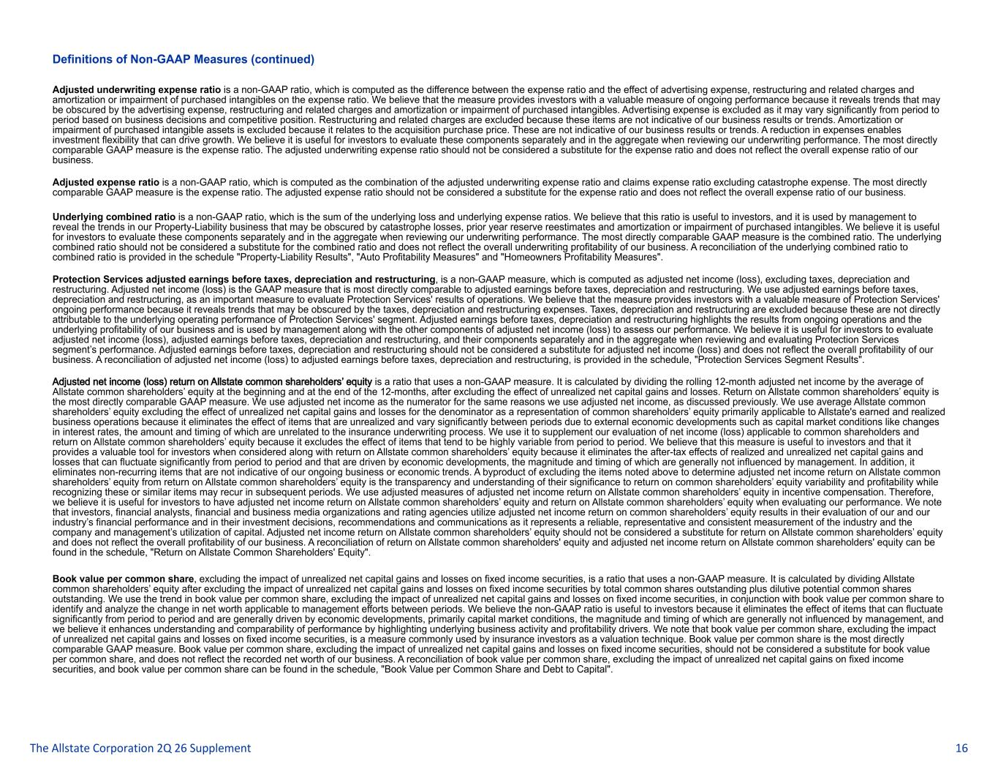
Definitions of Non-GAAP Measures (continued) Adjusted underwriting expense ratio is a non-GAAP ratio, which is computed as the difference between the expense ratio and the effect of advertising expense, restructuring and related charges and amortization or impairment of purchased intangibles on the expense ratio. We believe that the measure provides investors with a valuable measure of ongoing performance because it reveals trends that may be obscured by the advertising expense, restructuring and related charges and amortization or impairment of purchased intangibles. Advertising expense is excluded as it may vary significantly from period to period based on business decisions and competitive position. Restructuring and related charges are excluded because these items are not indicative of our business results or trends. Amortization or impairment of purchased intangible assets is excluded because it relates to the acquisition purchase price. These are not indicative of our business results or trends. A reduction in expenses enables investment flexibility that can drive growth. We believe it is useful for investors to evaluate these components separately and in the aggregate when reviewing our underwriting performance. The most directly comparable GAAP measure is the expense ratio. The adjusted underwriting expense ratio should not be considered a substitute for the expense ratio and does not reflect the overall expense ratio of our business. Adjusted expense ratio is a non-GAAP ratio, which is computed as the combination of the adjusted underwriting expense ratio and claims expense ratio excluding catastrophe expense. The most directly comparable GAAP measure is the expense ratio. The adjusted expense ratio should not be considered a substitute for the expense ratio and does not reflect the overall expense ratio of our business. Underlying combined ratio is a non-GAAP ratio, which is the sum of the underlying loss and underlying expense ratios. We believe that this ratio is useful to investors, and it is used by management to reveal the trends in our Property-Liability business that may be obscured by catastrophe losses, prior year reserve reestimates and amortization or impairment of purchased intangibles. We believe it is useful for investors to evaluate these components separately and in the aggregate when reviewing our underwriting performance. The most directly comparable GAAP measure is the combined ratio. The underlying combined ratio should not be considered a substitute for the combined ratio and does not reflect the overall underwriting profitability of our business. A reconciliation of the underlying combined ratio to combined ratio is provided in the schedule "Property-Liability Results", "Auto Profitability Measures" and "Homeowners Profitability Measures". Protection Services adjusted earnings before taxes, depreciation and restructuring, is a non-GAAP measure, which is computed as adjusted net income (loss), excluding taxes, depreciation and restructuring. Adjusted net income (loss) is the GAAP measure that is most directly comparable to adjusted earnings before taxes, depreciation and restructuring. We use adjusted earnings before taxes, depreciation and restructuring, as an important measure to evaluate Protection Services' results of operations. We believe that the measure provides investors with a valuable measure of Protection Services' ongoing performance because it reveals trends that may be obscured by the taxes, depreciation and restructuring expenses. Taxes, depreciation and restructuring are excluded because these are not directly attributable to the underlying operating performance of Protection Services' segment. Adjusted earnings before taxes, depreciation and restructuring highlights the results from ongoing operations and the underlying profitability of our business and is used by management along with the other components of adjusted net income (loss) to assess our performance. We believe it is useful for investors to evaluate adjusted net income (loss), adjusted earnings before taxes, depreciation and restructuring, and their components separately and in the aggregate when reviewing and evaluating Protection Services segment’s performance. Adjusted earnings before taxes, depreciation and restructuring should not be considered a substitute for adjusted net income (loss) and does not reflect the overall profitability of our business. A reconciliation of adjusted net income (loss) to adjusted earnings before taxes, depreciation and restructuring, is provided in the schedule, "Protection Services Segment Results". Adjusted net income (loss) return on Allstate common shareholders’ equity is a ratio that uses a non-GAAP measure. It is calculated by dividing the rolling 12-month adjusted net income by the average of Allstate common shareholders’ equity at the beginning and at the end of the 12-months, after excluding the effect of unrealized net capital gains and losses. Return on Allstate common shareholders’ equity is the most directly comparable GAAP measure. We use adjusted net income as the numerator for the same reasons we use adjusted net income, as discussed previously. We use average Allstate common shareholders’ equity excluding the effect of unrealized net capital gains and losses for the denominator as a representation of common shareholders’ equity primarily applicable to Allstate's earned and realized business operations because it eliminates the effect of items that are unrealized and vary significantly between periods due to external economic developments such as capital market conditions like changes in interest rates, the amount and timing of which are unrelated to the insurance underwriting process. We use it to supplement our evaluation of net income (loss) applicable to common shareholders and return on Allstate common shareholders’ equity because it excludes the effect of items that tend to be highly variable from period to period. We believe that this measure is useful to investors and that it provides a valuable tool for investors when considered along with return on Allstate common shareholders’ equity because it eliminates the after-tax effects of realized and unrealized net capital gains and losses that can fluctuate significantly from period to period and that are driven by economic developments, the magnitude and timing of which are generally not influenced by management. In addition, it eliminates non-recurring items that are not indicative of our ongoing business or economic trends. A byproduct of excluding the items noted above to determine adjusted net income return on Allstate common shareholders’ equity from return on Allstate common shareholders’ equity is the transparency and understanding of their significance to return on common shareholders’ equity variability and profitability while recognizing these or similar items may recur in subsequent periods. We use adjusted measures of adjusted net income return on Allstate common shareholders’ equity in incentive compensation. Therefore, we believe it is useful for investors to have adjusted net income return on Allstate common shareholders’ equity and return on Allstate common shareholders’ equity when evaluating our performance. We note that investors, financial analysts, financial and business media organizations and rating agencies utilize adjusted net income return on common shareholders’ equity results in their evaluation of our and our industry’s financial performance and in their investment decisions, recommendations and communications as it represents a reliable, representative and consistent measurement of the industry and the company and management’s utilization of capital. Adjusted net income return on Allstate common shareholders’ equity should not be considered a substitute for return on Allstate common shareholders’ equity and does not reflect the overall profitability of our business. A reconciliation of return on Allstate common shareholders' equity and adjusted net income return on Allstate common shareholders' equity can be found in the schedule, "Return on Allstate Common Shareholders' Equity". Book value per common share, excluding the impact of unrealized net capital gains and losses on fixed income securities, is a ratio that uses a non-GAAP measure. It is calculated by dividing Allstate common shareholders’ equity after excluding the impact of unrealized net capital gains and losses on fixed income securities by total common shares outstanding plus dilutive potential common shares outstanding. We use the trend in book value per common share, excluding the impact of unrealized net capital gains and losses on fixed income securities, in conjunction with book value per common share to identify and analyze the change in net worth applicable to management efforts between periods. We believe the non-GAAP ratio is useful to investors because it eliminates the effect of items that can fluctuate significantly from period to period and are generally driven by economic developments, primarily capital market conditions, the magnitude and timing of which are generally not influenced by management, and we believe it enhances understanding and comparability of performance by highlighting underlying business activity and profitability drivers. We note that book value per common share, excluding the impact of unrealized net capital gains and losses on fixed income securities, is a measure commonly used by insurance investors as a valuation technique. Book value per common share is the most directly comparable GAAP measure. Book value per common share, excluding the impact of unrealized net capital gains and losses on fixed income securities, should not be considered a substitute for book value per common share, and does not reflect the recorded net worth of our business. A reconciliation of book value per common share, excluding the impact of unrealized net capital gains on fixed income securities, and book value per common share can be found in the schedule, "Book Value per Common Share and Debt to Capital". The Allstate Corporation 2Q 26 Supplement 16

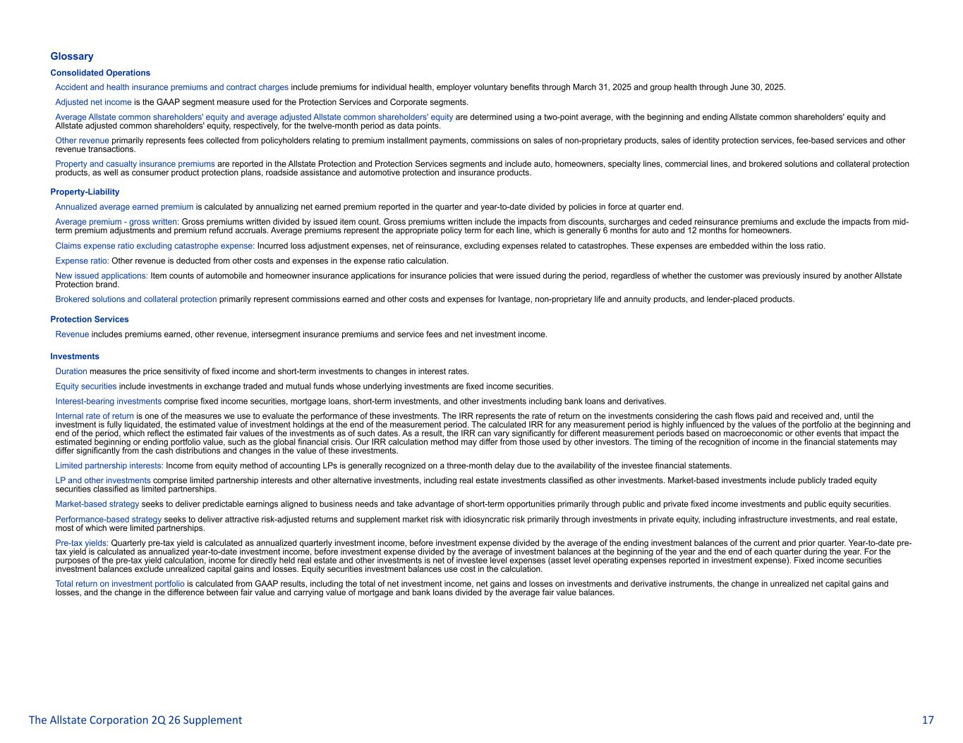
Glossary Consolidated Operations Accident and health insurance premiums and contract charges include premiums for individual health, employer voluntary benefits through March 31, 2025 and group health through June 30, 2025. Adjusted net income is the GAAP segment measure used for the Protection Services and Corporate segments. Average Allstate common shareholders' equity and average adjusted Allstate common shareholders' equity are determined using a two-point average, with the beginning and ending Allstate common shareholders' equity and Allstate adjusted common shareholders' equity, respectively, for the twelve-month period as data points. Other revenue primarily represents fees collected from policyholders relating to premium installment payments, commissions on sales of non-proprietary products, sales of identity protection services, fee-based services and other revenue transactions. Property and casualty insurance premiums are reported in the Allstate Protection and Protection Services segments and include auto, homeowners, specialty lines, commercial lines, and brokered solutions and collateral protection products, as well as consumer product protection plans, roadside assistance and automotive protection and insurance products. Property-Liability Annualized average earned premium is calculated by annualizing net earned premium reported in the quarter and year-to-date divided by policies in force at quarter end. Average premium - gross written: Gross premiums written divided by issued item count. Gross premiums written include the impacts from discounts, surcharges and ceded reinsurance premiums and exclude the impacts from mid- term premium adjustments and premium refund accruals. Average premiums represent the appropriate policy term for each line, which is generally 6 months for auto and 12 months for homeowners. Claims expense ratio excluding catastrophe expense: Incurred loss adjustment expenses, net of reinsurance, excluding expenses related to catastrophes. These expenses are embedded within the loss ratio. Expense ratio: Other revenue is deducted from other costs and expenses in the expense ratio calculation. New issued applications: Item counts of automobile and homeowner insurance applications for insurance policies that were issued during the period, regardless of whether the customer was previously insured by another Allstate Protection brand. Brokered solutions and collateral protection primarily represent commissions earned and other costs and expenses for Ivantage, non-proprietary life and annuity products, and lender-placed products. Protection Services Revenue includes premiums earned, other revenue, intersegment insurance premiums and service fees and net investment income. Investments Duration measures the price sensitivity of fixed income and short-term investments to changes in interest rates. Equity securities include investments in exchange traded and mutual funds whose underlying investments are fixed income securities. Interest-bearing investments comprise fixed income securities, mortgage loans, short-term investments, and other investments including bank loans and derivatives. Internal rate of return is one of the measures we use to evaluate the performance of these investments. The IRR represents the rate of return on the investments considering the cash flows paid and received and, until the investment is fully liquidated, the estimated value of investment holdings at the end of the measurement period. The calculated IRR for any measurement period is highly influenced by the values of the portfolio at the beginning and end of the period, which reflect the estimated fair values of the investments as of such dates. As a result, the IRR can vary significantly for different measurement periods based on macroeconomic or other events that impact the estimated beginning or ending portfolio value, such as the global financial crisis. Our IRR calculation method may differ from those used by other investors. The timing of the recognition of income in the financial statements may differ significantly from the cash distributions and changes in the value of these investments. Limited partnership interests: Income from equity method of accounting LPs is generally recognized on a three-month delay due to the availability of the investee financial statements. LP and other investments comprise limited partnership interests and other alternative investments, including real estate investments classified as other investments. Market-based investments include publicly traded equity securities classified as limited partnerships. Market-based strategy seeks to deliver predictable earnings aligned to business needs and take advantage of short-term opportunities primarily through public and private fixed income investments and public equity securities. Performance-based strategy seeks to deliver attractive risk-adjusted returns and supplement market risk with idiosyncratic risk primarily through investments in private equity, including infrastructure investments, and real estate, most of which were limited partnerships. Pre-tax yields: Quarterly pre-tax yield is calculated as annualized quarterly investment income, before investment expense divided by the average of the ending investment balances of the current and prior quarter. Year-to-date pre- tax yield is calculated as annualized year-to-date investment income, before investment expense divided by the average of investment balances at the beginning of the year and the end of each quarter during the year. For the purposes of the pre-tax yield calculation, income for directly held real estate and other investments is net of investee level expenses (asset level operating expenses reported in investment expense). Fixed income securities investment balances exclude unrealized capital gains and losses. Equity securities investment balances use cost in the calculation. Total return on investment portfolio is calculated from GAAP results, including the total of net investment income, net gains and losses on investments and derivative instruments, the change in unrealized net capital gains and losses, and the change in the difference between fair value and carrying value of mortgage and bank loans divided by the average fair value balances. The Allstate Corporation 2Q 26 Supplement 17

